**Chapter 1**

* + Cells are membrane-enclosed units filled with concentrated aqueous solution that can replicate themselves

**Unity and Diversity of Cells**

* + Cells vary in appearance and function
    - Bacteria cells are a few micrometers in length
    - Cells require different chemicals to sustain themselves
      * Usually reflects the cell’s function
    - Multicellular organisms have division of labor between cell types
* Living cells all have a similar basic chemistry
  + Cells can grow, reproduce, and respond to environmental stimulus
  + Genetic information (DNA) is carried in all cells
    - DNA is made of four nucleotides
    - Information encoded in DNA is transcribed to RNA which are translated into proteins
  + Proteins are built from amino acids
    - All organisms use the same set of 20 amino acids linked in different arrangements to make proteins
  + Viruses contain DNA/RNA but cannot reproduce themselves so they cannot be considered living
* All present-day cells have apparently evolved from the same ancestral cell
  + Daughter cells resemble parent cells because they are the product of cells splitting DNA instructions
  + Mutations may occur, corrupting existing DNA
    - Mutation change the offspring, making them more or less viable for survival
    - The genes of the surviving mutations are continued, leading to evolution
* Genes provide the instructions for cell form, function, and complex behavior
  + A cell’s genome is the sequence of nucleotides in an organism’s DNA, providing behavioral instructions
  + Differentiated cell types are generated during embryonic development based on the genome’s instructions

**Cells Under the Microscope**

* + Microscopes were invented in the 17th century
    - Light microscopes use visible light to illuminate specimens
    - Electron microscopes (1930s) use electrons instead of beams of light to illuminate a sample
* The invention of the light microscope led to the discovery of cells
  + Robert Hooke (1665) observed cork cells using a lense and discovered small chambers
  + “Cells” were named after the cells in a monastery
  + Charles Darwin’s theory of evolution coupled with cell mutation to prove evolution
* Light microscopes allow examination of cells and some of their components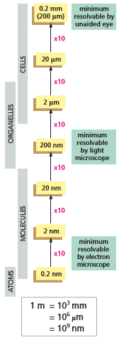
  + Extracellular matrix are protein fibers that separate cells from the outside of their polysaccharide walls
  + Cells are typically 5-20 micrometers in diameter
  + The nucleus is located in the middle of the cell and holds genetic information
  + The cytoplasm is the fluid internal substance of the cell
    - Organelles float in the cytoplasm
  + Fluorescent microscopes can electronically image specimens to about 20 nanometers (the size of a ribosome)
* The fine structure of a cell is revealed by electron microscopy
  + Electron microscopes image thin sections of samples and are capable of observing organelles
  + The plasma membrane separates the interior of the cell from its exterior environment
  + Internal membranes surround organelles inside of the cell
  + Transmission electron microscopes transmit a beam of electrons through the sample and observe the resultant pattern
  + Scanning electron microscopes scatter electrons off the surface of the sample to observe surface details
  + X-ray crystallography is used to observe the precise three-dimensional structure of protein molecules

**The Prokaryotic Cell**

* + Bacteria have the simplest structure
  + Eukaryotes are organisms whose cells have a nucleus
  + Prokaryotes (or “Bacterium”) are organisms without nuclei
    - Prokaryotes are large in number, can exchange genetic material, and evolve fast, rapidly acquiring the ability to use new food source or resist antibiotics
* Prokaryotes are the most diverse and numerous cells on Earth
  + Prokaryotes are extremely diverse and exhibit a large range of habitats
  + Mitochondria are thought to have evolved from aerobic bacteria that took to living inside eukaryotic cells
  + Chloroplasts evolved from photosynthetic bacteria that lived inside the cytoplasm of a plant ancestor
* The world of prokaryotes is divided into two domains: Bacteria and Archaea
  + Most prokaryotes in everyday life are bacteria
  + Archaea are found in everyday habitats as well as hostile environments, resembling the harsh environments of primitive earth
    - Archaea can exist in environments limited in oxygen

**The Eukaryotic Cell**

* + In general, Eukaryotic cells are bigger and more elaborate than bacteria and archaea
  + All complex multicellular organisms are formed from eukaryotic cells
* The nucleus is the information store of the cell
  + The nucleus is enclosed within two concentric membranes that form the nuclear envelope
    - Prokaryotic cells do not have a nuclear envelope
  + Nucleus contains the DNA of the cell
  + In a light microscope, the DNA is visible as individual chromosomes before cell division
    - DNA also carries genetic material in prokaryotic cells
* Mitochondria generate usable energy from food to power the cell
  + Mitochondria are present in most eukaryotic cells
    - They are one of the most conspicuous organelles through a light microscope
  + Mitochondria generates chemical energy for the cell
  + Food molecules, such as sugars, are oxidized into adenosine triphosphate (ATP)
    - Process called cellular respiration
    - Consumes oxygen and releases carbon dioxide
  + Mitochondria contain their own DNA and reproduce by dividing in two
* Chloroplasts capture energy from sunlight
  + Chloroplasts carry out photosynthesis by trapping the energy of sunlight in their chlorophyll molecules, creating glucose
  + Plants may extract stored chemical energy by oxidizing the sugars in their mitochondria, similar to an animal
    - Plants may produce energy in both sunlight and darkness
  + Chloroplasts contain their own DNA and divide by splitting in two
* Internal membranes create intracellular compartments with different functions
  + Organisms are surrounded by single membranes
  + The endoplasmic reticulum (ER) is the site of production for cell-membrane components and materials destined for cell export
  + The golgi apparatus modifies and packages molecules made in the ER
  + Lysosomes are responsible for intracellular digestion
    - Endocytosis is the process of absorbing exterior materials by forming vesicles
    - Exocytosis is the process of releasing interior materials by merging a vesicle with the cell membrane
* The cytosol is a concentrated aqueous gel of large and small molecules
  + The cytosol is the part of the cytoplasm not contained in intracellular membranes
  + In most cells, the cytosol is the largest single compartment
* The cytoskeleton is responsible for directed cell movements
  + Protein filaments that extend within the cell
  + There are three major filament types
    - Actin filaments are the thinnest filaments
    - Microtubules are the thickest filaments, forming as hollow tubes
    - Intermediate filaments serve to strengthen the cell
* The cytoplasm is far from static
  + Cell interior is in constant motion
  + Motor proteins use ATP to move along the cytoskeleton filaments to carry nutrients
  + Organelles move by colliding and random thermal motion
* Eukaryotic cells may have originated as predators
  + Eukaryotic cells are typically 10 times the length and 1000 times the volume of prokaryotic cells
  + The ancestral eukaryotic cell lived by capturing foreign cells and absorbing them
  + Protozoans are free-living actively motile microorganisms

**Model Organisms**

* + All cells are thought to have descended from a common ancestor
  + Cells can be categorized into model organisms, basic forms of categorizing cells based on ancestral relations
* Molecular biologists have focused on e. coli
  + Small, rod-shaped cell
  + Lives in guts of humans and other vertebrates
* Brewer’s yeast is a simple eukaryotic cell
  + Saccharomyces cerevisiae is the microorganism that is used for brewing beer and making bread
* Arabidopsis has been chosen as a model plant
  + Similar to plant cell
* Model animals include flies, fish, worms, and mice
  + Genes responsible for developing flies are similar to humans
  + Mammals are extremely complex organisms. Mice are often used for experiments as early mammals that can reproduce quickly
* Biologists also directly study human beings and their cells
  + *In Vitro* experiments are conducted in cultured cells (in glass)
  + *In vivo* experiments are done to intact organisms (in living)
  + All experiments done on humans are well documented for future reference
* Comparing genome sequences reveals life’s common heritage
  + Evolutionary change is very slow at a molecular level
    - Many features of present day organisms have been preserved for 3 billion years
  + The overall size and number of genes in organisms is fairly similar
    - E Coli carries 4.6 million nucleotide pairs and 4300 genes
    - Simple bacterium carry 500 genes
    - Prokaryotes have genomes of 1 million nucleotide pairs and 1000-8000 genes
    - Human genome contains 700 times more DNA than E Coli
  + Homologous designates organisms that descended from a common ancestor
* Genomes contain more than just genes
  + A large amount of DNA is sequences that code for processes that regulate gene activity
  + There are dispensable sequences included in the genome
  + DNA can program the growth, development, and reproduction of living cells and complex organisms

**Chapter 2**

* + Organic chemistry is the study of carbon compounds
  + Organic chemical reactions occur almost exclusively in aqueous solutions
  + Polymeric molecules are chains of chemical subunits linked end-to-end

**Chemical Bonds**

* Cells are made of relatively few types of atoms
  + A whole lot of shit about the structure of atoms, which you already know
* The outermost electrons determine how atoms interact
  + First shell - 2 electrons
  + Second shell - 8 electrons
  + Third shell - 8 electrons
  + Fourth/Fifth shell - 18 electrons
  + Chemical bonds bind atoms to one another
    - Ionic bond: electrons are donated between atoms
    - Covalent bond: Pair of electrons are shared
    - The number of electrons atoms must acquire or lose to attain a filled outer shell determines the number of bonds the atom can make
* Covalent bonds form by the sharing of electrons
  + Molecules are clusters of atoms held together by covalent bonds
    - Carbon forms a maximum of four covalent bonds
    - Oxygen forms a maximum of two covalent bonds
    - Hydrogen forms only one covalent bond
* There are different types of covalent bonds
  + Single bonds involve one pair of electrons
    - Allow for rotation
  + Double bonds involve two pairs of electrons
    - Prevents rotation (rigid arrangement of atoms)
  + Polar structures have positive charge concentrated towards one end of the molecule and negative charge concentrated towards the other end
    - Oxygen and nitrogen atoms attract electrons
    - Hydrogen atoms attract electrons weakly
    - C-H bonds are relatively nonpolar
* Covalent bonds vary in strength
  + Bond strength is the amount of energy that must be supplied to break the bond
    - 1 kcal/mole indicates it takes 1 kilocalorie of energy to break 6 x 1023 bonds
    - Covalent bonds have a high bond strength, making them breakable by enzymes instead of slight increases in thermal conditions
* Ionic bonds form from gain and loss of electrons
  + Ionic bonds usually form between atoms that can attain a complete outer shell by giving or receiving an electron
  + NaCl forms when an electron jumps from Na to Cl
    - When an electron jumps between atoms, both atoms become charged ions
    - Na+ and Cl- are attracted due to their opposite charges
  + Ions held together by solely ionic bonds are generally called salts instead of molecules
* Noncovalent bonds help bring molecules together in cells
  + Noncovalent bonds are individually weak but can sum to an effective binding force
  + Ionic bonds are noncovalent bonds called electrostatic attraction
    - Weaker electrostatic attraction occurs between polar covalent bonds
* Hydrogen bonds are important noncovalent bonds for many biological molecules
  + Hydrogen bonds are weaker than covalent bonds and are easily broken by random thermal motions
    - Hydrogen bonds are extremely brief
  + Hydrogen bonds are common between water molecules
  + Hydrogen bonds form wherever a positively charged H atom held in one molecule by a polar covalent linkage approaches a negatively charged atom
  + Molecules are hydrophilic if they carry positive or negative charges, making them dissolve readily in water
  + Molecules are hydrophobic if they are uncharged and form few or no hydrogen bonds and do not dissolve in water
* Some polar molecules form acids and bases in water
  + A hydrogen atom that loses its electron is essentially a proton
  + Hydronium ions (H3O+) form when an H+ interacts with a water molecule
  + Acids are substances that release protons when they dissolve in water (forming H3O+)
  + Concentration of H+ is expressed using a pH scale
    - Pure water has pH of 7.0 (neutral)
    - Acidic: pH < 7
    - Basic: pH > 7
  + Base are any molecule that accepts a proton when dissolved in water
  + The interior of cells are kept close to neutral by the presence of buffers
    - Buffers are mixtures of weak acids and bases that can regulate proton concentrations around pH 7

**Small Molecules in Cells**

* A cell is formed from carbon compounds
  + Carbon is an important organic atom because it can form four covalent bonds
  + Carbon compounds made in cells are called organic molecules
    - All other molecules are inorganic
  + Chemical groups are commonly repeating combinations of atoms
* Cells contain four major families of small organic molecules
  + Monomers are subunits for macromolecules
  + Small organic molecules can be categorized into sugars, fatty acids, amino acids, and nucleotides
* Sugars are both energy sources and subunits of polysaccharides
  + Monosaccharides are the simplest sugars with general formula (CH2O)n with n being 3,4,5 or 6
    - Monosaccharides can be linked by glycosidic covalent bonds
  + Carbohydrates are larger molecules made of sugars
    - C6H12O6 is glucose
  + Optical isomers are mirror-image pairs of molecules
  + Condensation reactions occur between -OH groups of two monosaccharides during which a water molecule is expelled as the bond forms
    - Hydrolysis is the reverse process in which a molecule of water is consumed
* Fatty acid chains are components of cell membranes
  + Fatty acid molecules have two distinct regions
    - The hydrocarbon chain is made exclusively of hydrogens and carbons and is hydrophobic
    - The carboxyl (-COOH) group behaves as an acid and ionized (-COO-), making them extremely hydrophilic
  + Saturated hydrocarbon tails have no double bonds between carbon atoms
  + Unsaturated tails have one or more double bonds, creating kinks in the hydrocarbon tails
  + Fatty acids are concentrated food reserve cells that can be broken down to produce about six times as much usable energy as glucose
  + Triacylglycerol molecules are formed of three fatty acid chains covalently joined
  + Lipids are fatty acids and their derivatives which are insoluble in water but soluble in fat and organic solvents
  + Lipid bilayers enclose all cells and internal organelles are are composed of phospholipids
    - Phospholipids have a hydrophilic head and hydrophobic tail, making them alight with tails facing inwards to create a double sided membrane
* Amino acids are subunits of proteins
  + Amino acids all possess a carboxylic acid group and an amino group
  + Cells use amino acids to build proteins, polymers made of amino acids that join in long chains and fold to create unique 3D structures
    - 20 types of amino acids are commonly found in proteins
    - The same 20 amino acids are found in all organisms
  + 5 of the 20 standard amino acids have side chains that form ions in solutions and can therefore carry a charge
* Nucleotides are the subunits of DNA and RNA
  + Subunits of DNA and RNA are nucleotides, made of nitrogen-containing ring compound linked with a 5 carbon sugar (ribose or deoxyribose)
    - Cytosine (C) , thymine (T), and uracil (U) are pyrimidines
      * Have six-membered pyrimidine ring
    - Guanine (G) and adenine (A) are purines
      * Bear a second, five-membered ring fused to the six-membered ring
  + Adenosine triphosphate (ATP) participates in the transfer of energy for metabolic reactions
    - Energy is released by breaking phosphoanhydride bonds
  + Nucleotides form together to store biological information as nucleic acids
    - Ribonucleic acids (RNA) contain bases A, G, C, and U
      * Temporary carrier of molecular instructions
    - Deoxyribonucleic acids (DNA) contain bases A, G, C, and T
      * Long-term repository for genetic information

**Macromolecules in Cells**

* + Macromolecules are constructed by covalently linked monomers or polymers
* Each macromolecule contains a specific sequence of subunits
  + Subunits are formed in a particular order, or sequence
  + Biological functions of proteins are absolutely dependent on the particular sequence of subunits in the linear chains
    - For a protein chain 200 amino acids long, there are 20200 possible combinations
    - For DNA 10,000 nucleotides long, there are 410,000 possibilities
* Noncovalent bonds specify the precise shape of a macromolecule
  + Single covalent bonds allow for rotations of the atoms they join, allowing for an almost unlimited number of conformations (shapes)
  + Weaker, noncovalent bonds typically enforce a specific structure
  + Van der Waals attractions are a third type of noncovalent interactions where electrical attraction is caused by fluctuating electric charges when two atoms are very close to each other
  + Hydrophobic interaction is a fourth kind of noncovalent bond which hold together phospholipid molecules in cell membranes
* Noncovalent bonds allow a macromolecule to bind other selected molecules
  + Individual bonds add up to create greater attractive power
  + Noncovalent bonds allow macromolecules to be used as building blocks for formation of larger structures

**Chapter 3**

* + Cells require both a source of atoms in the form of food molecules and a source of energy
  + Enzymes are specialized proteins that catalyze, or accelerate, reactions
    - The necessity of catalysis is beneficial to the cell because it allows for precise control of the cell’s metabolism
  + Chemical reactions occur in catabolic pathways and anabolic pathways
    - Catabolism breaks down foodstuffs into smaller molecules
    - The anabolic, or biosynthetic, pathways use the energy harnessed by catabolism to drive synthesis of molecules in cells

**The Use of Energy by Cells**

* Biological order is made possible by the release of heat energy from cells
  + The second law of thermodynamics expresses the universal tendency of things to become disordered
    - States the degree of disorder can only increase
    - Systems will change spontaneously toward the arrangements that have the greatest possibility
  + Entropy is the measure of a system’s disorder
  + Cells take energy from their environment (in the form of food, inorganic molecules, or photons from the sun) to generate order
* Cells can convert energy from one form to another
  + First law of thermodynamics: energy cannot be created or destroyed
    - But can be converted from one form to another
  + Animal cells break down chemical bonds in food (chemical-bond energy) and convert it to thermal motion of molecules (heat energy)
    - Thermal energy can only be harvested when molecule couples with systems in the cell
* Photosynthetic organisms use sunlight to synthesize organic molecules
  + Photosynthesis is the process that converts the electromagnetic energy in sunlight into chemical-bond energy in cells
  + Photosynthesis produces sugars, amino acids, nucleotides, and fatty acids
  + Step 1: Energy from sunlight is captured and stored as chemical-bond energy in activated carriers
  + Step 2: Activated carriers drive a carbon fixation process to manufacture sugars from CO2
* Cells obtain energy by the oxidation of organic molecules
  + Oxidation is the controlled burning of, in this case, food molecules
  + Cellular respiration is the process by which food molecules combine with oxygen (they oxidize) to produce CO2 and H2O
  + Photosynthesis and cellular respiration are complementary processes. Oxygen released by photosynthesis is consumed by nearly all organisms, producing CO2, and CO2 molecules are consumed in photosynthesis
* Oxidation and reduction involve electron transfers
  + Oxidation literally means the addition of oxygen atoms to a molecule
  + In general, oxidation refers to the removal of electrons from an atom
  + Reduction involves the addition of electrons to an atom
  + Oxidation and reduction always occur in parallel
    - Both apply when there is only a partial shift of electrons between atoms of a covalent bond
    - Forms a polar covalent bond
  + Hydrogenation reactions are reductions
  + Dehydrogenation reactions are oxidations

**Free Energy and Catalysis**

* + Catalysis is the acceleration of the specific chemical reactions needed to sustain life
* Chemical reactions proceed in the direction that causes a loss of free energy
  + Free energy is energy that can be harnessed to do work or drive chemical reactions
  + Chemical reactions proceed only in the direction that leads to a release of free energy
* Enzymes reduce the energy needed to initiate spontaneous reactions
  + Molecules in living organisms are in a relatively stable state and require an activation energy before it can overcome a chemical reaction
  + Cells can’t raise their own temperature to provide the activation energy so enzymes aid in supplying energy
  + Enzymes bind to substrates and holds them in a way that reduces the necessary activation energy
  + Catalyst are substances that can lower the activation energy, thereby increasing the rate of chemical reactions
  + Enzymes usually speed up only one particular reaction
* The free-energy change for a reaction determines whether it can occur
  + Free energy (or G) is energy that could be harnessed to do work
    - Free energy change is ΔG
  + ΔG measures the amount of disorder created in the universe when a reaction takes place
    - Energetically favorable reactions are those that create disorder by decreasing free energy (-ΔG) and occur spontaneously
    - Energetically unfavorable reactions create order (+ΔG) and cannot occur spontaneously
* ΔG changes as a reaction proceeds toward equilibrium
  + Chemical reactions occur based on energy stored in each individual molecule as well as the concentrations of the molecules in the reaction mixture
  + As a forward reaction proceeds, the product to reactant ratio will increase, leading to a -ΔG that grows less and less negative until it eventually stops
  + Chemical reactions will proceed until they reach equilibrium
    - Where rates of the forward and reverse reactions are equal
    - ΔG = 0
    - Living cells avoid reaching equilibrium by constantly replenishing reactants by exchanging with their surroundings
* The standard free-energy change, ΔG°, makes it possible to compare the energetics of different reactions
  + Standard free-energy change depends on the intrinsic characters of the reacting molecules
    - Depends on behavior of molecules under ideal conditions where concentrations of all reactants are 1 mol/liter
    - When the concentrations of [X] and [Y] are equal, ΔG = ΔG°
* The equilibrium constant is directly proportional to ΔG°
  + The ratio of substrate to produce at equilibrium is called the equilibrium constant (K)
    - K = [X]/[Y] in reaction Y → X
    - At equilibrium at 37℃: ΔG° = -1.42 log K
* In complex reactions, the equilibrium constant includes the concentrations of all reactants and products
  + In a reaction A + B ↔ AB: K = [AB] / [A] [B]
* The equilibrium constant indicates the strength of molecular interactions
  + Two molecules will bind to each other if the free-energy change for the interaction is negative
  + K becomes larger as the binding energy increases
    - The larger the K the more tightly the molecules will bind
* For sequential reactions, the changes in free energy are additive
  + Enzymes can catalyze reactions that are energetically unfavorable by directly coupling energetically unfavorable reactions with energetically favorable ones
  + For Reactions X → Y (ΔG° = +5) and Y → Z (ΔG° = -13)
    - ΔG° for the completed reaction is -8, making the overall pathway energetically favorable
    - X → Y is unfavorable
    - Y → Z is favorable
* Thermal motion allows enzymes to find their substrates
  + Enzymes and their substrates are both present in relatively small amounts in the cytosol of a cell
    - Enzymes can capture and process a thousand substrate molecules every second
  + Diffusion through the cytosolic space allows molecules to move around the cytosol due to random thermal movements
    - Every molecule in the cytosol collides with a huge number of other molecules each second
    - Tests show small organic molecules can move extremely fast through the cytosol (50 nanometers per second)
    - The most common substrates (with a concentration of about 0.5 mM) collide with enzymes about 500,000 times per second
  + Random encounters between enzymes and substrates result in enzyme-substrate complex
    - Stabilized by multiple, weak bonds between the enzyme and substrate
    - Include hydrogen bonds, van der Waals attractions, and electrostatic attractions
    - Mismatched molecules will dissociate as fast as they associate due to an insufficient number of matching bonds
    - Properly matched substrates will bind to the enzyme with sufficient bonds to allow time for a covalent bond in the substrate to be made or broken
* Vmax and KM measure enzyme performance
  + To catalyze a reaction, an enzyme must first bind its substrate. The reaction then occurs and the product is released to diffuse away
  + Vmax is the point at which the active sites of all enzyme molecules in the sample are fully occupied by a substrate
  + The turnover number for enzymes is around 1000 substrate molecules per second (although values between 1 and 100,000 have been measured)
  + The Michaelis constant (KM) is the concentration of substrate needed to make the enzyme work efficiently

**Activated Carriers and Biosynthesis**

* + In most cases, the energy stored to fuel unfavorable reactions are stored as chemical-bond energy in a set of activated carriers
    - These molecules diffuse rapidly from the energy generation to the sites where energy is used for biosynthesis or other activities
  + Activated carriers store energy in an easily exchangeable form
    - Most important ones are ATP and two very similar molecules NADH and NADPH
* The formation of an activated carrier is coupled to an energetically favorable reaction
  + Energy capture is achieved by a coupled reaction in which an energetically favorable reaction is used to drive an energetically unfavorable one

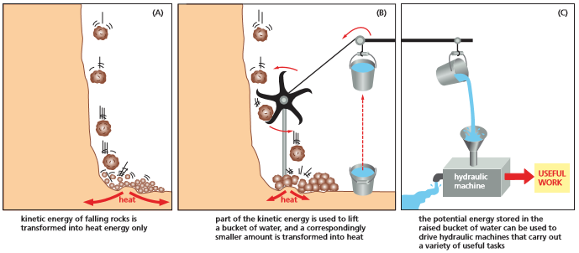

* ATP is the most widely used activated carrier
  + ATP is the most important and versatile of the activated carriers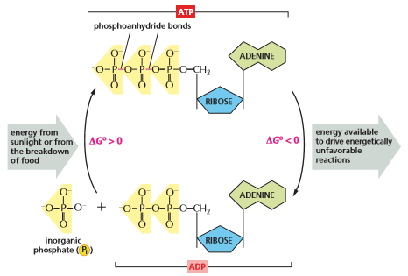
  + ATP is synthesized in an energetically unfavorable phosphorylation reaction in which a phosphate group is added to ADP
  + When required, ATP gives up its energy packet in an energetically favorable hydrolysis to ADP which can be recycled to create ATP
  + ATP is the most abundant activated carrier in cells
    - It is used to operate pumps that actively transport substances in and out of the cell
* Energy stored in ATP is often harnessed to join two molecules together
  + A common type of reaction in biosynthesis is the joining of two molecules, A and B through a condensation reaction
    - A-H + B-OH → A-B + H2O
  + ATP hydrolysis can be coupled indirectly with this reaction to make it go faster
* NADH and NADPH are both activated carriers of electrons
  + NADH and NADPH both carry energy in the form of two high-energy electrons plus a proton (H+), which together form a hydride ion (H-)
  + When the activated carriers pass energy to a donor molecule, they become oxidized to form NAD+ and NADP+
  + NADPH is efficient at donating its hydride ion due to a large negative free-energy change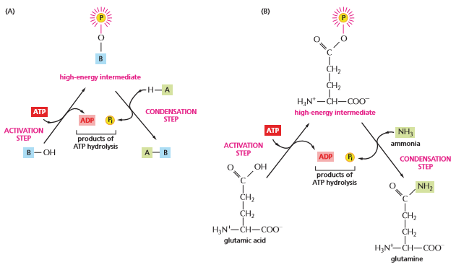
* NADPH and NADH have different roles in cells
  + NADPH and NADH differ by a single phosphate group
  + In a cell the ratio of NAD+ to NADH is kept high while NADP+ and NADPH is kept low
    - This leaves plenty of NAD+ to act as the oxidizing agent and plenty of NADPH to act as the reducing agent
* Cells make use of many other activated carriers
  + FADH2 carries hydrogen and high-energy electrons, similar to NADH and NADPH
  + Coenzyme A can carry an acetyl group in a readily transferable linkage called acetyl CoA

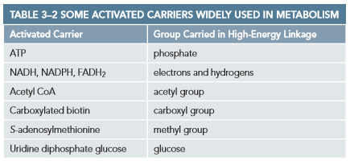

* The synthesis of biological polymers requires an energy input
  + The macromolecules of the cell are made from subunits (monomers)
  + Breakdown of polymers occurs through enzyme-catalyzed hydrolysis reactions which are energetically favorable
  + DNA and RNA, proteins, and polysaccharides are all polymers that are produced by repeated addition of a subunit onto one end of a growing chain

**Chapter 4**

* + Proteins are the main building blocks of cell assembly
  + Enzymes promote intracellular chemical reactions

**The Shape and Structure of Proteins**

* The shape of a protein is specified by its amino acid sequence
  + Proteins are assembled mainly from a set of 20 different amino acids
    - Protein molecules are made from long chains of amino acids held together by covalent peptide bonds
  + Proteins are referred to as polypeptides
    - Amino acid chains are referred to as polypeptide chains
    - The amino acid sequence is the unique order of amino acids in each protein
  + Each polypeptide chain consists of a backbone that is adorned with a variety of chemical side chains
    - Polypeptide backbone is formed from a repeated sequence of the core atoms
    - The end carrying the amino group is called the amino terminus (N-terminus)
    - The end carrying the carboxyl group is called the carboxyl terminus (C-terminus)
    - Amino acid side chains are the part of the amino acid that is not involved in forming peptide bonds
      * Side chains give amino acids their unique properties
  + Long peptide chains are flexible and allow free rotation of the atoms they join
    - Proteins can fold in many ways
    - The stability of polypeptide chain is largely influenced by the combined strength of large numbers of noncovalent bonds
    - Hydrophobic interaction can also determine the shape of a protein
    - An important factor for the folding of any protein is the distribution of its polar and nonpolar amino acids
    - Polar amino acids buried within the protein usually hydrogen bond to other polar amino acids or to the polypeptide backbone
* Proteins fold into the conformation of lowest energy
  + The final folded structure (conformation) adopted by polypeptide chains is determined by a shape in which its free energy is minimized
  + Proteins can be unfolded or denatured by treatment with solvents that disrupt the noncovalent interactions holding the folded chain
    - When the denaturing solvent is removed the protein often refolds spontaneously (renaturation)
  + All the information necessary to specify the 3D shape of a protein is contained in its amino acid sequence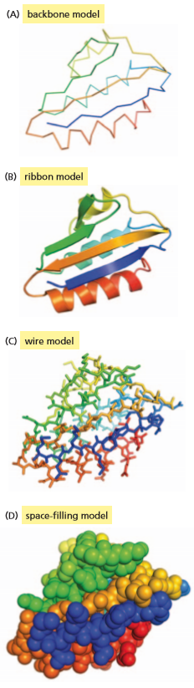
  + When proteins fold incorrectly they form aggregates that can damage cells and even whole tissues
    - Misfolded proteins are thought to contribute to neurodegenerative disorders, such as Alzheimer’s and Huntington’s disease
    - Prions are misfolded proteins that can convert properly folded version of a protein into abnormal configurations, making them contagious
  + Chaperone proteins are special proteins that assist with protein folding
* Proteins come in a wide variety of complicated shapes
  + The vast majority of proteins are between 50 and 2000 amino acids long
  + HPr is a bacterial transport protein that facilitates the transport of sugar into bacterial cells
  + The ribbon model can help predict which amino acids might be involved in the protein's activity
  + The space filling model provides a contour map of the protein’s surface, revealing which amino acids are exposed to the surface
* The ⍺ helix and the 𝛽 sheet are common folding patterns
  + The ⍺ helix was found in the protein a-keratin which is abundant in skin
  + The 𝛽 sheet was found in the protein fibroin, the major constituent of silk
  + These folding patterns are common because they result form hydrogen bonds that form between N-H and C--O groups
* Helices form readily in biological structures
  + A helix is a regular structure that resembles a spiral staircase and is generated by placing many similar subunits next to one another
  + Multiple helices will sometimes wrap around one another to make a stable structure called a coiled-coil
* 𝛽 sheets form rigid structures at the core of many proteins
  + 𝛽 sheets are made when hydrogen bonds form between segments of a polypeptide chain that lay side by side
  + A parallel 𝛽 sheet forms when the neighboring segments run in the same direction
  + Antiparallel 𝛽 sheets form when the neighboring segments run in opposite directions
  + 𝛽 sheets stack together tightly with their amino acid side chains interdigitated like the teeth of a zipper
* Proteins have several layers of organization
  + Primary structure is the amino acid sequence
  + Secondary structure is the structure of alpha helixes and beta sheets that form certain segments of the polypeptide chain
  + Tertiary structure is the loops and folds that form between the N- and C- termini
  + Quaternary structure is how the polypeptide chains interact to form proteins
  + Protein domain is defined as any segment of a polypeptide chain that can fold independently into a compact, stable structure
* Many proteins also contain unstructured regions
  + Intrinsically disordered sequences are short stretches linking domains in otherwise highly ordered proteins
  + Unstructured sequence can flex and bend, and wrap around one or more target proteins like a scarf
  + Intrinsically disordered sequences can help scaffold proteins bring together proteins in an intracellular signaling pathway
* Few of the many possible polypeptide chains will be useful
  + For a polypeptide that is n amino acids long, 20n different chains are possible
  + Functional proteins must only engage in the desired associations with other proteins in the cell
  + The structures of some proteins are so stable and effective that they have been conserved throughout evolution among many diverse organisms
* Proteins can be classified into families
  + Protein families have similar amino acid sequences and three-dimensional conformation
* Large protein molecules often contain more than one polypeptide chain
  + Binding sites are regions on a protein’s surface that interacts with other molecules through sets of noncovalent bonds
  + Each polypeptide chain in these proteins is called a subunit
  + Dimers are symmetrical complexes of two protein subunits
* Proteins can assemble into filaments, sheets or spheres
  + A chain of identical protein molecules can be formed if the binding site on one protein molecules if complementary to another region on the surface of another protein molecule of the same type
* Some types of proteins have elongated fibrous shapes
  + Globular proteins have polypeptide chains that fold up into a compact shape like a ball with an irregular surface
    - Results in an overall round shape
  + Fibrous proteins have a simple, elongated three-dimensional structure
  + Intermediate filaments are coiled-coil regions that are capped at either end by globular domains
  + Fibrous proteins are especially abundant outside the cell where they form the extracellular matrix that helps cells bind together to form tissues
* Extracellular proteins are often stabilized by covalent cross-linkages
  + Many protein molecules are attached to the outside of a cell’s plasma membrane or secreted as part of the extracellular matrix
  + Disulfide bonds are sulfur-sulfur bonds that are the most common covalent cross-links in proteins

**How Proteins Work**

* All proteins bind to other molecules
  + Biological properties of a protein molecule depend on its physical interaction with other molecules
  + Binding of a protein to other biological molecules always shows specificity
    - Each protein molecule can bind with just one or a few molecules out of the many thousands of molecules it encounters
  + Ligands are any substances that are bound by a protein
  + The ability of a protein to bind selectively wi based on the formation of weak, noncovalent interactions (hydrogen bonds, electrostatic attractions, and van der Waals attractions
  + When molecules have poorly matching surfaces, few noncovalent interactions occur, and the two molecules dissociate as rapidly
  + Binding site is the region of a protein that associates with a ligand
    - Usually consists of a cavity in the protein surface formed by a particular arrangement of amino acid side chains
    - The amino acid side chains can belong to amino acids that are widely separated and brought together by protein folds
* There are billions of different antibodies, each with a different binding site
  + Antibodies are immunoglobulin proteins produced by the immune system in response to foreign molecules
    - Each antibody binds to a particular target molecule extremely tightly, inactivating the target or marking it for destruction
    - Antigens are the target molecules
  + Antibodies are Y-shaped with two identical antigen-binding sites, each complementary to a small portion of the surface of the antigen molecule
    - Antibodies can be used in laboratories to identify, purify, and study other molecules
* Enzymes are powerful and highly specific catalysts
  + Enzymes are responsible for chemical transformations that occur in cells
    - Enzymes bind to ligands called substrates and convert them into chemically modified products
  + Enzymes often work in tandem, with the product of one enzyme becoming the substrate for the next
    - Metabolic pathways are elaborate networks of enzymes
* Lysozyme illustrates how an enzyme works
  + Lysozymes are enzymes that act as natural antibiotics
  + Lysozymes sever the polysaccharide chains that form the cell walls of bacteria
  + A transition state is the state in which the atoms around the bond have an altered geometry and electron distribution
  + Lysozymes have an active site that cradles the contours of its substrate molecule
    - Lysozymes hold its polysaccharide substrate in such a way that one of the two sugars involved in the bond to be broken is distorted from its normal, most stable configuration
    - Conditions are thereby created that reduce the activation energy necessary for the hydrolysis to take place
* Many drugs inhibit enzymes
  + Many of the drugs we take prevent illness by blocking the activity of a particular enzyme
  + Pharmaceutical companies often develop drugs by first using automated methods to screen libraries of compounds to find chemicals that are able to inhibit the activity of an enzyme of interest
* Tightly bound small molecules add extra functions to proteins
  + Generally the order of amino acids in proteins give macromolecules their shape and functional versatility
  + Proteins often employ small, nonprotein molecules to perform functions that would be difficult or impossible using amino acids alone
  + Rhodopsin is a light-sensitive protein, uses retinal to trigger a cascade of reactions to release an electrical signal

**How Proteins are Controlled**

* + The cell regulates the amount of the protein it contains
  + The cell controls enzymatic activities by confining sets of enzymes to particular subcellular compartments
* The catalytic activities of enzymes are often regulated by other molecules
  + A common type of control occurs when molecules other than substrates specifically bind to an enzyme at a special regulatory site, altering the rate at which the enzyme funcitons
  + Feedback inhibition occurs when an enzyme acting in one part of a reaction pathway is limited by a late product of that pathway
    - When large quantities of a product begin to accumulate, the product binds to an earlier enzyme and slows down its catalytic action
    - Feedback inhibition is a negative regulation
      * It prevents an enzyme from acting
  + Positive regulation occurs when an enzyme’s activity is stimulated by a regulatory molecule rather than being suppressed
* Allosteric enzymes have two or more binding sites that influence one another
  + Enzymes must have at least two different binding sites on their surface
    - The active site recognizes the substrates
    - Other sites recognize regulatory molecules
    - Sites communicate to allow the catalytic events at the active site to be influenced by the binding of the regulatory molecule at its separate site
  + Conformational changes occur when a ligand binds to one of the sites to cause a shift in protein structure
  + Many protein molecules are allosteric, meaning they can adopt two or more slightly different conformations
* Phosphorylation can control protein activity by causing a conformational change
  + Enzymes are regulated by the binding of small molecules
  + Protein phosphorylation controls the activity of many types of proteins in eukaryotic cells
    - Enzyme -catalyzed transfer for the terminal phosphate group of ATP to the hydroxyl group on a serine, threonine, or tyrosine side chain of the protein
    - This is catalyzed by protein kinase
  + Dephosphorylation is the removal of the phosphate group
    - Catalyzed by protein phosphatase
* Covalent modifications also control the location and interaction of proteins
  + Proteins can be modified by the addition of an acetyl group to a lysine side chain
  + Phosphorylation can create docking sites where other proteins can bind, thus promoting the assembly of proteins into larger complexes
* GTP-binding proteins are also regulated by the cyclic gain and loss of a phosphate group
  + GTP-binding proteins bind in the place of ATP
  + GTP acts as molecular switches by transforming between GTP and GDP
* ATP hydrolysis allows motor proteins to produce directed movements in cells
  + Motor proteins generate the forces responsible for muscle contraction and most other eukaryotic cell movements
  + To make conformational changes unidirectional it is enough to make any one of the steps irreversible
    - Irreversibility is achieved by coupling one of the conformational changes to the hydrolysis of an ATP molecule bound to the protein
* Proteins often form large complexes that function as protein machines
  + As proteins grow in size, the functions that the proteins can perform become more elaborate
  + Biological processes are catalyzed by a highly coordinated, linked set of many proteins (protein machines)
  + In protein machines, the hydrolysis of bound nucleoside triphosphates drives an ordered series of conformational changes in some of the individual protein subunits

**Chapter 7**

* + DNA does not synthesize proteins itself, but it carries information for it
  + The segment of DNA is called a gene
  + Transcription: cells copy DNA into RNA
  + Translation: Making protein from RNA

**From DNA to RNA**

* Portions of DNA sequence are transcribed into RNA
  + Process called transcription because the information is written in the same units of nucleotides
  + RNA is a linear polymer made of four different nucleotide subunits linked by phosphodiester bonds
  + RNA differs from DNA
    - The nucleotides in RNA are ribonucleotides rather than deoxyribose
    - RNA contains the bases Adenine, Guanine, and Cytosine, and Uracil (instead of Thymine)
    - RNA is single-stranded, letting it fold in a variety of shapes
* Transcription produces RNA that is complementary to one strand of DNA
  + One of the two strands of the DNA double helix acts as a template for the synthesis of RNA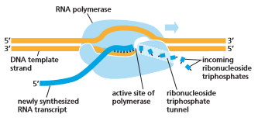
  + RNA polymerase covalently links the growing RNA chain
  + RNA transcript is the chain produced by transcription
  + RNA polymerase catalyzes the formation of phosphodiester bonds that link nucleotides and form the backbone of the RNA chain
    - RNA is grown in the 5’-to-3’ direction
  + RNA strands are released immediately after synthesis, meaning multiple strands can be made from one DNA sequence
    - The synthesis of the next RNA strand usually begins before the first finishes
  + RNA uses ribonucleoside for phosphates as substrates (catalyzes ribonucleotides, not deoxyribonucleotides)
  + RNA polymerase can start an RNA chain without a primer
    - This is because RNA does not have to be as accurate as DNA
    - RNA is not used as the permanent storage of genetic information in cells, so mistakes in RNA transcripts have minor consequences
    - RNA polymerase makes a mistake every 104 nucleotides while DNA polymerase makes a mistake every 107 nucleotides copied
* Cells produce various types of DNA
  + Messenger RNA (mRNA) are encoded by genes specifying the amino acid sequences of proteins
    - Each mRNA typically carries information for just one gene, coding for a single protein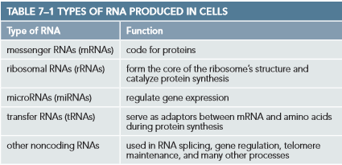
    - In bacteria, adjacent genes are often transcribed as a single mRNA, therefore carrying information for several proteins
  + Ribosomal RNA (rRNA) form the structural and catalytic core of the ribosome
    - rRNA translate mRNA into proteins
  + Transfer RNA (tRNA) act as adaptors that select specific amino acids and hold them in place on a ribosome for their incorporation into protein
  + microRNA (miRNA) serve as key regulators of eukaryotic gene expression
  + Gene expression refers to the process by which information encoded in a DNA sequence is translated into a product that has some effect on a cell or organism
    - When the final product of a gene is a protein, gene expression includes both transcription and translation
    - When the final product is an RNA molecule, gene expression includes just transcription
* Signals in DNA tell RNA polymerase where to start and finish transcription
  + RNA polymerase begins transcription at the transcription start site
  + When an RNA polymerase randomly collides with a DNA molecule, it loosely binds to and travels along the double helix until it finds a promoter
    - Promoters contain a specific sequence of nucleotides that lie immediately upstream of the starting point for RNA synthesis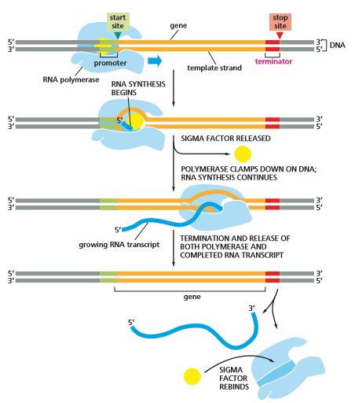
  + RNA polymerase opens up the double helix in front of the promoter and begins pairing with one of the two strands (the template strand)
  + Chain elongation continues until a terminator sequence is encountered
    - At terminator sequence the RNA polymerase stops and releases both the DNA template and the RNA transcript
    - The terminator sequence is coded into the 3’ end of the RNA transcript
  + The desired template strand (in the two DNA strands) is determined based on the polarity of the promoter
    - Because RNA polymerase can only synthesize RNA in the 5’-to-3’ direction, once the polymerase is bound it must use the DNA strand oriented in the 3’-to-5’ direction
* Initiation of eukaryotic gene transcription is a complex process
  + Differences between bacteria and eukaryotic gene transcription:
    - Eukaryotic cells have 3 different RNA polymerase, responsible for transcribing different types of genes
      * RNA polymerases I and III transcribe genes for tRNA, rRNA, and various other structural and catalytic RNAs
      * RNA polymerase II transcribes the majority of eukaryotic genes, including miRNAs and proteins
    - Eukaryotic RNA polymerase requires the assistance of accessory proteins (general transcription factors) to initiate transcription
    - Initiation mechanisms are much more elaborate. They use regulatory DNA sequences to enable more complex forms of transcriptional regulation compared to bacteria
    - Eukaryotic transcription initiation must take into account the packing of DNA into nucleosomes
* Eukaryotic RNA polymerase requires general transcription factors
  + General transcription factors are accessory proteins that assemble on the promoter
    - They position the RNA polymerase, and pull apart the DNA double helix to expose the template strand
  + Assembly process typically begins on the TATA box, a segment of the DNA double helix composed of T and A nucleotides
    - TATA box is typically located 25 nucleotides upstream from the transcription start site
  + The transcription initiation complex includes the TATA box and other assembled factors (including RNA polymerase II)
    - Once transcription has begun, most of the general transcription factors dissociate from the DNA, making them available for other transcription initiations
* Eukaryotic mRNAs are processed in the nucleus
  + Bacterial DNA is exposed to the cytoplasm, which contains ribosomes on which protein synthesis takes place
    - As an mRNA molecule starts to be synthesized, ribosomes attach to the free 5’ end of the RNA transcript and begin protein translation
  + In Eukaryotic cells, DNA is enclosed in the nucleus
    - Transcription occurs in the nucleus
    - Protein synthesis takes place on ribosomes in the cytoplasm
  + Before a eukaryotic mRNA can be translated, it must leave the nucleus through small pores in the nuclear envelope
    - Before leaving the mRNA must go through several RNA processing steps, including capping, splicing, and polyadenylation, to increase the stability of the mRNA molecule
    - RNA capping modifies the 5’ end of the RNA transcript by adding an atypical nucleotide (a guanine nucleotide carrying a methyl group)
    - Polyadenylation modifies the 3’ end by cutting the RNA chain at a particular sequence of nucleotides and adding a series of adenine nucleotides
      * Forms a poly-A tail that is generally a few hundred nucleotides long
* In Eukaryotes, protein-coding genes are interrupted by noncoding sequences called introns
  + Most eukaryotic pre-mRNAs have to undergo additional processing before they are functional mRNAs
  + Most protein-coding eukaryotic genes have coding sequences interrupted by long, noncoding, intervening sequences called introns
    - Introns vary in length from a single nucleotide to more than 10,000 nucleotides
  + Scattered pieces of coding sequence, called express sequences or exons, are usually shorter than introns and represent a small fraction of the total length of the gene
* Introns are removed from pre-mRNAs by RNA splicing
  + RNA splicing occurs after capping and while RNA polymerase II continues to transcribe the gene
    - poly-A tails are added after splicing or before the final splicing reaction occurs
  + RNA splicing removes introns from the newly synthesized RNA and stitches together exons
  + RNA molecules are functional after splicing and modification of both 5’ and 3’ ends
  + Determining parts of the sequence to be spliced
    - Most of the nucleotide sequence of an intron is unimportant
    - Each intron contains a few short nucleotide sequences that act as cues for its removal from the pre-mRNA
  + Splicing is carried out by small nuclear RNAs (snRNA) which packed with additional proteins to form small nuclear ribonucleoproteins (snRNP)
    - snRNPs recognize splice-site sequences through complementary base-pairing between the RNA components and the sequences in the pre-mRNA
    - snRNPs form the core of the spliceosome, the assembly of RNA and protein molecules that carry out RNA splicing in the nucleus
  + Alternative splicing is splicing of one gene arrangement in different ways to produce distinct proteins
    - Alternative splicing played a large part in eukaryotic evolution by helping to develop new proteins
* Mature eukaryotic mRNAs are exported from the nucleus
  + Of the number of pre-mRNA transcripts synthesized, only a small fraction of mature mRNAs will be useful to the cell
    - Remaining RNA fragments are useless and potentially dangerous to the cell if allowed to leave the nucleus
    - Remaining RNA fragments are degraded there and reused for transcription
  + The transport of mRNA from the nucleus to the cytosol is highly selective
  + Selective transport is managed by nuclear pore complexes, which act as gates in the nuclear envelope
    - To be exported, the mRNA molecule must be bound to several proteins, including poly-A-binding proteins, cap-binding complex, and proteins that bind to properly spliced mRNA
* mRNA molecules are eventually degraded in the cytosol
  + In bacteria, most mRNAs are degraded rapidly (about 3 minutes)
  + In eukaryotic cells, mRNAs have varying lifetimes
    - Those with β-globin have lifetimes of more than 10 hours
    - Others have lifetimes of less than 30 minutes
  + Different lifetimes of mRNAs help the cell control the amount of each protein it synthesizes
* The earliest cells may have had introns in their genes
  + All cells use RNa polymerase and complementary base-pairing to synthesize RNA from DNA
  + RNA splicing provides eukaryotes with the ability to produce a variety of proteins form a single gene and the ability to evolve new genes by mixing-and-matching exons from preexisting genes
  + Drawbacks of RNA splicing are that the cell has to maintain a larger genome and has to discard a large fraction of the RNA it synthesizes without ever using it
    - Some argue that introns were shed over evolution, developing a more streamlined genome
    - Some argue that introns were originally parasitic mobile genetic elements that happened to invade an early eukaryotic ancestor, colonizing its genome. They are still present because the eukaryotes never bothered to remove the genetic clutter

**From RNA to Protein**

* An mRNA sequence is decoded in sets of three nucleotides
  + Since DNA and RNA are structurally similar, they can be transcribed easily
  + RNA to protein represents translation of information from 4 different possible nucleotides to 20 different types of amino acids
  + The rules by which the nucleotide sequence is translated into the amino acid sequence is known as the genetic code
    - There are 64 different possible combinations of three nucleotides (43), however only 20 different amino acids are commonly found in proteins
    - The code is redundant, with some amino acids specified by more than one triplet
    - Each group of three consecutive nucleotides is called a codon, specifying one amino acid
  + An mRNA sequence can be translated in any one of three different reading frames, depending on where the decoding process begins
    - Only one of the three possible reading frames codes for the correct protein
* tRNA molecules match amino acids to codons in mRNA
  + The translation of mRNA into protein depends on adaptor molecules that can recognize and bind to a codon at one site on their surface and to an amino acid at another site
    - Adaptors consist of a set of small RNA molecules called transfer RNAs (tRNA), each about 80 nucleotides in length
  + Four short segments of the folded tRNA are double-helical, forming a cloverleaf shape
    - Folding occurs when one part of the RNA strand interacts with another part
    - The cloverleaf folds again to create a compact, L-shaped structure
  + Two regions of unpaired nucleotides form at either end of the L-shaped tRNA molecule
    - Anticodons are a set of three consecutive nucleotides that bind, through base-pairing, to the complementary codon in an mRNA molecule
    - The other region at the 3’ end of the molecule is the site where the amino acid that matches the codon is covalently attached to the tRNA
  + Some amino acids have more than one tRNA
  + Some tRNAs are constructed so that they require accurate base-pairing only at the first two positions of the codon and can tolerate a mismatch at the third position
  + Wobble base-pairings make it possible to fit the 20 amino acids to their 61 codons with as few as 31 kinds of tRNA molecules
    - The exact number of tRNAs differs from one species to the next
* Specific enzymes couple tRNAs to the correct amino acid
  + Recognition and attachment of the correct amino acid depends on enzymes called aminoacyl-tRNA synthetases, which covalently couple each amino acid to its appropriate set of tRNA molecules
    - There is a different synthetase enzyme for each amino acid (there are 20 synthetases total)
  + Synthetases recognize specific nucleotides in both the anticodon and the amino acid-accepting arm of the correct tRNA
  + The synthetase-catalyzed reaction that attaches the amino acid to the 3’ end of the tRNA is a reaction coupled to energy-releasing hydrolysis of ATP
* The mRNA message is decoded by ribosomes
  + Accurate and rapid translation of mRNA into protein requires a molecular machine that can move along the mRNA, capture complementary tRNA molecules, hold the tRNAs in position, and covalently link the amino acids that they carry to form peptide chains
    - This is performed by the ribosome, a large complex made of dozens of small proteins and ribosomal RNAs (rRNA)
      * A typical eukaryotic cell contains millions of ribosomes in its cytoplasm
  + Eukaryotic and prokaryotic ribosomes are very similar in structure and function
  + Ribosomes are made of two subunits
    - Small ribosomal subunit matches the tRNAs to the codons of the mRNA
    - Large ribosomal subunits catalyze the formation of the peptide bonds that covalently link the amino acids together into a polypeptide chain
    - Two subunits come together on an mRNA molecule near its 5’ end to start the synthesis of a protein
    - The mRNA is pulled through the ribosome in the 5’-to-3’ direction, translating its nucleotide sequence into an amino acid sequence one codon at a time, using the tRNAs as adaptors
  + When synthesis of the protein is finished, the two subunits of the ribosome separate
    - Eukaryotic ribosomes add about 2 amino acids each second
    - Prokaryotic ribosomes add about 20 amino acids each second
  + Ribosomes contain a binding site for an mRNA molecule and three binding sites for tRNA molecules, called the A, P, and E site
    - To add an amino acid to the growing peptide chain, the appropriate charged tRNA enters the A site by base-pairing with the complementary codon on the mRNA molecule
    - The amino acid is then linked to the peptide chain held by the tRNA on the neighboring P site
    - The large ribosomal subunit shifts forward, moving the spent tRNA to the E site before ejecting it
    - This cycle repeats as the chain grows from its amino to its carboxyl end until a stop codon in the mRNA is encountered
* The ribosome is a ribozyme
  + Ribosomes are composed of ⅔ RNA and ⅓ protein
  + The rRNA are folded into compact, precise three dimensional structures
  + The ribosomal proteins are generally located on the surface and rRNA is located in the center
    - Ribosomal proteins fold and stabilize the RNA core while facilitating changes in conformation
  + Ribozymes are RNA molecules that possess catalytic activity
  + The ribosome, with its catalytic RNA core, could be viewed as an ancestor of cells that were run almost entirely by ribozymes
* Specific codons in the mRNA signal the ribosome where to start and to stop protein synthesis
  + In lab work, ribosomes can be forced to translate any RNA molecule
  + In a cell, a specific start signal is required to initiate translation
    - Start site defines the reading frame for the entire length of mRNA
    - The rate of initiation determines the rate at which the protein is synthesized from mRNA
  + The initiator tRNA carries the amino acid methionine, associated with the start codon AUG
    - New proteins always have methionine as the first amino acid
    - The methionine is usually removed later by a specific protease
  + The initiator tRNA, charged with methionine, is loaded into the P site along with translation initiation factor proteins
    - Only a charged initiator tRNA molecule is capable of binding tightly to the P site in the absence of the large ribosomal subunit
  + The initiator tRNA end binds to the 5’ end of the mRNA molecule and moves forward (5’-to-3’) along the mRNA, searching for the first AUG
  + When the AUG is encountered, several initiation factors dissociate from the small ribosomal subunit to make way for the large ribosomal subunit which completes ribosomal assembly
    - Protein synthesis begins with the addition of tRNAs to the A site
  + Mechanism for selecting start codon is different in bacteria
    - Bacteria mRNA have no 5’ caps, instead containing specific ribosome-binding sequences that are located upstream of the AUG
    - Prokaryotic mRNA are often polycistronic, encoding several different proteins
      * Eukaryotic mRNA codes for a single protein
  + End of translation in both prokaryotes and eukaryotes is signaled by stop codons (UAA, UAG, and UGA)
    - Stop codons are not recognized by tRNA and do not specify an amino acid, instead signalling to stop coding
    - Release factor proteins bind to stop codons that reach the A site, altering the activity of the ribosome, causing it to catalyze the addition of water instead of an amino acid
      * This frees the carboxyl end of the peptide chain
  + Chaperon proteins help proteins fold correctly in the cell
* Proteins are made on polyribosomes
  + Synthesis of protein takes between 20 seconds and several minutes
  + Multiple ribosomes usually bind to each mRNA molecule to be translated
    - The next ribosome begins translation as soon as the first ribosome moves to make room
    - mRNA molecules being translated are usually found in the form of polyribosomes (aka polysomes)
      * Made of ribosomes spaced about 80 nucleotides apart along a single mRNA molecule
    - Many more protein molecules can be made in a given time than if there were only one ribosome per mRNA
* Inhibitors of prokaryotic protein synthesis are used as antibiotics
  + Many antibiotics are compounds that inhibit bacterial RNA and protein synthesis
    - Do not affect eukaryotic RNA
      * Can be taken in large doses to harm bacteria without being toxic to humans
    - Exploit structural and functional differences between bacterial and eukaryotic ribosomes
  + Many common antibiotics were isolated from fungi
    - Since fungi and bacteria occupy the same ecological niches, fungi have evolved potent toxins to kill bacteria that are harmless to themselves
    - Fungi are eukaryotic
* Controlled protein breakdown helps regulate the amount of each protein in a cell
  + After a protein is released from the ribosome, the cell can control its activity and longevity
    - Protein concentration can be determined by managing their life-span
    - Structural proteins may last for years
    - Metabolic enzymes last for days or even seconds
  + Cells possess specialized pathways to enzymatically break down proteins into their constituent amino acids
  + Proteases are enzymes that degrade proteins into individual amino acids
    - Proteolytic pathways recognize and remove damaged or misfolded proteins
  + Proteasomes are large protein machines in eukaryotic cells that break down proteins in the cytosol and nucleus
    - Proteases cut proteins into short peptides which are jettisoned from either end of the proteasome
  + Special enzymes tag select proteins with a short chain of ubiquitin molecules
    - Ubiquitin is a small protein tag that marks a protein for termination
    - Ubiquitin molecules are unfolded and fed into proteasomes
* There are many steps between DNA and Protein
  + The final concentration of each protein in a cell depends on the rate at which each of the steps is carried out
  + Cells can change the concentration of most of their proteins according to their needs
  + Transcription and translation are universal processes

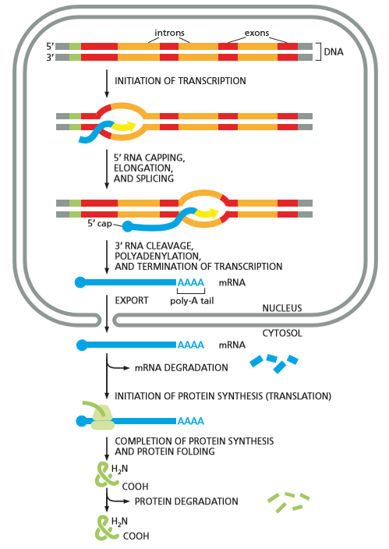

**RNA and the Origins of Life**

* + One view is that the RNA world existed on Earth before DNA was prevalent
    - RNA stored both genetic information and catalyzed chemical reactions in primitive cells
* Life requires autocatalysis
  + Autocatalytic systems are organic monomers and polymers that function together to generate molecules of the same types, fueled by raw materials in the primitive environment on Earth
  + RNA molecules could, in principle, catalyze their own synthesis
* RNA can both store information and catalyze chemical reactions
  + A single strand of RNA or DNA can specify the sequence of a complementary polynucleotide
  + Without catalysts, polymer formation is slow, error-prone, and inefficient
    - Nucleotide polymerization is catalyzed by protein enzymes, such as DNA and RNA polymerases
  + RNA is synthesized as a single-stranded molecule
    - Complementary base-pairing can occur between nucleotides of the same chain, creating a 3D shape
  + RNA molecules can serve as catalysts due to their unique folded shapes, letting them catalyse many types of chemical reactions
* RNA is thought to predate DNA in evolution
  + The first cells on Earth would have been much less complex and less efficient that present day cells
  + The earliest cells would also have differed fundamentally from the cells we know today in having their hereditary information stored in RNA instead of DNA
  + The double-helical structure of DNA and the use of thymine instead of uracil enhances its stability by making it easy to repair
    - If one strand is damaged, the other strand can be used as a template to repair it
  + RNA, with its ability to provide genetic, structural, and catalytic functions, must have preceded DNA in evolution

**Chapter 8**

* + Just knowing the nucleotide sequence of a cell will not tell us how to reconstruct the organism
  + Gene expression only involves the expressions of the genes that are switched on
    - Gene expression becomes much more elaborate in multicellular organisms
  + Nearly all the cells of a multicellular organism contain the same genome
    - Cell differentiation is achieved by changes in gene expression

**An Overview of Gene Expression**

* + Gene expression is the complex process by which cells selectively direct the synthesis of proteins and RNAs encoded in their genome
  + Cell differentiation rises because cells make and accumulate different sets of RNA and protein molecules
    - They express different genes
* The different cell types of a multicellular organism contain the same DNA
  + The various cell types of an organism differ because they express genes differently
  + Cell types of one organism all have the same genes
    - DNA extracted from skin cells can be used to reconstruct the entire organism
* Different cell types produce different sets of proteins
  + Mass spectrometry can be used to determine the total protein content of a cell
  + Proteins that are common in all the cells of a multicellular organism include structural proteins, RNA polymerases, DNA repair enzymes, ribosomal proteins, and metabolic proteins
* A cell can change the expression of its genes in response to external signals
  + External signals, such as hormones, can be used to increase or reduce the production of certain genes
* Gene expression can be regulated at various steps from DNA to RNA to protein
  + Cells can control the proteins it contains by:
    - Controlling when and how often a given gene is transcribed
    - Controlling how an RNA transcript is spliced or otherwise processed
    - Selecting which mRNAs are exported from the nucleus to the cytosol
    - Regulating how quickly certain mRNA molecules are degraded
    - Selecting which mRNAs are translated into protein by ribosomes
    - Regulating how rapidly specific proteins are destroyed after they have been made
  + For most genes, the control of transcription is used, ensuring no unnecessary intermediates are synthesized

**How Transcriptional Switches Work**

* Transcriptional regulators bind to regulatory DNA sequences
  + The promoter region of a gene (that binds the RNA polymerase and orients it) includes a transcription initiation site
    - The transcription initiation site is where RNA synthesis begins
    - Approximately 50 of the upstream nucleotides are necessary for the RNA polymerase to recognize the promoter
  + Nearly all genes have regulatory DNA sequences that switch the gene on or off
    - In bacteria these sequences are simple on/off switches that are 10 nucleotides long
    - In eukaryotes, these are 10,000 nucleotides long and act as molecular microprocessors
  + Regulatory DNA sequences are recognized by proteins called transcription regulators
    - The binding of transcription regulators to a regulatory DNA sequence acts as the switch to control transcription
    - Proteins recognize the sequence because the surface of the protein fits tightly against the surface features of the DNA double sequence in that region
      * In most cases, the protein inserts into the major groove of the DNA helix and makes a series of intimate molecular contacts
* Transcription switches allow cells to respond to changes in their environment
  + Bacteria regulate the expression of many of their genes according to the food sources that are available in the environment
    - In E. coli, five genes code for enzymes that manufacture the amino acid tryptophan
    - These five genes are arranged in a cluster on the chromosome and are transcribed from a single promoter as one long mRNA molecule, called an operon
      * Operons are common in bacteria but uncommon in eukaryotes
    - When tryptophan concentrations are low, operons are transcribed to encourage the synthesis of tryptophan
  + Operons
    - Within the operon promoter is a short DNA sequence, called the operator, that is recognized by a transcription regulator
    - When the transcription regulator binds to the operator, it blocks access of RNA polymerase to the promoter, preventing transcription of the operon
      * For tryptophan production, the transcription regulator is called the tryptophan repressor
  + The repressor is a simple device that switches production of a set of biosynthetic enzymes on and off according to the availability of the end product of the pathway that the enzymes catalyze
* Repressors turn the genes off and activators turn them on
  + Transcriptional repressor proteins switches genes on or off (represses them)
  + Transcription activator proteins work on promoters that are only marginally able to bind and position RNA polymerase on their own
    - Activators switch genes on (opposite of repressors)
  + Activator proteins often have to interact with a second molecule to be able to bind to DNA
* An activator and a repressor control the Lac operon
  + The Lac operon in E. coli is controlled by both the Lac repressor and the CAP activator
    - The Lac operon encodes proteins required to import and digest lactose
  + The Lac repressor shuts off the operon in the absence of lactose
    - The operon is highly expressed only when glucose is absent and lactose is present
    - The genetic circuit behaves like a switch that carries out a logic operation in a computer
* Eukaryotic transcription regulators control gene expression from a distance
  + Enhancers are the DNA sites to which eukaryotic gene activators bind
    - Enhancers dramatically enhances the rate of transcription even when located thousands of nucleotide pairs from a gene’s promoter
  + Eukaryotic transcription regulators can attract proteins that modify chromatin structure, thereby affecting the accessibility of the promoter
* Eukaryotic transcription regulators help initiate transcription by recruiting chromatin modifying proteins
  + In eukaryotic cells, activator and repressor proteins exploit chromatin structure to help turn genes on and off
    - Chromatin structure can be altered by chromatin-remodeling complexes and enzymes that covalently modify the histone proteins in the core of the nucleosome
  + Gene repressor proteins can modify chromatin in ways that reduce the efficiency of transcription initiation

**The Molecular Mechanisms that Create Specialized Cell Types**

* + All cells must be able to switch genes on and off in response to signals in their environment. Cells of multicellular organisms have evolved in specialized ways to form arrays of different cell types
* Eukaryotic genes are controlled by combinations of transcription regulators
  + Because eukaryotic transcription regulators can control transcription initiation when bound to DNA far from the promoter, the nucleotide sequences that control the expression of a gene can be spread over long stretches of DNA
    - Much of the intervening DNA serves as “spacer” sequences and are not directly recognized by transcription regulators
  + Combinatorial control refers to the way that groups of transcription regulators work together to determine the expression of a single gene
    - In many cases, repressors and activators are present on the same complexes
* The expression of different genes can be coordinated by a single protein
  + All cells need to coordinate the expression of different genes
    - When eukaryotic cell receives a signal to divide, a number of unexpressed genes are turned on together to set in motion cell division
  + Even though control of gene expression is combinatorial, the effect of a single transcription regulator can still be decisive in switching any particular gene on or off by completing the combination needed to activate or repress that gene
* Combinatorial control can also generate different cell types
  + The ability to switch many different genes on or off using a limited number of transcription regulators is one of the means by which eukaryotic cells diversify into particular types of cells during embryonic development
  + Some transcriptional regulators can even convert one specialized cell type to another
    - Eg: fibroblasts for muscle-like cells and have accumulated many of the other necessary transcription regulators required for the control of muscle-specific genes. The addition of MyoD completes the requirements to direct the cells to become muscle
    - Reprogramming can produce dramatic effects, suggesting that it may one day be possible to produce in the lab any cell type for which the correct combination of transcription regulators can be identified
* Specialized cell types can be experimentally reprogrammed to become pluripotent stem cells
  + Transcription regulators can coax various differentiated cells to dedifferentiate into pluripotent stem cells that are capable of forming into all the specialized cell types of the body
    - Pluripotent stem cells are similar to embryonic stem cells
  + Cultured mouse fibroblasts have been reprogrammed to become induced pluripotent stem (iPS) cells, looking and behaving like embryonic stem cells
* The formation of an entire organ can be triggered by a single transcription regulator
  + A single “master” transcription regulator called Ey can be used to trigger the formation of a whole organ
  + Ey controls the expression of multiple genes by binding to DNA sequences in their regulatory regions
    - Genes controlled by Ey encode additional transcriptional regulators that control the expression of other genes
    - This cascade of regulators could be attributed to how a complex organism can self-assemble piece by piece
* Epigenetic mechanisms allow differentiated cells to maintain their identity
  + Once a cell has become differentiated into a particular type, it will generally remain differentiated
  + Terminally differentiated cells are those that do not divide after their differentiation
    - Eg: skeletal muscle cells, neurons
  + Many other cells will divide many times over the life of an individual
    - Eg: fibroblasts, smooth muscle cells, liver cells
  + Cell memory is the ability of a proliferating cell to maintain its identity
  + A positive feedback loop is when a master transcription regulator activates transcription of its own gene, in addition to that of other cell-type specific genes
    - Each time a cell divides the regulator is distributed to both daughter cells where it continues to stimulate the positive feedback loop
    - This ensures the regulator will continue to be produced in subsequent cell generations
  + DNA methylation is another way of enforcing cell identity
    - Occurs on certain cytosine bases
    - Covalent modification turns off genes by attracting proteins that bind to methylated cytosines and block gene transcription. Methylation patterns are passed on by the action of an enzyme that copies the methylation pattern on the parent DNA strand to the daughter DNA strand
  + Epigenetic inheritance are processes in which patterns of gene expression are transmitted from parent to daughter cell without altering the actual nucleotide sequence of the DNA

**Post-Transcriptional Controls**

* + Post-transcriptional controls operate after transcription has begun
    - They play a crucial role in regulating the expression of almost all genes
* Each mRNA controls its own degradation and translation
  + The more time mRNa persists in a cell before it is degraded, the more protein it will produce
  + Most eukaryotic mRNAs have half-lives of less than 30 minutes
    - mRNA that codes for ꞵ-globin has a half-life of more than 10 hours
  + Bacterial mRNAs contain a short ribosome-binding sequence located upstream of the AUG codon where translation begins
    - By blocking the ribosome-binding sequence, the bacterium can either inhibit or promote the translation of an mRNA
  + Eukaryotic mRNAs possess a 5’ cap that helps guide the ribosome to the first AUG, the codon where translation starts
    - Eukaryotic repressor proteins can inhibit translation initiation by binding to specific nucleotide sequences in the 5’ untranslated region of the mRNA, therefore preventing the ribosome from finding the first AUG
* Regulatory RNAs control the expression of thousands of genes
  + Noncoding RNAs have various functions
    - Structural and catalytic roles
    - Regulating gene expression
  + Regulatory RNAs include:
    - microRNAs
    - small interfering RNAs
    - long noncoding RNAs
* MicroRNAs direct the destruction of target mRNAs
  + MicroRNAs (miRNA) control gene expression by base-pairing with specific mRNAs and reducing both their stability and their translation into protein
    - miRNAs are thought to regulate the expression of at least ⅓ of all protein-coding genes in humans
  + miRNA is packaged with specialized proteins to form an RNA-induced silencing complex (RISC) which searches for complementary mRNAs in the cytoplasm
    - Once a mRNA forms base pairs with an miRNA, it is either destroyed immediately by a nuclease present or its translation is blocked
    - Destruction of the mRNa releases the RISC and allows it to seek out additional mRNA targets
      * A single miRNA can eliminate one mRNA molecule one after another, blocking the production of the protein that the mRNAs encode
  + A single miRNA can inhibit the transcription of a whole set of different mRNAs so long as the mRNAs carry a common sequence, usually located in either their 5’ or 3’ untranslated regions
  + A gene that encodes an miRNA occupies relatively little space in the genome compared with one that encodes a transcription regulator
    - miRNA was discovered only recently due to its extremely small size
  + There are thought to be approximately 500 different miRNAs encoded into the human genome
* Small interfering RNAs are produced from double-stranded, foreign RNAs to protect cells from infections
  + Double stranded RNAs produced by many viruses and transposable genetic elements can be eliminated by the same components that process and package miRNAs
    - Process called RNA interference (RNAi)
  + Steps of RNAi:
    - Double stranded foreign RNAs are cut into short fragments by a Dicer protein
      * Results in double stranded fragments called small interfering RNAs (siRNA)
    - RISCs that carry miRNAs take up the siRNAs and discard one strand, using the remaining single strand to seek and destroy complementary foreign RNA molecules
      * The infected cell turns the foreign RNA back on itself
  + RNAi resembles certain aspects of the adaptive immune responses of vertebrates
* Thousands of long noncoding RNAs may also regulate mammalian gene activity
  + Long noncoding RNAs are a class of RNA molecules that are more than 200 nucleotides in length
  + Xist is a noncoding RNA about 17,000 nucleotides long and is a player in X inactivation
    - Process by which one of the two X chromosomes in the cells of female mammals is permanently silenced
  + Some long noncoding RNAs arise from protein-coding regions of the genome that are transcribed from the “wrong” DNA strand
    - Antisense transcripts
    - Can bind to the mRNAs produced from that DNA segment, regulating their translation and stability and sometimes produce siRNAs

**Chapter 5**

* + Studying fungi revealed that genetic information consists primarily of instructions for making proteins
  + DNA was recognized in the 1940s
    - Structure of DNA determined by Watson and Crick in 1953

**The Structure of DNA**

* + Chromosomes were discovered in the 19th century
  + Chromosomes contain both DNA and protein
* A DNA molecule consists of two complementary chains of nucleotides
  + DNA stands for deoxyribonucleic acid
  + Each strand is composed of four types of nucleotide subunits that form two strands
    - Strands held together by hydrogen bonds between the base portions
  + Nucleotides are composed of a nitrogen-containing base and a 5 carbon sugar and one of two phosphate groups
    - For the Nucleotides in DNA, the sugar is deoxyribose
    - The bases are adenine (A), cytosine (C), guanine (G), and thymine (T)
  + The way the nucleotide subunits are linked together gives a DNA strand a chemical polarity
    - The 3’ end has a hydroxyl
    - The 5’ end has a phosphate
  + The two polynucleotide chains form a double helix, held together by hydrogen-bonding between the bases on different strands
    - A always pairs with T
    - G always pairs with C
    - Each two-ring base (purine: Adenine and Guanine) pairs with a single-ring base (pyrimidine: Thymine, Cytosine)
  + Each purine-pyrimidine pair is called a complementary base-pair
    - Base pairs are similar in length, holding the sugar-phosphate backbones an equal distance apart
  + The two strands of the helix run antiparallel to each other
  + The double helix contains 10 base pairs per helical turn
  + A sequence of nucleotides on each strand of the double helix is complementary to the nucleotide sequence on the other strand
* The structure of DNA provides a mechanism for heredity
  + Information is encoded in the order of the nucleotides along each DNA strand
    - Organisms differ from one another because their respective DNA molecules have different nucleotide sequences
  + The correspondence between the 4-letter nucleotide alphabet of DNA and the 20-letter amino acid alphabet of proteins is the genetic code
  + Gene expression is the process in which the nucleotide sequence is transcribed into the nucleotide sequence of an RNA molecule and then translated into the amino acid sequence of a protein

**The Structure of Eukaryotic Chromosomes**

* + Chromosomes are long strands of double stranded DNA molecules in eukaryotic cells
  + DNA is folded by specialized proteins
  + Bacteria typically carry their genes on a single, circular DNA molecule
* Eukaryotic DNA is packaged into multiple chromosomes
  + In eukaryotes, DNA in the nucleus is distributed among several chromosomes
    - DNA in humans include approximately 3.2 x 109 nucleotides across 23 or 24 different chromosomes
      * Males have a Y chromosome instead of two X chromosomes, giving them 24 instead of 23 different types of chromosomes
    - Each chromosome is incredibly long DNA molecule associated with proteins that fold and pack the DNA into a compact structure
      * The DNA and protein complex is called a chromatin
  + Human cells each contain two copies of each chromosome, one inherited from the mother and one from the father
    - Homologous chromosomes are the pair of maternal and paternal chromosomes
    - Non Homologous chromosome pairs are sex chromosomes in males, where the Y chromosome comes from the father and the X chromosome comes from the mother
  + DNA hybridization is a method of dying each chromosome a different color using chromosome-specific DNA molecules coupled to different fluorescent dyes
  + An ordered display of the full set of 46 human chromosomes is the human karyotype
* Chromosomes contain long strings of genes
  + A gene is often defined as a segment of DNA that contains the instructions for making a particular protein or RNA molecule
  + The total genetic information carried by the chromosomes in a cell or organism make up its genome
    - The total number of genes vary between organisms
      * Humans have 30,000
      * Simple bacterium have 500
    - Chromosomes from many eukaryotes contain a large excess of interspersed “junk” DNA
      * This DNA may have been crucial for the long-term evolution of the organism, even if it has no demonstrated purpose
      * Portions of DNA are conserved between related species
  + In general, the more complex the organism, the larger its genome
    - Some exceptions occur
      * The human genome is 200 times larger than yeast but 30 times smaller than some plants and 60 times smaller than some species of amoeba
* Specialized DNA sequences are required for DNA replication and chromosome segregation
  + A DNA molecule must be able to be replicated
  + The processes involving replication are collectively known as the cell cycle
    - Interphase is the step where chromosomes are duplicated
    - Mitoses is the step when chromosomes are segregated into two daughter nuclei
  + Interphase
    - Chromosomes are extended as long, thin, tangled threads of DNA in the nucleus (called interphase chromosomes)
    - One type of nucleotide sequence acts as the replication origin where DNA replication begins
      * Eukaryotes have many replication origins to ensure long DNA molecules are replicated rapidly
    - Telomeres are formed from another DNA sequence at each end of the chromosome
      * They cap the end of the DNA molecule, preventing them from being mistaken by the cell as waste DNA
    - Centromeres are a third type of specialized DNA that allow duplicate chromosomes to be separated during M phase
      * During this stage, the DNA coils up and becomes highly compact mitotic chromosomes
* Interphase chromosomes are not randomly distributed within the nucleus
  + Each chromosome occupies a particular region of the interphase nucleus so that they do not become entangled
  + Some chromosomes are attached to particular sites of the nuclear envelope
    - Nuclear envelope is the pair of concentric membranes surrounding the nucleus
  + Some chromosomes are attached to the nuclear lamina
    - Nuclear lamina is the protein meshwork that supports the nuclear envelope
  + The nucleolus is the region where parts of different chromosomes carrying genes that encode ribosomal RNAs cluster together
* The DNA in chromosomes is always highly condensed
  + During mitosis, chromosome 22 compacts to nearly 10,000 times its full length
  + DNA of interphase chromosomes are approximately 20 times less condensed than that of mitotic chromosomes
* Nucleosomes are the basic units of eukaryotic chromosome structure
  + Proteins that bind to DNA to form eukaryotic chromosomes are divided into histones and nonhistone chromosomal proteins
    - Chromatin is the complex of both protein classes with nuclear DNA
  + Histones
    - Histone mass in a cell is about equal to that of DNA
    - Histones are responsible for the nucleosome, the first and most fundamental level of chromatin packing
  + When chromatin fibers are partially unfolded, an electron microscope can reveal nucleosome core particles, appearing as little beads on a string of DNA
    - Nucleosome core particles consists of DNA wound around a core of proteins formed from histones
    - The DNA between core particles is called “linker DNA”
      * Linker DNA varies in length up to 80 nucleotides long
    - An individual nucleosome core particle consists of a complex of eight histone proteins
      * Two each of H2A, H2B, H3, and H4 (the histone octamer)
      * These histones are relatively small proteins with a high proportion of positively charged amino acids, allowing them to bind easily to the negatively charged sugar-phosphate backbone of DNA
      * Histones play an important role in controlling eukaryotic chromosome structure
    - Nucleosome core particle includes a stretch of 147 nucleotide pairs long DNA wound around the histone octamer
* Chromosome packing occurs on multiple levels
  + Nucleosome strings are further packed to generate a more compact structure
  + The additional packing of nucleosomes into chromatin fibers depends on a fifth histone called H1
    - H1 pulls adjacent nucleosomes together into a regular repeating array
  + The nucleosome string folds to create a chromatin fiber
  + The chromatin fiber is folded into loops that condense to produce interphase chromosome

**The Regulation of Chromosome Structure**

* Changes in nucleosome structure allow access to DNA
  + Chromatin-remodeling complexes are protein machines that use the energy of ATP hydrolysis to change the position of the DNA wrapped around nucleosomes
    - These complexes attach to both the histone octamer and the wrapped DNA to alter their configurations
  + Chromatin structure can be modified by the reversible chemical modifications of the histones
    - The tails of the four core histones can be subject to covalent modifications by adding or removing acetyl, phosphate, or methyl groups
    - These modifications can serve as docking sites on the histone tails for regulatory proteins, promoting chromatin condensation and decondensation
  + Enzymes that modify histone tails are tightly regulated
  + Histone modifying enzymes and chromatin-remodeling complexes work synonymously to manipulate the chromatin structure
* Interphase chromosomes contain both condensed and more extended forms of chromatin
  + The most condensed form of interphase chromatin is the heterochromatin
  + The rest of interphase chromatin is called euchromatin
  + Chromatin structures are established and maintained by different sets of histone tail modifications that attract distinct sets of nonhistone proteins
    - Heterochromatin can spread because the histone tail modification attract a set of heterochromatin-specific proteins that create the same histone tail modifications on adjacent nucleosomes
    - Heterochromatin spreads until it encounters a barrier DNA sequence that stops the propagation
  + Most DNA that is permanently folded into heterochromatin do not contain genes
    - Genes that are accidentally packaged into heterochromatin usually fail to be expressed, leading to disease
    - The interphase X chromosomes of female mammals are permanently silenced because having two active X chromosomes is lethal
  + When cells divide they generally pass on their histone modifications, chromatin structure, and gene expression patterns to the two daughter cells

**Chapter 6**

* + DNA replication is the process of creating a DNA copy to be divided when producing two identical daughter cells
  + DNA must be continually surveyed to repair damage by chemicals and radiation in the environment
    - Mutations are permanent changes that sometimes occur despite the systems protecting the cell’s DNA
    - Mutations may be beneficial in the long run, leading to evolution
    - Mutations may be highly detrimental, leading to cancer
  + Without the protein machines that monitor DNA, life would not exist

**DNA Replication**

* Base-Pairing Enables DNA Replication
  + The DNA double helix contains two complementary strand, meaning each can serve as a template for the synthesis of a new complementary strand
    - This enables a cell to copy/replicate its genes before passing them on to descendants
    - The replication machine is a cluster of proteins that regulate replication
  + DNA replication produces two complete double helices from the original DNA molecule
    - This process is semiconservative because each daughter DNA double helices ends up with an original strand plus a completely new strand
* DNA synthesis begins at replication origins
  + The two strands of DNA are held together tightly by hydrogen bonds. Enzymes called initiator proteins must be used to separate the two DNA strands
    - Initiator proteins bind to sites on the DNA sequences called replication origins
      * Replication origins are approximately 100 nucleotide pairs long
      * Replication origins are rich in A-T base pairs because they have fewer hydrogen bonds
      * Having multiple replication origins allows for DNA replication to occur at many places at once, increasing the efficiency
    - Initiator proteins work their way down the strand, breaking hydrogen bonds
* Two replication forks form at each replication origin
  + Replication forks are Y-shaped junctions that form at each replication origin where a replication machine moves along the DNA, opening up the two double helix strands
  + The two forks move away from the origin in opposite direction, unzipping the DNA double helix and replicating as they go
    - DNA replication in bacterial and eukaryotic chromosomes is bidirectional
    - The forks move at about 1000 nucleotide pairs per second in bacteria and 100 nucleotide pairs per second in humans
* DNA polymerase synthesizes DNA using a parental strand as a template
  + DNA polymerase is one of the primary enzymes in the replication machine
  + DNA polymerase catalyzes the addition of nucleotides to the 3’ end of a growing DNA strand
    - Forms a complementary nucleotide sequence to the template
  + Polymerization reaction involves the formation of a phosphodiester bond between the 3’ end of the growing DNA chain and the 5’-phosphate group of the incoming nucleotide
    - Energy of polymerization is provided by the incoming deoxyribonucleoside triphosphate
* The replication fork is asymmetrical
  + The 5’-to-3’ direction of the DNA polymerization reaction poses a problem at the replication fork
    - The two strands of the double helix are antiparallel
      * One new DNA strand is being made as a template that runs from 3’-to-5’ while the other runs 5’-to-3’
    - All DNA polymerase add new subunits only to the 3’ end of a DNA strand
  + A “backstitching” maneuver must be used to synthesize the opposite strand
    - The DNA strand made in the 3’-to-5’ direction is made discontinuously, in successive small steps of the DNA polymerase moving 5’-to-3’
      * The small steps result in Okazaki fragments
  + Okazaki fragments are later joined to form a continuous, new strand
    - The lagging strand is made discontinuously from the okazaki fragments
  + The strand made continuously is called the leading strand
* DNA polymerase is self-correcting
  + DNA polymerase makes an error once every 107 nucleotide pairs
    - Sometimes less stable G-T or C-A pairs can be formed. If allowed to remain they will accumulate as mutations and become potentially harmful
  + DNA has two qualities that greatly increase accuracy of DNA replication
    - The enzyme monitors the base-pairing between each incoming nucleotide and only catalyzes the nucleotide addition reaction for the correct match
    - When DNA polymerase makes a mistake and adds the wrong nucleotide, it can correct the error through proofreading
  + Proofreading occurs at the same time as DNA synthesis
    - Before the enzyme adds the next nucleotide to a growing DNA strand, it checks the previously added nucleotide
    - If the previous nucleotide is incorrect, the polymerase clips off the mispaired nucleotide and tries again
      * Proofreading is carried out by a nuclease that cleaves off the phosphodiester backbone
      * Proofreading explains why DNA only synthesizes in the 5’-to-3’ direction
        + If it coded from 3’-to-5’, it would not be able to remove previous nucleotides
* Short lengths of RNA act as primers for DNA synthesis
  + A different enzyme is used to begin DNA synthesis because polymerase cannot code without an already present correct 3’ end
    - A short length of RNA (10 nucleotides long) is synthesized using the DNA strand as a template and attached to the template strand to act as a primer for DNA synthesis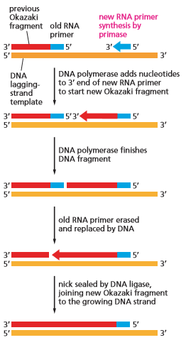
    - The enzyme that synthesizes the RNA primer is called primase
  + Primase is an example of an RNA polymerase, an enzyme that synthesizes RNA using DNA as a template
    - RNA is synthesized on the DNA strand by complementary base-pairing in the same way as DNA
      * RNA uses uracil instead of thymine
    - An RNA primer is needed only to start replication at a replication origin
      * Once the fork has been established, the DNA polymerase may move along the template strand with one primer
      * On the lagging strand, new primers are needed to continue polymerization because DNA synthesis is discontinuous
    - DNA polymerase continues to build okazaki fragments until it encounters the next primer
  + Three additional enzymes are required to join okazaki fragments
    - They remove the RNA primer, replace it with DNA, and join the DNA fragments together
    - A nuclease degrades the RNA primer
    - A DNA polymerase called repair polymerase replaces the RNA with DNA
    - DNA ligase joins the 5’-phosphate end of one DNA fragment to the adjacent 3’-hydroxyl end of the next
  + Primase can begin new polynucleotide chains because it does not proofread its work
    - Primers frequently contain mistakes
    - Since primers contain RNA instead of DNA, they are automatically removed and replaced with DNA
      * The repair DNA polymerases that replace them proofread as they synthesize
* Proteins at a replication fork cooperate to form a replication machine
  + DNA replication requires the cooperation of a large number of proteins to open the double helix and synthesize new DNA
  + For DNA replication to occur, the double helix must be unzipped ahead of the replication fork so that the incoming nucleoside triphosphates can form base pairs
    - Performed by DNA helicases and single-strand DNA-binding proteins
    - Helicase uses the energy of ATP hydrolysis to propel itself and pry apart the double helix
    - Single strand DNA-binding proteins cling to single-stranded DNA and prevent the strands from re-forming base pairs and keeps them in elongated form
  + Tension builds behind the DNA helicase as the double helix unwinds, making unwinding increasingly difficult
    - DNA topoisomerases relieve the tension by producing nicks in the DNA backbone that temporarily release the tension, then they reseal the nick before falling off the DNA
  + A sliding clamp protein keeps DNA polymerase firmly attached to the template while it is synthesizing new strands of DNA
    - The sliding clamp forms a ring around the newly formed DNA double helix, allowing the enzyme to move along the template strand
    - Assembly of the clamp around DNA requires the clamp loader, which hydrolyzes ATP each time it locks a sliding clamp around a newly formed DNA double helix
  + Most of the proteins involved in DNA replication are held together by a large multienzyme complex that moves as a unit along the parental DNA double helix
* Telomerase replicates the ends of eukaryotic chromosomes
  + Because DNA replication proceeds only in the 5’-to-3’ direction, the lagging strand of the replication fork has to be synthesized in the form of discontinuous DNA fragments
  + As the replication fork approaches the end of a chromosome, the lagging strand cannot be replicated all the way to the chromosome tip
    - When the final RNA primer on the lagging strand is removed, there is no way to replace it with DNA
  + Bacteria solve this problem by having circular DNA molecules as chromosomes
  + Eukaryotes solve this problem by having long, repetitive nucleotide sequences at the ends of their chromosomes which are incorporated into structures called telomeres
    - Telomerase is an enzyme that extends the ends of the replicating lagging strand by adding multiple copies of the same short DNA sequence to the template strand, allowing conventional DNA replication to complete the strand
  + Telomeres form structures that mark the true ends of a chromosome, letting cells to distinguish unambiguously between the natural ends of chromosomes and the double-strand DNA breaks that sometimes accidentally occur

**DNA Repair**

* + Genetic alterations in the long term contribute to diversity and evolution of living species
  + In the short term, to an individual organism, genetic alterations can be detrimental
  + The majority of DNA damage is an unintended consequence of the chemical reactions that occur inside cells
  + DNA repair is the process by which DNA damage is quickly corrected
* DNA damage occurs continually in cells
  + DNA is constantly undergoing thermal collisions with other molecules, often resulting in major chemical changes in the DNA
    - Depurination removes a purine base from a nucleotide, giving rise to lesions that resemble missing teeth
    - Deamination is the spontaneous loss of an amino group from a cytosine in DNA to produce the base uracil
  + UV radiation from sunlight also damages DNA, promoting covalent linkage between two adjacent pyrimidine bases
  + Other chemical damages can occur and, when left unrepaired, will lead to substitution of one nucleotide or deletion of one nucleotide in the daughter DNA strand after DNA replication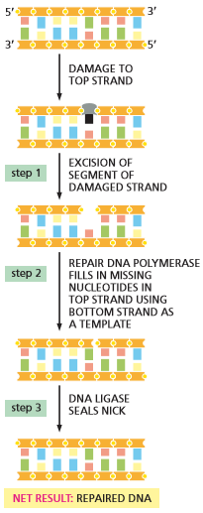
* Cells possess a variety of mechanisms for repairing DNA
  + Nearly all repair mechanisms depend on the double-helical nature of DNA
  + The basic pathway involves three general steps:
    - Damaged DNA is recognized and removed, leaving a small gap on one strand of the DNA double helix
    - A repair DNA polymerase binds to the 3’-hydroxyl end of the cut DNA strand and fills in gaps by making a complementary copy of the undamaged strand
      * Repair DNA polymerase synthesizes DNA strands in the same way as DNA polymerase
    - DNA ligase seals the sugar-phosphate backbone
* A DNA mismatch repair system removes replication errors that escape proofreading
  + Mismatch repair is dedicated to correcting mistakes in replication and corrects 99% of replication errors
    - Overall accuracy is then one error in every 109 nucleotides instead of every 107 nucleotides
  + Whenever replication machinery makes a copying mistake, it leaves behind a mispaired nucleotide (a mismatch)
    - Mismatches will result in permanent mutation in the next round of DNA replication
  + Mismatch repair proteins recognizes DNA mismatches and removes a portion of the DNA strand containing the error and resynthesizes the missing DNA
    - Mismatch repair proteins avoid correct DNA sequences by removing a portion of the newly made DNA strand, which lacks a type of chemical modification that is present on preexisting parent DNA
    - Mismatch repair prevents cancer which is caused by permanent mutations formed by mismatches
* Double-strand DNA breaks require a different strategy for repair
  + If both strands of the DNA are damaged at the same time, they cannot be repaired by utilizing the complementary strand
  + Double-strand breaks are particularly dangerous because they can lead to the fragmentation of chromosomes and subsequent loss of genes
    - If the broken pieces become separated, the cell has no spare copy it can use to reconstruct the missing information
  + Nonhomologous end joining is a repair mechanism that rapidly sticks the broken ends back together before they can drift apart and get lost
    - This method “cleans” the broken ends before joining, often leading to nucleotides being lost at the site of repair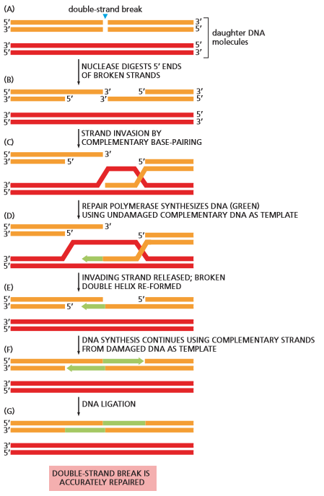
  + Homologous recombination is a method that avoids the loss of nucleotides
* Homologous recombination can flawlessly repair DNA double-strand breaks
  + If a double-strand break occurs in one double helix shortly after a stretch of DNA has been replicated, the undamaged double helix can readily serve as a template to guide the repair of the broken DNA
  + Homologous recombination results in a flawless repair of the double-strand break with no loss of genetic information
    - Homologous recombination most often occurs shortly after a cell’s DNA has been replicated before cell division, when duplicate helices are close together
  + A nuclease chews back the 5’ ends of both strands at the break
  + One of the broken 3’ ends “invades” the unbroken homologous DNA duplex and searches for a complementary sequence through base pairing
    - Once an accurate match is found, the invading strand is elongated by a repair DNA polymerase, using the complementary strand as a template
  + The newly repaired strand rejoins the original partner, forming base pairs that hold the two strands of the broken double helix together
    - Repair along the originally broken strands is facilitated by additional DNA synthesis at the 3’ ends followed by DNA ligation
  + Homologous recombination can be used to repair many types of DNA damage, making it the most handy DNA repair mechanism available in the cell
  + Homologous recombination has a crucial role in the exchange of genetic information during the formation of germ cells (sperm/egg)
* Failure to repair DNA damage can have severe consequences for a cell or organism
  + Occasionally, the cell’s DNA replication and repair processes fail and give rise to a mutation
  + Because the structure and activity of each protein depends on its amino acid sequence, a protein with an altered sequence may function poorly or not at all
  + Sickle-cell anemia is an inherited disease, illustrating the importance of protecting reproductive cells against mutation
  + Cancer is an unchecked mutated cell proliferation
  + Cells possess a sophisticated set of mechanisms to reduce the number of mutations that occur in their DNA
* A record of the fidelity of DNA replication and repair is preserved in genome sequences
  + The majority of mutations do neither harm nor good to an organism
    - Those that do have harmful consequences are usually eliminated from the population through natural selection
  + The genetic message has been preserved for millions of years due to natural selection and DNA replication and repair, leading to similar genomes across many animals

**Chapter 10**

* + We now have access to complete molecular blueprints for thousands of different organisms and thousands of different people
  + In the early 1970s it became possible to isolate a selected piece of DNA from the millions of nucleotide pairs in a typical chromosome and replicate, sequence, and modify this DNA
    - Modified DNA molecules can be introduced into another organism’s genome, where they become a functional and heritable part of the organism’s genetic instructions
  + Recombinant DNA technology or genetic engineering are the technological breakthroughs that have advanced our understanding of the organization and evolutionary history of complex eukaryotic genomes
  + Recombinant DNA technology has had a profound influence on our understanding and treatment of disease
    - Can be used to detect genetic diseases
    - Development of recombinant DNA technology has had the greatest impact on our everyday lives

**Manipulating and Analyzing DNA Molecules**

* + Isolating and manipulating individual genes is difficult because genes represent a small part of a much larger DNA molecule
    - Even bacterial genomes are enormously long
  + Single genes can be separated from a eukaryotic genome using a class of bacterial enzymes called restriction nucleases
    - Enzymes cut double-stranded DNA at particular sequences
    - Segments can be used to produce a reproducible set of specific DNA fragments from any genome
* Restriction nucleases cut DNA molecules at specific sites
  + Restriction nucleases function to restrict the transfer of DNA between strains of bacteria
  + Different bacterial species produce different restriction nucleases, each cutting at a different, specific nucleotide sequence
    - Target sequences are short - generally four to eight nucleotide pairs
    - Many sites of cleavage will occur in any long DNA molecule
    - Each restriction nuclease will cut a particular DNA molecule at the same sites, meaning for a given sample of DNA, a particular enzyme will generate the same set of DNA fragments
  + The size of resulting fragments depends on the targeted sequences
    - A restriction nuclease with a target sequence of eight nucleotides would be expected to cleave DNA on average once every 65,536 nucleotide pairs
* Gel electrophoresis separates DNA fragments of different sizes
  + DNA fragments can be separated from each other on the basis of their length by gel electrophoresis
    - Gel electrophoresis can also be used to separate mixtures of proteins
  + A mixture of DNA fragments is loaded at one end of a slab of agarose or polyacrylamide gel
  + When a voltage is applied across the gel, a negatively charged DNA fragments will migrate towards the positive electrode
    - Larger fragments will migrate more slowly because their size impedes their movement through the porous gel
    - Over several hours, the DNA fragments become spread out across the gel according to size, forming a ladder of discrete bands, each composed of a collection of DNA molecules of identical length
      * DNA can then be directly removed using a scalpel
* Bands of DNA in a gel can be visualized using fluorescent dyes or radioisotopes
  + The separated DNA bands on a gel are not visible by themselves. To see these bands, the DNA must be labeled or stained in some way
    - One method involves exposing the gel to a dye that fluoresces under UV light when bound to DNA
    - An even more sensitive detection method involves incorporating a radioisotope into the DNA molecules before separation (often times 32P is used)
  + Exposing a gel to a fluorescent dye that binds to DNA will allow every band on the gel to be seen
    - It does not reveal which bands contain a DNA sequence of interest
    - A probe is designed to bind specifically to the desired nucleotide sequence by complementary base-pairing
* Hybridization provides a sensitive way to detect specific nucleotide sequences
  + DNA denaturation will release the two strands of the DNA double helix from each other
    - The simplest way of doing so is heating the DNA up to around 90 degrees celsius
    - When the temperature is slowly lowered, the complementary strands will readily come back together to re-form a double helix
  + Hybridization, or DNA renaturation, is driven by the re-formation of the hydrogen bonds between complementary base pairs
  + One can design a short, single-stranded DNA probe that is complementary to the nucleotide sequence of interest
    - Since so many genomes are known, designing a probe is straightforward
    - Probes can be designed in labs or academic facilities
    - Probes carry a fluorescent or radioactive label to facilitate detection of the nucleotide sequence to which they bind
  + Once a suitable probe has been obtained, it can be used to search for nucleic acids with a complementary sequence
  + Fragments are first transferred to a special sheet of paper which is then exposed to the labeled probe
    - Technique is called Southern blotting

**DNA Cloning in Bacteria**

* + DNA cloning refers to the production of many identical copies of a DNA sequence
    - DNA cloning is the starting point for understanding the function of any stretch of DNA within the genome
* DNA cloning begins with genome fragmentation and production of recombinant DNAs
  + Whole genomes are too large and unwieldy for laboratory
  + Recombinant DNA molecules are fragments that can be joined together to produce the DNA molecules that will be amplified
  + Bacterial restriction nucleases can be used to cut long DNA molecules into covalently sized fragments
    - Fragments can be rejoined using DNA ligase, an enzyme that seals the nicks that arise in the DNA backbone
    - DNA ligase allows investigators to join together any two pieces of DNA in a test tube, producing unnatural recombinant DNA molecules
  + Production of recombinant DNA molecules is a key step in the classical approach to DNA cloning
  + Special DNA molecules that serves as a carrier, or vector, which can be copied
* Recombinant DNA can be inserted into plasmid vectors
  + Vectors typically used for gene cloning are relatively small, circular DNA molecules called plasmids
    - Each plasmid contains a replication origin, which enables it to replicate in a bacterial cell independently of the bacterial chromosome
    - Each plasmid contains cleavage sites for common restriction nucleases so that the plasmid can be conveniently opened and a foreign DNA fragment inserted
  + Plasmids used for cloning are streamlined versions of naturally occurring plasmids
    - Bacterial plasmids often carry genes that render them resistant to one or more antibiotics
  + To insert a piece of DNA into a plasmid vector, the purified plasmid DNA is opened up by a restriction nuclease that cleaves it at a single site and the DNA fragment to be cloned is then spliced into that site using DNA ligase
* Recombinant DNA can be copied inside bacterial cells
  + The mechanism that controls bacteria’s natural uptake of surrounding DNA molecules is called transformation
    - Early observations suggested it could “transform” one bacterial strain into another
  + In a natural population, a source of DNA transformation is the remains of dead bacteria
    - Recombinant DNA can be created in a laboratory and used for transformation
  + DNA fragments can be recovered from plasmids by using the same restriction nuclease to cut it out and by using gel electrophoresis to separate the parts
* Genes can be isolated from a DNA library
  + When DNA is cut it generates millions of fragments. The desired fragment can be selected by introducing the fragments into bacteria and selecting the bacteria cells that have amplified the desired DNA molecule
  + The collection of cloned DNA fragments in a bacterial culture is the DNA library
    - The genomic library represents the entire genome of an organism
    - A labeled DNA probe can be designed to bind to a specific part of the gene’s DNA sequence to single out a particular gene within the genomic library
  + DNA probes can be created by applying the genetic code in reverse and identifying an amino acid sequence to deduce the corresponding gene sequence
    - Today the sequence of any gene in an organism can be looked up in an electronic database
* cDNA libraries represent the mRNAs produced by particular cells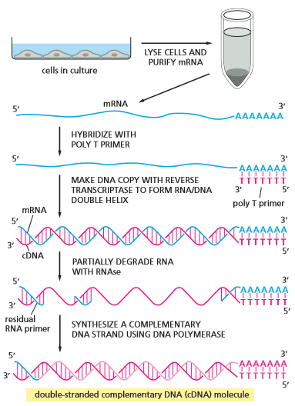
  + The cDNA library can be used to isolate a gene free of all its introns
  + The DNA that goes into a cDNA library is not genomic DNA; it is DNA copied from the mRNAs present in a particular type of cell
  + To prepare cDNA
    - All mRNAs are extracted and double-stranded DNA copies are produced by the enzymes reverse transcriptase and DNA polymerase
    - cDNA stands for complementary DNA
  + There are several differences between genomic DNA clones and cDNA clones
    - Genomic clones represent a random sample of all the DNA sequences found in an organism’s genome
      * Genomic clones contain large amounts of noncoding DNA, repetitive sequences, introns, regulatory DNA, and spacer DNA
    - cDNA clones contain predominantly protein-coding sequences for the genes transcribed into mRNA

**DNA cloning by PCR**

* + A polymerase chain reaction (PCR) provides a more straightforward approach to DNA cloning
  + PCR can amplify any nucleotide sequence rapidly and selectively
    - PCR is performed entirely in a test tube
* PCR uses a DNA polymerase to amplify selected DNA sequences in a test tube
  + PCR depends on the selectivity of DNa hybridization and the ability of DNA polymerase to copy a DNA template reliably
  + Enzyme adds nucleotides to the 3’ end of the growing DNA strand
  + Polymerase requires a primer
    - Primers can direct polymerase to specific DNA sequences to be amplified
    - The primers are synthesized chemically, meaning PCR can only be used to clone a DNA segment for which the sequence is known
* Multiple cycles of amplification *in vitro* generates billions of copies of the desired nucleotide sequence
  + At the start of each cycle, the DNA strands are separated and a unique primer is annealed to each
  + DNA polymerase replicates each strand independently
  + Billions of copies of the original sequence can be made in 20-30 cycles
* PCR is also used for diagnostic and forensic application
  + PCR can be used to detect invading microorganisms at very early stages of infection
  + Short sequences complementary to a segment of the infectious genome are used as primers and after a few cycles of amplification, even small samples of an invading microbacteria can be found
  + PCR is widely used in modern forensic medicine
    - Can be used to isolate a DNA fingerprint from a patient’s genome
    - The genome of each human slightly differs in DNA sequence from other people

**Exploring and Exploiting Gene Function**

* + There are many ways to study genes, usually chosen based on background knowledge in their applicable field
* Whole genomes can be sequenced rapidly
  + Researchers developed several schemes for determining the nucleotide sequence of any purified DNA fragment
  + Dideoxy sequencing (aka Sanger sequencing) uses DNA polymerase to make partial copies of the DNA fragment to be sequenced, ultimately producing a collection of different DNA copies that terminate at every position in the original DNA sequence
    - DNA copies would differ in length by a single nucleotide, making them separable through gel electrophoresis
    - The nucleotide sequence of the original DNA would be determined manually from the order or labeled DNA fragments in the gel
    - Modern sanger sequencing is completely automated
* Next-generation sequencing techniques make genome sequencing faster and cheaper
  + Second-generation sequencing methods coming after the Sanger method are faster and cheaper
  + Rapid methods allow multiple genomes to be sequenced in parallel in a matter of weeks, enabling cataloging of thousands of human genomes
    - Most methods rely on PCR amplification of a random collection of DNA fragments
  + Third-generation sequencing methods permit the sequencing of just a single molecule of DNA by pulling the DNA molecule through a very tiny channel
* Comparative genome analyses can identify genes and predict their function
  + One can determine if a nucleotide sequence contains a gene and what the gene likely does based on the gene’s known activity in other organisms
  + Comparative analysis has revealed that the coding regions of genes from a wide variety of organisms show a large degree of sequence conservation
  + Knowing where a nucleotide sequence comes from is only the first step toward determining what role it has in the development or physiology of the organism
* Analysis of mRNAs by microarray or RNA-Seq provides a snapshot of gene expression
  + Cells express only a subset of the genes available in its genome, differing from one cell to another
  + The DNA microarray is a tool that allowed investigators to analyze the different RNAs produced by cells or tissues
  + DNA microarrays were originally glass microscope slides containing hundreds of thousands of DNA fragments
  + Drawbacks:
    - The sequences of the mRNA samples to be analyzed must be known in advance and represented by a corresponding probe on the array
  + RNA-Seq is the sequencing of cDNAs made from RNAs through second generation sequencing methods
* In Situ hybridization can reveal when and where a gene is expressed
  + Microarrays and RNA-Seq do not reveal exactly where in the cell or tissue the mRNAs are produced
  + In situ hybridization allows a specific nucleic acid sequence to be visualized in its normal location
  + In situ hybridization uses single-stranded DNA or RNA probes, labelled with fluorescent dyes or radioactive isotopes, to detect complementary nucleic acid sequences
    - Frequently used to study the expression patterns of a particular gene or collection of genes in an adult
* Reporter genes allow specific proteins to be tracked in living cells
  + Reporter genes encodes a protein that can be easily monitored by its fluorescence or enzymatic activity
  + Green Fluorescent Protein (GFP) is one of the most popular reporter proteins used today
    - Molecule that gives jellyfish their green luminescence
  + In many cases the gene that encodes GFP is attached to one end of the gene of interest, resulting in a GFP fusion protein
* The study of mutants can help reveal the function of a gene
  + One of the best ways to determine a gene’s function is to observe changes that occur when the gene is inactivated by a mutation
* RNA interference (RNAi) inhibits the activity of specific genes
  + A gene of known sequence can be inactivated deliberately and the effects on the cell or organism’s phenotype can be observed
    - Often referred to as “reverse genetics”
  + RNA interference (RNAi) exploits a natural mechanism used to protect cells against certain viruses and proliferation of mobile genetic elements
    - Double-stranded RNA molecules with a nucleotide sequence matching the desired gene to be inactivated are introduced into the cell or organism
    - The double stranded RNA is cleaved and processed to produce shorter, double-stranded fragments called small interfering RNAs
    - siRNAs are unwound to form single stranded DNA fragments that hybridize with the target gene’s mRNAs and direct their degradation
  + RNAi is frequently used to inactivate genes in cultured mammalian cell lines
* A known gene can be deleted or replaced with an altered version
  + Using recombinant DNA techniques, the coding sequence of a cloned gene can be mutated to change the functional properties of its protein product
  + The altered gene is often inserted into the genome of reproductive cells so that it can be stably inherited by subsequent generations
  + Organisms whose genomes have been altered in this way are called transgenic organisms (aka genetically modified organisms (GMOs))
    - The introduced gene is called transgene
  + To study the function of an altered gene, ideally one would want to generate an organism in which the normal gene has been completely replaced by an altered one
  + Gene knockout occurs when the activity of both copies of a gene is eliminated entirely
* Mutant organisms provide useful models of human disease
  + It is considered unlawful to modify humans with transgenic engineering due to ethical concerns
  + Genomes of humans can be searched for mutations that increase the risk of disease
    - These genes can be applied to other animals, such as mice, to study their effects
* Transgenic plants are important for both cell biology and agriculture
  + Callus are masses of undifferentiated cells caused by the disorganized proliferation of cells
  + Calluses can be used to regenerate entire plants
  + Plants can be modified using calluses to provide different effects
* Even rare proteins can be made in large amounts using cloned DNA
  + DNA cloning and genetic engineering make it possible to produce any protein, including the rare ones, in unlimited amounts
  + Expression vectors include transcription and translational signals that direct an inserted gene to be expressed at very high levels

**Chapter 12**

* + Cells grow by exchanging molecules with their environment
  + CO2 and O2 can simply diffuse across the lipid bilayer of the plasma membrane
  + Membrane transport proteins span the lipid bilayer and provide passageways across the membrane for select substances
  + Transporters shift small organic molecules or inorganic ions from one side of the membrane to the other by changing shape
  + Channels form tiny hydrophilic pores across the membrane through which substances can pass by diffusion
    - Most channels only permit the passage of inorganic ions (ion channels)
    - The passage of ions across the membrane can generate voltage across the membrane
      * These voltage differences enable nerve cells to communicate

**Principles of Transmembrane Transport**

* + The hydrophobic interior of the lipid bilayer creates a barrier to the passage of most hydrophilic molecules, including all ions
  + Facilitated transport is the process in which special membrane transport proteins accelerate the passage of molecules across lipid bilayers
* Lipid bilayers are impermeable to ions and most uncharged polar molecules
  + Given enough time, virtually any molecule will diffuse across a lipid bilayer
    - The smaller and more hydrophobic the molecule, the more rapidly it will diffuse across the membrane
  + Solutes are substances that are dissolved in water (polar molecules)
  + Small nonpolar molecules (O2 and CO2) dissolve readily in lipid bilayers and therefore rapidly diffuse across them
    - Cells depend on this process for cellular respiration
  + Uncharged polar molecules diffuse readily across a bilayer if they are small enough (H2O and ethanol) while larger ones will diffuse slowly or not at all (glycerol and glucose)
  + Charged molecules and inorganic ions cannot naturally pass through lipid bilayers
    - Synthetic lipid bilayers are 109 times more permeable to water than to even small ions, such as Na+ and K+
* The ion concentrations inside a cell are very different from those outside
  + Living cells are able to maintain internal ion concentrations that are very different from those outside
  + The most important inorganic ions for cells are Na+, K+, Ca2+, Cl-, and H+
    - These ions play a key role in the production of ATP by all cells
  + Na+ is the most plentiful positively charged ion outside the cell
  + K+ is the most plentiful positively charged ion inside the cell
  + The quantity of positive charges must be almost perfectly balanced by the quantity of negative charges inside and outside the cells
    - If charges are not balanced, the cell could potentially be torn apart
    - Na+ outside the cell is balanced by Cl-
    - K+ inside the cell is balanced by negatively charged organic and inorganic ions (nucleic acids, proteins, and cell metabolites)
* Differences in concentration of inorganic ions across a cell membrane create a membrane potential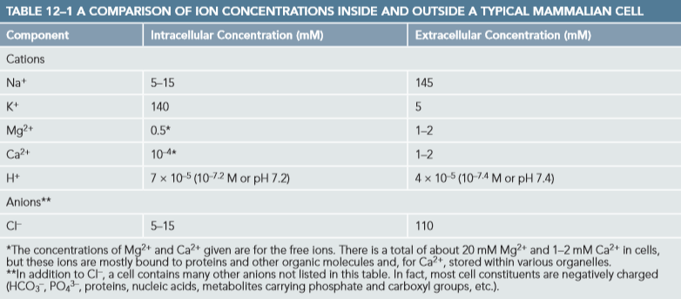
  + Tiny excesses of positive or negative charge occur
  + Membrane potential is a voltage difference across the membrane generated by excessive charges
  + When the cell is “unstimulated,” the exchange of anions and cations across the membrane is precisely balanced
  + The resting membrane potential is the voltage across the cell membrane
    - Resting membrane potential is between -20 and -200 millivolts (mV)
    - The interior of the cell is more negatively charged than the exterior
  + The membrane potential allows cells to power the transport of certain metabolites and lets excitable cells communicate with their surrounding cells
* Cells contain two classes of membrane transport proteins: transporters and channels
  + Membrane transport proteins are present in all cell membrane
    - Each protein provides passage for a particular water-soluble molecule (ion, sugar, or amino acid)
  + Each type of cell membrane has its own characteristic set of transport proteins, which determines exactly which solutes can pass in and out of the cell or organelle
  + Most membrane transport proteins have polypeptide chains that criss-cross back and forth across the bilayer, forming a continuous protein-lined pathway that lets select molecules cross the membrane without directly contacting the hydrophobic interior of the lipid bilayer
  + Channels discriminate mainly based on size and electric charge
    - When the channel is open, any ion or molecule that is small enough or carries the corresponding charge may pass through
  + Transporters transfer only molecules or ions that fit into specific binding sites on the protein
    - It is the requirement of specific binding that gives transporters their selectivity
* Solutes cross membranes by either passive or active transport
  + Generally, the direction of transport depends only on the relative concentrations of the solute on either side of the membrane
  + Molecules will spontaneously flow “downhill” from a region of high concentration to a region of low concentration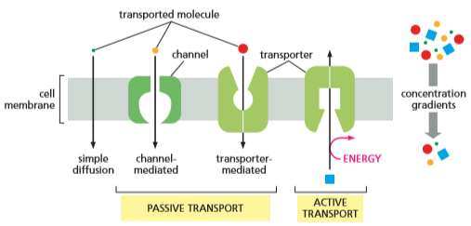
    - Passive transport requires no additional driving force
  + Passive transport does not require the expenditure of energy by a transport protein
  + Active transport moves a solute against its concentration gradient by coupling it with some process that provides an input of energy
    - Pumps harness an energy source to power the transport process
    - Energy comes from ATP hydrolysis, a transmembrane ion gradient, or sunlight
* Both the concentration gradient and membrane potential influence the passive transport of charged solutes
  + For an uncharged molecule, the direction of passive transport is determined by its concentration gradient
  + The membrane potential tends to pull positively charged solutes into the cell and drive negatively charged ones
    - The cytosolic side of the plasma membrane tends to have a negative potential relative to the extracellular side
  + A charged solute will also tend to move down its concentration gradient
  + The electrochemical gradient is the net force driving a charged solute across a cell membrane
    - Composite of two forces: one due to concentration gradient and one due to membrane potential
    - The net force determines the direction of solute flow across the membrane by passive transport
  + When voltage and concentration gradients work in the same direction, they create a steep electrochemical gradient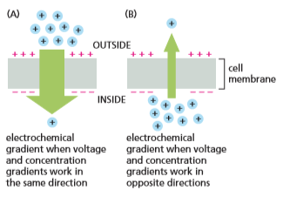
    - Na+ is positively charged and at a higher concentration outside the cell than inside and tends to enter cells if given an opportunity
  + When voltage and concentration gradients have opposite effects, the resulting electrochemical gradient can be small
    - K+ is concentrated inside the cell but has little net movement across the membrane due to its small electrochemical gradient across the resting plasma membrane
* Water moves passively across cell membranes down its concentration gradient - a process called osmosis
  + Cells are about 70% water by weight so movement of water across cell membranes is crucially important
  + Water molecules can diffuse directly across the lipid bilayer because they are small and uncharged
    - Some cells have special channel proteins called aquaporins in their plasma membrane which greatly facilitate the flow of water molecules
  + Osmolarity is the total concentration of solute particles inside the cell
    - The concentration of solute particles inside the cell usually exceeds solute concentration outside the cell
  + Osmosis is the movement of water down its concentration gradient
  + Osmosis can make a cell swell if it is not constrained
    - Most animal cells have a gel-like cytoplasm that resists osmotic swelling
    - Plant cells are prevented from swelling by their tough cell walls
    - Turgor pressure is a measure of osmotic swelling pressure
      * Plants use turgor pressure to keep their cell walls tense. If turgor pressure is lost, the plant wilts

**Transporters and their Functions**

* + Transporters are responsible for the movement of most small, water-soluble, organic molecules and some inorganic ions across cell membranes
  + Transporters are highly selective. Each cell membrane contains a characteristic set of different transporters appropriate to that particular membrane
    - Plasma membrane contains transporters for nutrients, including sugars, amino acids, and nucleotides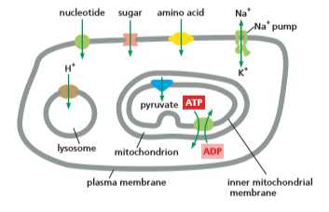
    - Lysosome membrane contains a H+ transporter that imports H+ to acidify the lysosome interior for digestion
    - The inner membrane of mitochondria contains transporters for importing pyruvate that mitochondria use as fuel for generating ATP as well as transporters for ATP export
* Passive transporters move a solute along its electrochemical gradient
  + The glucose transporter mediates passive transport in the plasma membrane of many mammalian cell types
    - The protein can adopt several conformations and it switches reversibly and randomly between them
    - In one conformation, the transporter exposes binding sites for exterior glucose
    - In the other conformation, the transporter exposes bindings sites to the interior of the plasma membrane
  + The chemical component of its electrochemical gradient is zero because glucose is uncharged
    - The direction of transport is determined by its concentration gradient alone
    - When glucose is in high concentration outside cells, the sugar binds to the transporter’s externally displayed binding sites
      * The transporter switches conformation and carries the bound sugar inward, releasing it into the cytosol
    - When blood glucose levels are low, the hormone glucagon stimulates liver cells to produce large amounts of glucose by the breakdown of glycogen
    - When glucose is in high concentration inside cells, the glucose binds to the internally displayed binding sites on the transporter and glucose is transported out of the cells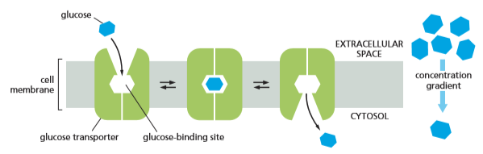
  + The net flow of glucose can go in or out of the cell depending on the glucose concentration gradient
    - Inward if glucose is more concentrated outside the cell
    - Outward if glucose is more concentrated inside the cell
  + Passive transporters play no role in determining direction of transport but can be selective to what they transport
    - Glucose transporter bind only D-glucose and not L-glucose, which the cell cannot use for glycolysis
* Pumps actively transport a solute against its electrochemical gradient
  + Cells cannot rely solely on passive transport
  + Active transport of solutes is essential for transport against electrochemical gradients
    - Important for maintaining intracellular ionic composition
  + Transmembrane pumps perform active transport
    - ATP-driven pumps hydrolyze ATP to drive uphill transport
    - Coupled pumps link the uphill transport of one solute across a membrane to the downhill transport of another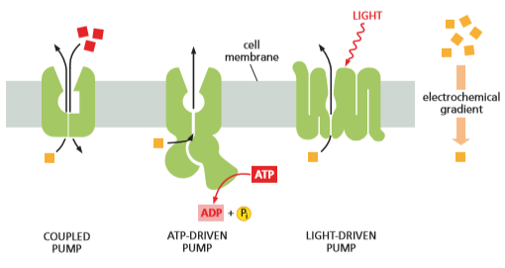
    - Light-driven pumps use energy derived from sunlight to drive uphill transport
  + Different forms of active transport are often linked
    - ATP-driven Na+ pump transports Na+ out of the cell against its electrochemical gradient
      * Na+ can then flow back into the cell, down its electrochemical gradient
    - The flow of Na+ back into the cell can provide energy for transport of other substances into the cell against their electrochemical gradient
      * If the Na+ pump stopped the Na+ gradient would run down and Na+ coupled pumps would cease to operate
* The Na+ pump in animal cells uses energy supplied by ATP to expel Na+ and bring in K+
  + The ATP-driven Na+ pump typically accounts for 30% or more of total ATP consumption
  + The pump uses energy derived from ATP hydrolysis to transport Na+ out of the cell and carry K+ in
    - The pump is known as the Na+-K+ ATPase or Na+-K+ pump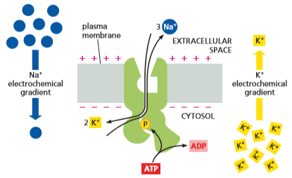
  + The energy of ATP hydrolysis induces a series of protein conformational changes that drive the Na+/K+ ion exchange
    - The phosphate group removed from the ATP gets transferred to the pump itself
  + The ion transport involves a reaction cycle, in which each step depends on the previous one. If one step halts, the entire cycle cannot continue
    - The entire cycle takes 10 milliseconds
    - The tight coupling between steps ensures the process only occurs when all appropriate ions are available to be transported
* The Na+ pump generates a steep concentration gradient of Na+ across the plasma membrane
  + The pump constantly expels the Na+ that enters the cell through other transporters and ion channels
  + The pump keeps the Na+ concentration in the cytosol about 10-30 times lower than in the extracellular fluid and the K+ concentration about 10-30 times higher
    - The high concentration of Na+ outside the cell represents a very large store of energy
    - Even if the Na+ pumps are shut down, there is sufficient stored energy to sustain many minutes of various membrane pumps that are driven by the downhill flow of Na+
* Ca2+ pumps keep the cytosolic Ca2+ concentration low
  + Ca2+, like Na+, is also kept at a low concentration in the cytosol compared to its concentration in the extracellular fluid
    - Ca2+ is much less plentiful than Na+, both inside and outside the cell
  + Ca2+ can bind to various proteins in the cell, altering their activities. This makes Ca2+ pumps crucial
    - An influx of Ca2+ into the cytosol acts as an intracellular signal to trigger various cell processes, such as muscle contraction, fertilization, and nerve cell communication
  + The lower the background concentration of free Ca2+ in the cytosol, the more sensitive the cell is to an increase in cytosolic Ca2+
    - Eukaryotic cells maintain a very low concentration of free Ca2+ in their cytosols against a much higher extracellular Ca2+ concentration
  + Concentration differences of Ca2+ are achieved by ATP driven Ca2+ pumps which actively pump Ca2+ out of the cytosol
    - Ca2+ pumps are ATPases that work similarly to Na+ pumps but return to their original conformation without a requirement for binding and transporting a second ion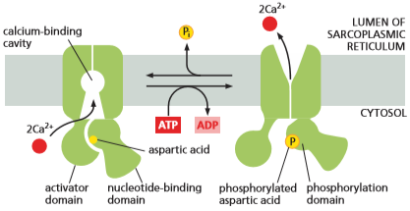
      * Na+ and Ca2+ pumps have similar amino acid sequences and structures, indicating that they share a common evolutionary origin
* Coupled Pumps exploit solute gradients to mediate active transport
  + A gradient of any solute can be used to drive the active transport of a second molecule
    - The downhill movement of the first solute down its gradient provides the energy to power the uphill transport of the second
  + Coupled pumps are active transporters that can couple:
    - The movement of one inorganic ion to that of another
    - The movement of an inorganic ion to that of a small organic molecule
    - The movement of one small organic molecule to that of another
  + Symports are pumps that move both solutes in the same direction across the membrane
  + Antiports move solutes in opposite directions across the membrane
  + Uniports move only one type of solute across the membrane
    - The passive glucose transporter is an example of a uniport

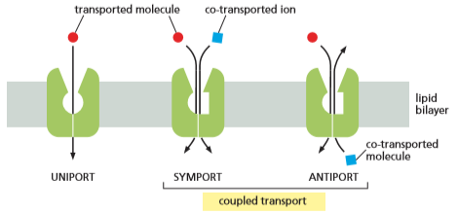

* Electrochemical Na+ gradient drives coupled pumps in the plasma membrane of animal cells
  + Symports that make use of the inward flow of Na+ have an especially important role in the import of other solutes in animal cells
    - Epithelial cells that line the gut pump glucose from the gut lumen across the gut epithelium and into the blood. If they had only passive glucose uniport, they would release glucose into the gut at the same rates as if you were fasting or just ate
    - In glucose-Na+ symporters, the binding of Na+ and glucose is cooperative, meaning that both molecules must be present for coupled transport to occur

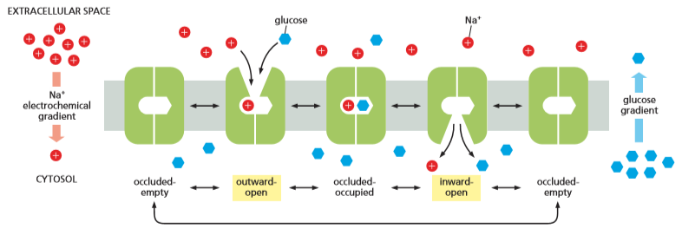

* + Gut epithelial cells have two types of glucose transporters located at opposite ends of the cell
    - In the apical domain, which faces the gut lumen, they have glucose-Na+ symporters that take up glucose, creating a high glucose concentration in the cytosol
    - In the basal and lateral domains, the cells have passive glucose uniporters which release the glucose down its concentration gradient for use by other tissues
    - The two types of glucose transporters are kept segregated in their proper domains of the plasma membrane by a diffusion barrier, preventing mixture of membrane components between the two domains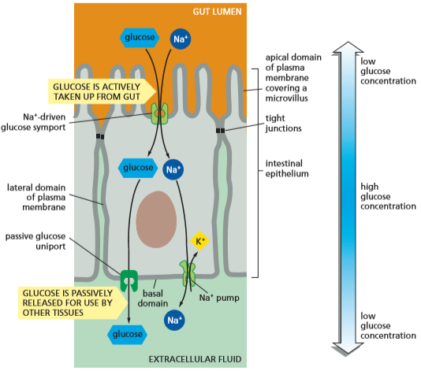
  + Cells in the lining of the gut, kidney, and many other organs contain a variety of active symports that are similarly driven by the electrochemical gradient of Na+
  + Na+-driven antiporters are also important to cells
    - Na+-H+ exchanger uses the downhill influx of Na+ to pump H+ out of the cell, preventing the cell interior from becoming too acidic
* Electrochemical H+ gradients drive coupled pumps in plants, fungi, and bacteria
  + Plant cells, bacteria, and fungi do not have Na+ pumps in their plasma membrane
    - They rely mainly on an electrochemical gradient of H+ to import solutes into the cell
  + H+ pumps are used to pump H+ out of the cell, creating an acid pH in the medium surrounding the cell
    - The import of sugars and amino acids into bacterial cells is then mediated by H+ symporters which use the electrochemical H+ gradient to import nutrients
  + In some photosynthetic bacteria, the H+ gradient is created by the activity of light-driven H+ pumps such as bacteriorhodopsin
  + In other bacteria, fungi, and plants, the H+ gradient is generated by H+ pumps in the plasma membrane that use the energy of ATP hydrolysis to pump H+ out of the cell
    - These H+ pumps resemble the Na+ pumps and Ca2+ pumps in animal cells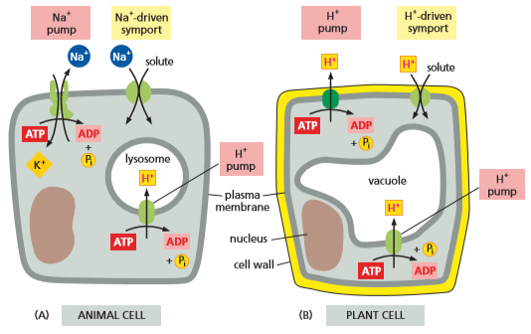
  + A different type of ATP-dependant H+ pump is found in membranes of intracellular organelles (lysosomes, vacuoles, etc)
    - These pumps actively transport H_ of the cytosol into the organelle, keeping the pH of the cytosol neutral and the pH of the interior of the organelle acidic

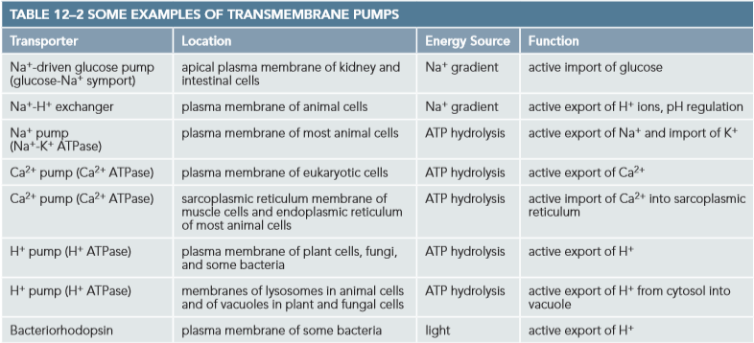

**Ion Channels and the Membrane Potential**

* + Channels create a hydrophilic pathway through which water-soluble molecules may pass
  + A few channels form relatively large, aqueous pores
    - Gap junctions occur between two adjacent cells
    - Porins form pores in the outer membrane of mitochondria and some bacteria
  + Most channels form narrow, highly selective pores
    - If large, permissive channels formed, they would lead to large leaks if they directly connected the cytosol of the cell to the extracellular space
  + Aquaporins facilitate the flow of water. They are structured in a way that they allow the passive diffusion of uncharged water molecules while prohibiting the movement of H+ and other ions
* Ion channels are ion-selective and gated
  + Ion channels show ion selectivity, depending on the diameter and shape of the ion channel and the distribution of the charged amino acids that line it
    - Each ion in aqueous solutions are surrounded by a small shell of water molecules, most of which have to be shed for the ion to pass, in single file, through the selectivity filter of the channel
    - Ion channels are narrow enough in places to force ions to contact with the cell wall, ensuring only ions of the appropriate size may pass
  + Ion channels are not continuously open
    - Ion channels open only briefly and then close again
    - Most ion channels are gated, with a specific stimulus triggering them to switch between a closed and open state by a change in their conformation
  + An open ion channel does not need to undergo conformational changes with each ion it passes, so it can have a high maximum rate of transport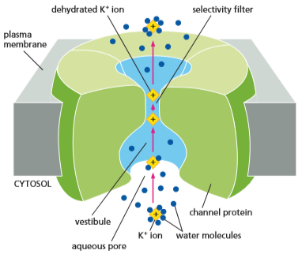
    - More than a million ions can pass through an open channel each second
    - The rate is 1000 times faster than that of any transporter
  + Channels cannot couple the ion flow to an energy source to carry out active transport
    - Most channels simply make the membrane transiently permeable to selected inorganic ions (mainly Na+, K+, Ca2+, and Cl-)
  + Active transport pumps make ion concentration far from equilibrium. The opening of ion channels lets ions rapidly flow down their electrochemical gradients, creating a change in the membrane potential
* Membrane potential is governed by the permeability of a membrane to specific ions
  + Changes in membrane potential are the basis of electrical signaling in many types of cells (including nerve and muscle cells in animals or touch-sensitive cells in carnivorous plants)
    - Electrical charges are mediated by alterations in the permeability of membranes to ions
    - In an unstimulated (“resting-state”) animal cell, the negative charges on the organic molecules inside the cell are balanced by K+
    - K+ is imported into the cell by the Na+ pump and K+ channels called K+ leak channels
    - K+ leak channels flicker between open and closed states regardless of cellular conditions, allowing K+ to flow freely in its open configuration
  + When K+ leak channels are open, K+ has a tendency to flow out of the cell down its steep concentration gradient
    - The movement of K+ ions leaves behind unbalanced negative charges on the interior of the cell, creating a voltage difference (membrane potential)
    - An equilibrium condition is established because the charge difference prevents more K+ from moving out of the cell
      * The membrane potential keeping K+ inside the cell is just strong enough to counteract the tendency of K+ to move down its concentration gradient out of the cell
      * The electrochemical gradient for K+ is zero in this state
  + The membrane potential in steady state conditions (when the flow of positive and negative ions across the plasma membrane is precisely balanced) is called the resting membrane potential
    - The Nernst equation expresses the equilibrium quantitatively and makes it possible to calculate the resting membrane potential if ion concentrations on both sides of the membrane are known
    - The resting membrane potential in animal cells lies between -20 and -200 mV and is mostly represented by the K+ electrochemical gradient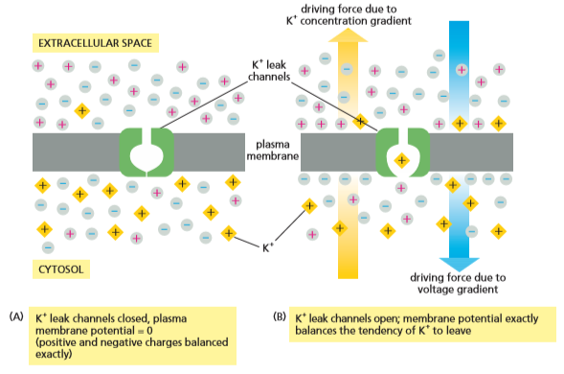
  + When a cell is stimulated, other ion channels in the plasma membrane open, changing the membrane’s permeability to those ions
    - Whether the ions enter or leave the cell depends on the electrochemical gradients
    - Membrane potential depends on both the state of the membrane’s ion channels and the ion concentrations on either side of the membrane
  + Bulk changes in ion concentrations cannot occur quickly enough to drive the rapid changes to membrane potential associated with electrical signaling
    - Cell signaling occurs due to rapid opening and closing of ion channels which occurs within milliseconds
* Ion channels randomly snap between open and closed states
  + Patch-clamp recording is an electrical recording technique to detect and measure the electric current flowing through a single channel molecule
    - A fine glass tube is used as a microelectrode to isolate and make electrical contact with a small area of the membrane, making it possible to record the activity of ion channels in all sorts of cell types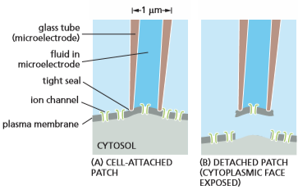
    - With the appropriate circuitry, the voltage across the membrane patch can be set and the membrane clamped in place, making it possible to see how changes in membrane potential affect the opening and closing of the ion channels in the membrane
  + With a sufficiently small area of membrane in the patch, sometimes only a single ion channel will be present
    - Modern electrical instruments are precise enough to monitor a single channel at as little as 10-12 amps (current)
    - Monitoring revealed that even as conditions are held constant, the currents abruptly appear and disappear, as though the channels are opened and closed randomly
    - Patch-clamp recording was the first technique that could monitor conformational changes
  + Ion channels are either fully open or fully closed.
    - If conditions tend for an open channel, the channel will spend a much greater portion of its time in the open conformation, although it will not remain open continuously
* Different types of stimuli influence the opening and closing of ion channels
  + There are more than a hundred types of ion channels and dozens of different channels for the same ion
    - Ion channels differ from one another primarily with respect to their ion selectivity and gating
      * Selectivity: The type of ions they allow to pass
      * Gating: the conditions that influence their opening and closing
  + For voltage-gated channels the probability of being open is controlled by the membrane potential
  + For ligand-gated channels opening is controlled by the binding of some molecule (the ligand) to the channel
  + For mechanically-gated channels opening is controlled by a mechanical force applied to the channel
    - The auditory hair cells in the ear have their channels pulled open by sound vibrations, causing ions to flow into the hair cells
* Voltage-gated ion channels respond to the membrane potential
  + Voltage-gated ion channels play a major role in propagating electrical signals along all nerve cell processes
    - Voltage-gated ion channels are present in many cell types, including nerves, muscle cells, egg cells, protozoans, and even plant cells
  + Voltage-gated ion channels have domains called voltage sensors that are extremely sensitive to changes in the membrane potential
    - Changes above a certain threshold value exert sufficient electrical force on these domains to encourage the channel to switch from its closed to its open conformation
    - Membrane potential does not affect how wide the channel is open, but instead alters the probability that it will open
    - A large patch of membrane carrying channel proteins will have different percentages of channels open at different times
  + When one type of voltage-gated ion channel opens, the membrane potential of the cell can change, in turn activating or inactivating other voltage-gated ion channels
    - This chain reaction is fundamental to all electrical signaling in cells

**Ion Channels and Nerve Cell Signaling**

* + Neurons (nerve cells) receive, integrate and transmit signals
    - Neurons carry signals inwards from sense organs to the central nervous system
  + Each neuron consists of a cell body which contains the nucleus with long, thin extensions radiating outwards from it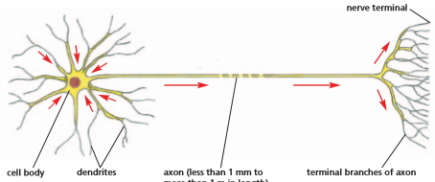
    - Axons are an extension which conducts electrical signals away from the cell body toward distant target cells
      * The far end of axons commonly divides into many branches, each branch ending in a nerve terminal
    - Dendrites are extensions that radiate from the cell body like antennae and provide an enlarged surface area to receive signals from the axons of other neurons
  + Signals always consist of changes in the electrical potential across the neuron’s plasma membrane
* Action potentials allow rapid long-distance communication along axons
  + A neuron is stimulated by a signal delivered to a localized site on its surface, initiating a change in the membrane potential at that site
    - To transmit the signal onward, the local change in membrane potential has to spread from this site
    - Site usually spreads from the dendrite or the cell body to the axon terminals, which relay the signal to the next cells in the pathway
  + The transmission of signals forms a neural circuit
  + Local change in membrane potential generated by a signal can spread passively along an axon or a dendrite to adjacent regions of the plasma membrane
    - Passively spread signals become weaker with increasing distance, making passive spreading a short distance method
    - For long-distance communication, passive spread is inadequate
  + Neurons perform long-distance communication through an active signaling mechanism
    - A local electrical stimulus of sufficient strength triggers an explosion of electrical activity in the plasma membrane that propagates along the membrane of the axon, continuously renewing itself along the way
    - The action potential or nerve impulse is the travelling wave of electrical excitation that can carry a message at speeds of up to 100 meters per second
* Action potentials are mediated by voltage-gated cation channels
  + Neuron stimulation leads to the membrane potential shifting to a less negative (towards zero) value
    - Process called depolarization
  + If depolarization is sufficiently large, it will cause the voltage-gated Na+ channels in the membrane to open transiently at the site, allowing a small amount of Na+to enter the cell down its steep electrochemical gradient
    - The influx of positive charge further depolarizes the membrane, opening additional Na+ channels and causes further depolarization
    - Within a millisecond the membrane potential in the local region of the neuron’s plasma membrane shifts from its resting value of about -60 mV to about +40 mV
  + The voltage of +40 mV is close to the membrane potential at which the electrochemical driving force of Na+ is zero
    - The effects of the membrane potential and the concentration gradient of Na+ are equal and opposite so that Na+ has no further tendency to enter/exit the cell
    - If channels continued to respond to the altered membrane potential, the cell would be stuck with most of its voltage-gated Na+ channels open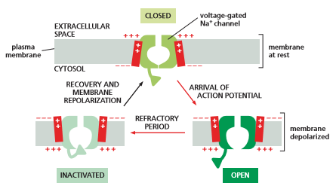
  + Na+ channels have an automatic inactivating mechanism that causes them to rapidly adopt a special inactivated conformation in which the channel is closed
    - Na+ channels remain in their inactivated state until the membrane potential returns to its initial negative value
  + During an action potential the depolarized axonal membrane is helped to return to its resting potential by the opening of voltage-gated K+ channels
    - These channels stay open as long as the membrane remains depolarized
      * Once depolarization reaches its peak, K+ ions begin to flow out of the cell through the K+ channels
    - The rapid outflow of K+ through the voltage-gated K+ channels brings the membrane back to its resting state more rapidly than it could have achieved by K+ outflow through the K+ leak channels alone
  + The self-amplifying depolarization of a small patch of plasma membrane quickly spreads outwards as neighboring regions of membrane are depolarized, eventually reaching the axon terminal

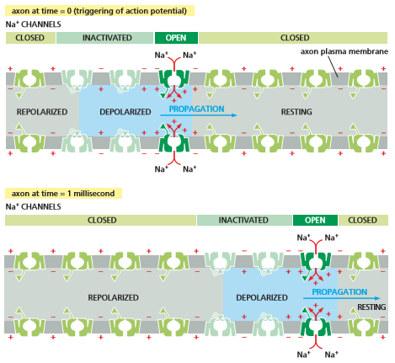

* Voltage-gated Ca2+ channels in nerve terminals convert an electrical signal into a chemical signal
  + When an action potential reaches the nerve terminals at the end of an axon, the signal must be relayed to the target cells that the terminals contact (neurons or muscle cells)
    - The signal is transmitted along junctions called synapses
  + The presynaptic and postsynaptic cells are separated by a narrow synaptic cleft which the electrical signal cannot cross (20 nm wide)
    - The electrical signal is converted into a chemical signal in the form of a neurotransmitter
      * Neurotransmitters are secreted signal molecules that are initially stored in the nerve terminals within membrane-enclosed synaptic vesicles
  + When an action potential reaches the nerve terminal, some of the synaptic vesicles fuse with the plasma membrane and release neurotransmitters into the synaptic cleft
  + The depolarization of the nerve-terminal plasma membrane caused by the arrival of the action potential transiently opens voltage-gated Ca2+ channels, concentrated in the membranes of presynaptic nerve terminals
    - Because the Ca2+ concentration outside the terminal is more than 1000 times greater than the free Ca2+ concentration in its cytosol, Ca2+ enters the nerve terminal through the open channels
    - The increase in Ca2+ concentration in the cytosol of the terminal triggers the membrane fusion that releases the neurotransmitter
* Transmitter-gated ion channels in the postsynaptic membrane convert the chemical signal back into an electrical signal
  + The released neurotransmitter rapidly diffuses across the synaptic cleft and binds to neurotransmitter receptors concentrated in the postsynaptic plasma membrane of the target cell
    - Binding of neurotransmitters to its receptors causes a change in the membrane potential of target cells which triggers the cell to fire an action potential
    - After action potential is fired, the neurotransmitter is removed from the synaptic cleft by enzyme destruction or pumping back into the nerve terminals that released it or by uptake into neighboring non-neuronal cells
      * Rapid removal of neurotransmitter limits the duration and spread of the signal 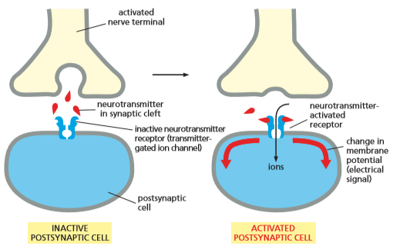
  + Neurotransmitter receptors can be of various types
    - Some mediate relatively slow effects in the target cell
    - Others trigger rapid responses, depending on receptors that are transmitter-gated ion channels
      * Subclass of ligand-gated ion channels
      * Convert chemical signal carried by a neurotransmitter back into an electrical signal
  + Channels open transiently in response to the binding of the neurotransmitter, changing the ion permeability of the postsynaptic membrane, causing a change in the membrane potential
    - A big enough change can depolarize the postsynaptic membrane and trigger an action potential in the postsynaptic cell
* Neurotransmitters can be excitatory or inhibitory
  + Neurotransmitters can either excite or inhibit a postsynaptic cell
  + The main receptors for excitatory neurotransmitters are ligand-gated channels
    - Such as acetylcholine and glutamate
    - When a neurotransmitter binds, these channels open to allow Na+ which depolarizes the plasma membrane, activating the postsynaptic cell and encouraging the firing of an action potential
  + The main receptors for inhibitory neurotransmitters are ligand-gated Cl- channels
    - Such as 𝛾-aminobutyric acid (GABA) and glycine
    - When a neurotransmitter binds, these channels open, increasing the membrane permeability to Cl-, inhibiting the postsynaptic cell by making its plasma membrane harder to depolarize
  + Toxins that bind to excitatory or inhibitory neurotransmitters can have dramatic effects
    - Curare can cause muscle paralysis by blocking excitatory receptors at neuromuscular junctions
    - Strychnine causes muscle spasms, convulsions, and death by blocking inhibitory glycine receptors on neurons in the brain and spinal cord

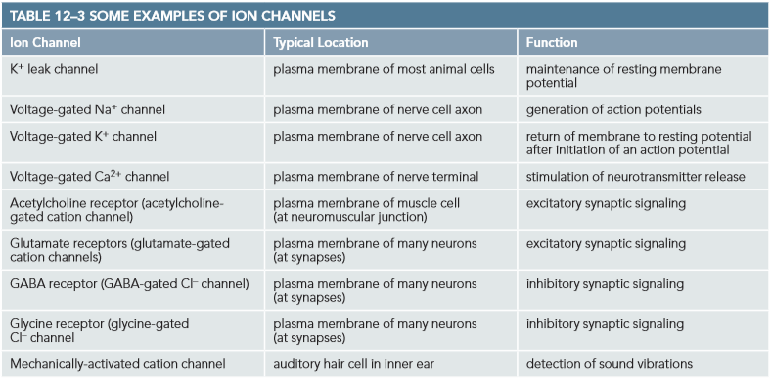

* Most psychoactive drugs affect synaptic signaling by binding to neurotransmitter receptors
  + Many drugs used to treat insomnia, anxiety, depression, and schizophrenia act by binding to transmitter-gated ion channels in the brain
    - Sedatives and tranquilizers bind to GABA-gated Cl- channels
      * Binding makes the channels easier to open by GABA, rendering the neuron more sensitive to GABA’s inhibitory action
    - Antidepressants block the Na+-driven symport responsible for the uptake of excitatory neurotransmitters
  + The number of distinct types of neurotransmitter receptors is large and fall into a small number of families
    - With so many receptors it might be possible to design a new generation of psychoactive drugs that act more selectively on specific sets of neurons
  + The complexity of synaptic signaling may make the brain especially vulnerable to genetic abnormalities
* The complexity of synaptic signaling enables us to think, act, learn, and remember
  + The mechanism for synaptic signalling seems unnecessarily cumbersome as well as error-prone
  + The value of synapses that rely on secreted chemical signals becomes clear when we consider how they function in the context of the nervous system
    - To carry out their functions, neurons have to do more than generate and relay signals, they also have to combine, interpret, and record them
      * Chemical synapses makes this possible
    - Computing an appropriate output is achieved by a complicated interplay between different types of ion channels in the neuron’s plasma membrane
  + A synapse can also adjust the magnitude of its response, reacting based on how heavily a synapse was used in the past
    - Synaptic plasticity is the ability to adapt, triggered by the entry of Ca2+ through special cation channels in the postsynaptic plasma membrane
      * Can lead to functional alterations on either side of the synapse
    - Synaptic changes can last hours or longer than weeks, potentially making them an important part in learning and memory
* Optogenetics uses light-gated ion channels to transiently activate or inactivate neurons in living animals
  + Light-gated channels used to sense light for plants can function properly when artificially transferred to other cell types, thereby rendering those cells responsive to light
    - Light-gated channels called channelrhodopsin
  + Channelrhodopsin can be used to manipulate the activity of neurons and neural circuits
    - Light strips in mice’s brains can be used to trigger implanted channelrhodopsin that can change the behavior of the mouse when activated
  + Optogenetics is the method of genetic engineering that uses light to control neurons
    - Light-gated channels can be exploited to study a wide variety of organisms and greatly enhance our understanding of the molecular and cellular basis of human behavior

**How We Know - Squid Reveal Secrets of Membrane Excitability**

* + Loligo paelei (squid) have some of the largest nerve cell axons found in nature
  + The larger the diameter of an axon, the diameter of an axon, the more rapidly signals can travel along its path
  + Because of the relatively large axon size in a squid, investigators can isolate individual axons and insert an electrode into it to measure the axon’s membrane potential and monitor its electrical activity
  + Lets researchers answer which ions are important for establishing the resting membrane potential and for initiating and propagating an action potential and ow changes in the membrane potential can change ion permeability
* Setup for action
  + An electrode made from a glass capillary tube containing a conduction solution can be thrust down the axis of the isolated axon so its tip lies in the cytoplasm
    - Voltage difference inside and outside the axon can be measured
  + The action potential itself is triggered by applying a brief electrical stimulus to one end of the axon
    - Action potential can travel in either direction
  + The three most plentiful ions inside and outside an axon are Na+, K+, and Cl-
  + The cytoplasm can be removed from the axon through extrusion. The axon could then be filled with a pure solution of Na+, K+, and Cl-
    - Determined the cell components crucial to the action potential are the plasma membrane, Na+ and K+ ions, and the energy provided by the concentration gradients of these ions
* Channel traffic
  + The membrane potential of an axon is close to the equilibrium potential for K+
    - When the external concentration of K+ was varied, the resting potential of the axon changed roughly in accordance with the Nernst equation
    - At rest, the membrane is chiefly permeable to K+
      * Largely due to K+ leak channels
  + When the external concentration of Na+ is varied, there is no effect on the resting potential of the axon
  + The height of the peak of the action potential varies with the concentration of Na+ outside the axon

**Chapter 13**

* + Sugars are very important food molecules
  + Cellular respiration occurs when energy is released when the sugar molecule is broken down and oxidized to carbon dioxide and water
    - Energy released is captured in activated carriers (ATP and NADH)

**The Breakdown and Utilization of Sugars and Fats**

* + Glucose is broken down in stages because carrier molecules cannot carry all the energy released by glucose at once
    - Stages are managed by specific enzymes
  + Animal cells make ATP in two ways:
    - Energetically favorable enzyme-catalyzed reactions involved in the breakdown of foods are coupled with the unfavorable ADP + Pi → ATP reaction
    - Oxidative Phosphorylation: Energy from other activated carriers is used to drive ATP production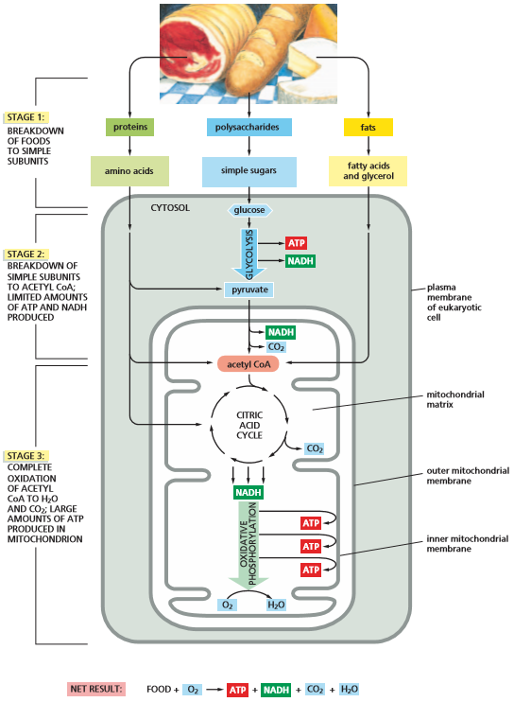
* Food molecules are broken down in three stages
  + Catabolism is the enzyme catalyzed breakdown process of organic molecules into simpler ones
  + Stage 1: (Digestion) enzymes convert large polymeric molecules in food into simpler monomeric subunits
    - Proteins into amino acids
    - Polysaccharides into sugars
    - Fats into fatty acids and glycerol
    - Step occurs outside the cell (intestine) or in lysosomes
  + Stage 2: (Glycolysis) each molecule of glucose is split into two pyruvates and creates ATP and NADH
    - Step occurs in the cytosol
    - Pyruvate is transferred from the cytosol into the mitochondrion’s large, internal compartment (the matrix)
    - In the mitochondria, each pyruvate is converted into CO2 plus acetyl CoA
  + Stage 3: (Citric Acid Cycle) the acetyl group is transferred to an oxaloacetate molecule to form citrate, which enters the citric acid cycle. The transferred acetyl group is oxidized to CO2 with production of NADH
    - NADH are transported along the electron-transport chain and used to drive oxidative phosphorylation
      * Produces ATP and consumes O2
    - When the majority of the energy released by oxidation is harnessed to produce most of the cell’s ATP
  + ATP is produced to redistribute the energy derived from the breakdown of sugars and fats
  + Roughly 109 molecules of ATP are in solution in a typical cell at any time. All of these ATPs get turned over every 1-2 minutes
* Glycolysis extracts energy from the splitting of sugar
  + Glycolysis produces ATP without the involvement of oxygen
    - Glycolysis occurs in the cytosol
    - Two ATP are initially consumed to provide energy to split the sugar
    - Four molecules of ATP (net gain of 2 molecules) and two molecules of NADH are produced
  + Glycolysis splits a molecule of glucose (6 carbon atoms) into two molecules of pyruvate (each 3 carbon atoms)
  + Electrons in pyruvate are at a lower energy state than those in a molecule of glucose
* Glycolysis produces both ATP and NADH
  + Most of the energy released from the breakdown of glucose is used to drive the synthesis of ATP molecules from ADP and Pi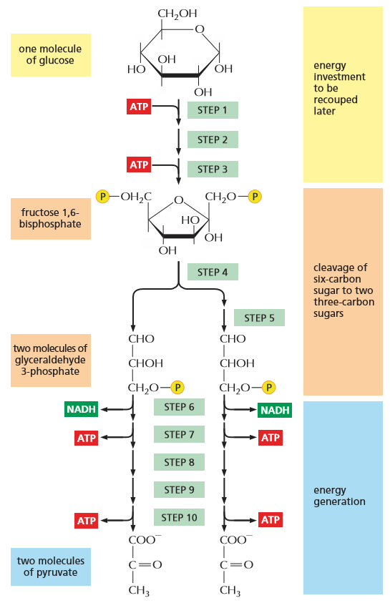
  + Substrate-level phosphorylation is the ATP synthesis that takes place in steps 7 and 10 of glycolysis.
    - It occurs by the transfer of a phosphate group directly from a substrate molecule to ADP
    - By contrast, most phosphorylations occur by the transfer of phosphate from ATP to a substrate molecule
  + The remainder of energy released during glycolysis is stored in electrons of the NADH molecule
  + Although no molecular oxygen is involved in glycolysis, oxidation does occur when a hydrogen atom plus an electron is removed from the sugar intermediate and transferred to NAD+, producing NADH
    - Two molecules of NADH are formed during glycolysis per molecule of glucose
  + The NADH molecules donate their electrons to the electron-transport chain in the inner mitochondrial membrane
    - Electron transfers release energy as electrons fall from a state of high energy to a state of low energy
    - NADH is converted back into NAD+ when electrons are given up
  + NADH can also be created through fermentation
* Fermentations can produce ATP in the absence of oxygen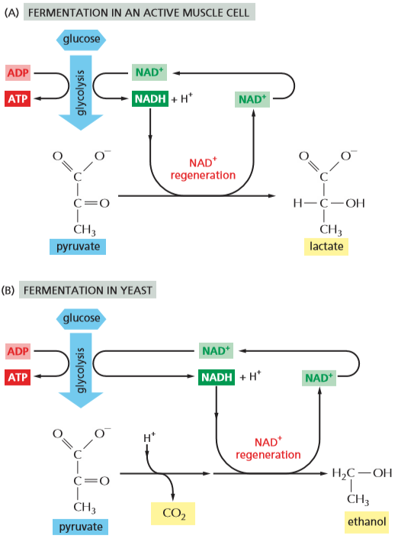
  + Anaerobic microorganisms can grow and divide in the absence of oxygen
  + Glycolysis is the principle source of ATP when there is an absence of oxygen
  + In anaerobic conditions, the pyruvate and NADH made by glycolysis remain in the cytosol
    - Pyruvate is converted into products that are excreted from the cell
    - The NADH gives up its electrons in the cytosol, creating NAD+
  + Energy-yielding pathways that break down sugar in the absence of oxygen are called fermentations
  + Bacteria and archaea can also generate ATP in the absence of oxygen by anaerobic respiration
    - Anaerobic respiration uses a molecule other than oxygen as the final oxygen acceptor
    - Involves an electron-transport chain embedded in the membrane
* Glycolytic enzymes couple oxidation to energy storage in activated carriers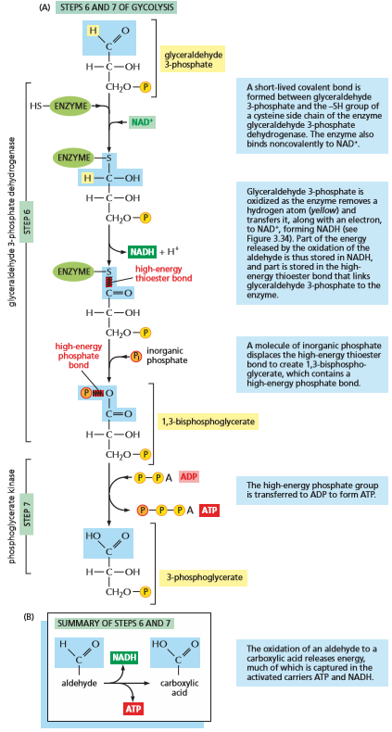
  + Cells harvest useful energy form the oxidation of organic molecules by coupling an energetically unfavorable reaction to an energetically favorable one
  + Steps 6 and 7 convert the three-carbon sugar intermediate glyceraldehyde 3-phosphate into 3-phosphoglycerate
    - Two electrons from the aldehyde to NAD+ to to form NADH and to transfer a phosphate group to a molecule of ADP to form ATP
    - Overall reaction is energetically favorable (ΔG° = -3.0 kcal/mole)
  + Energy contained in a phosphate bond can be measured using the standard free-energy change (ΔG°) when the bond is broken by hydrolysis
  + Molecules with phosphate bonds that have more energy than ATP readily transfer their phosphate group to ADP to form ATP
    - Bonds are described as high energy because their hydrolysis is energetically favorable
* Several organic molecules are converted to acetyl CoA in the mitochondrial matrix
  + In aerobic metabolism in eukaryotic cells, the pyruvate is actively pumped into the mitochondrial matrix
    - The pyruvate dehydrogenase complex breaks down pyruvate into CO2, NADH, and acetyl CoA
  + Fat is a major source of energy for most nonphotosynthetic organisms
    - Fatty acids derived from fat are converted into acetyl CoA in the mitochondrial matrix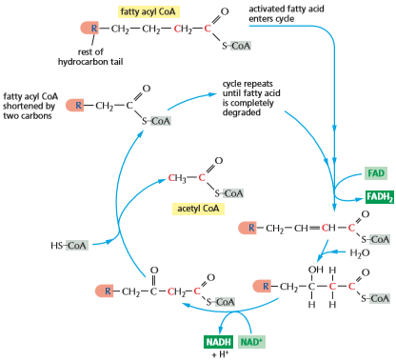
    - Fatty acids are activated by covalent linkage to CoA and broken down completely by a cycle of reactions that trims two carbons at a time from their carboxylic end, generating one molecule of acetyl CoA per cycle
      * Two activated carriers (NADH and FADH2) are also produced
  + Some amino acids are transported into the mitochondrial matrix where they are converted into acetyl CoA
  + The mitochondrion is the center toward which all energy-yielding catabolic processes lead
    - In aerobic bacteria, glycolysis, acetyl CoA, and the citric acid cycle take place in the cytosol
  + The acetyl group in acetyl CoA is oxidized to CO2 and H2O in the mitochondrial matrix to release more energy
* The citric acid cycle generates NADH by oxidizing acetyl groups to CO2
  + The citric acid cycle accounts for ⅔ of the total oxidation of carbon compounds in most cells
    - Major end products are CO2 and high-energy electrons (NADH)
  + CO2 is released as a waste product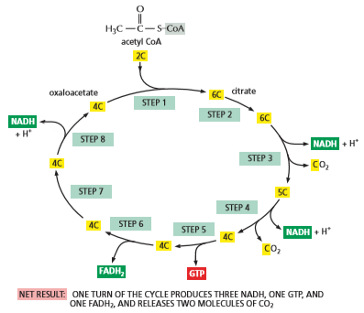
  + High-energy electrons from NADH are passed to the electron-transport chain in the inner mitochondrial membrane
    - Electrons combine with O2 to produce H2O
  + Citric acid cycle takes place in the mitochondrial matrix
    - Does not directly use O2 but uses NAD+ that requires O2 to make it
  + Citric acid cycle catalyzes the complete oxidation of the carbon atoms of the acetyl groups in acetyl CoA, converting them into CO2
    - The acetyl group is transferred to oxaloacetate (4-carbon molecule) to form the 6-carbon tricarboxylic acid (citric acid)
    - The chain of 8 reactions forms a cycle because oxaloacetate regenerates at the end
  + Each turn of the cycle also produces one molecule of FADH2 from FAD and one molecule of the ribonucleoside triphosphate GTP from GDP
    - FADH2 is a carrier of high-energy electrons and hydrogen
    - Energy is used to produce ATP through oxidative phosphorylation
  + The O2 that we breathe is reduced to water by the electron transport chain. It is not incorporated directly into the CO2 we exhale
* Many biosynthetic pathways begin with glycolysis or the citric acid cycle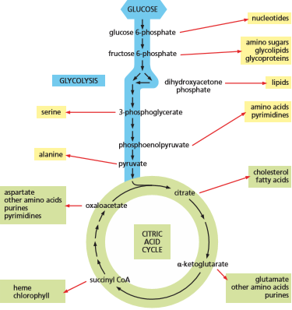
  + Anabolic pathways are series of enzyme-catalyzed reactions that convert the intermediates of glycolysis and the citric acid cycle into amino acids, nucleotides, lipids, and other small organic molecules
  + Image: examples of how intermediates of the citric acid cycle are used to produce other biological molecules
* Electron transport drives the synthesis of the majority of the ATP in most cells
  + Oxidative phosphorylation generates ATP by capturing chemical energy produced during glycolysis and the citric acid cycle
    - NADH and FADH2 transfer their high-energy electrons to the electron-transport chain
      * The electron-transport chain is a series of electron carriers embedded in the inner mitochondrial membrane in eukaryotic cells
  + As electrons pass through the electron-transport chain, they lose energy at each electron acceptor and donor molecules
    - This energy is used to drive H+ across the inner membrane, from the mitochondrial matrix to the intermembrane space
    - A proton gradient across the inner membrane serves as a source of energy that can drive a variety of reactions
      * Ie: the phosphorylation of ADP to generate ATP on the matrix side of the inner membrane
  + Electrons are added to O2 at the end, immediately attracting H+ and breaking apart into water molecules
    - H2O represents the lowest energy level of the electrons
  + The complete oxidation of a glucose molecule to H2O and CO2 produces about 30 molecules of ATP
    - Glycolysis alone produces only two molecules of ATP
  + Oxidative phosphorylation occurs in eukaryotic cells and aerobic bacteria

**Regulation of Metabolism**

* + All organisms must replenish their ATP pools through the oxidation of sugar or fats to maintain order within their cells
    - This must be done constantly despite being unable to constantly eat or have access to sunlight
  + Animals and plants have developed to maintain constant supplies of food
    - Food reserves can be synthesized when there is a surplus of food to be used later
  + Key metabolites can be routed into anabolic or catabolic pathways depending on if the cell wants to build other molecules or burn them to provide immediate energy
* Catabolic and anabolic reactions are organized and regulated
  + Reactions occur in very small spaces
  + The same substrate is often a part of many different pathways
    - The pathways compete for one substrate (ie: pyruvate)
  + Control mechanisms are used to regulate and coordinate the activity of enzymes that catalyze the myriad metabolic reactions that go on in a cell
    - The activity of enzymes can be controlled by covalent modification and by the binding of small regulatory molecules
    - Regulation can enhance or inhibit the activity of an enzyme
* Feedback regulation allows cells to switch from glucose breakdown to glucose synthesis
  + Gluconeogenesis synthesizes glucose from pyruvate
    - Gluconeogenesis is a reversal of glycolysis, building glucose from pyruvate
    - It makes use of many of the same enzymes as glycolysis, running them in reverse
      * There are three steps in glycolysis that are so energetically favorable that they cannot be reversed
      * Bypass reactions are used to get around these steps
  + Cells decide whether to synthesize glucose or degrade it based on the binding of a variety of metabolites which provide feedback regulation
    - Phosphofructokinase is an enzyme that is activated by byproducts of ATP hydrolysis and is inhibited by ATP, so when ATP is depleted and its metabolic byproducts accumulate, phosphofructokinase is turned on and glycolysis proceeds to produce ATP, which later shuts it down
    - Coordinated regulatory mechanisms enable a cell to respond rapidly to changing conditions and adjust its metabolism accordingly
  + Some biosynthetic bypass reactions are energetically costly and must be tightly regulated or else energy will be consumed and heat produced for no reason
* Cells store food molecules in special reservoirs to prepare for periods of need
  + Fasting cells can mobilize glucose that has been stored as glycogen, a branched polymer of glucose
  + The synthesis and degradation of glycogen occur by separate metabolic pathways, which can be coordinated according to need
    - When more ATP is needed than can be generated from food molecules, cells break down glycogen in a reaction that is catalyzed by glycogen phosphorylase, producing glucose 1-phosphate
    - Glycogen synthetic and degradative pathways are coordinated by feedback regulation. Enzymes in each pathway are allosterically regulated by glucose 6-phosphate
  + Regulation helps prevent glycogen breakdown when ATP is plentiful and to favor glycogen synthesis when glucose 6-phosphate concentration is high
  + Fat is a far more important storage material than glycogen because it can store more energy per gram and because glycogen binds a great deal of water, creating a much larger mass to energy ratio
    - An average adult stores enough glycogen for only about a day of normal activity but enough fat to last a month
      * If glycogen was used instead of fat, body weight would increase by about 60 pounds
    - Most fat is stored as droplets of water-insoluble triacylglycerols in specialized fat cells (adipocytes)
      * Hormonal signals can trigger the release of fatty acids into the bloodstream to be processed
  + After a meal, most of the acetyl CoA entering the citric acid cycle is derived from glucose. While fasting, the acetyl CoA is derived from fatty acids
    - Food reserves in both plants and animals serve a vital part in the human diet
  + Plants convert sugars they produce into fats and starch
    - The embryo inside a plant seed must live on stored food reserves for a long time until the seed germinates
    - Plant seeds often contain especially large amounts of fats and starch, making them a major food source for animals
    - Fats and starch are both stored in chloroplasts that serve as food reservoirs that are mobilized by the cell to produce ATP in mitochondria during periods of darkness

**Chapter 14**

* + Before oxygen existed in the atmosphere, it is thought that early cells produced ATP by breaking down organic molecules that had been generated by geochemical processes
  + Membrane-based electron-transport mechanisms are used by cells to extract energy from a wide variety of sources
    - These are essential in the conversion of light energy into chemical-bond energy in photosynthesis and to the generation of ATP from food molecules during cell respiration
    - These mechanisms operate in both mitochondria and chloroplasts
* Cells obtain most of their energy by a membrane-based mechanisms
  + ATP is the main form of chemical energy in cells
  + Some ATP is generated during glycolysis in the cytosol. The majority of ATP is produced by oxidative phosphorylation
    - Oxidative phosphorylation requires a membrane while glycolysis does not
    - In eukaryotes, oxidative phosphorylation occurs in mitochondria and depends on an electron-transport process that drives the transport of protons across the inner mitochondrial membrane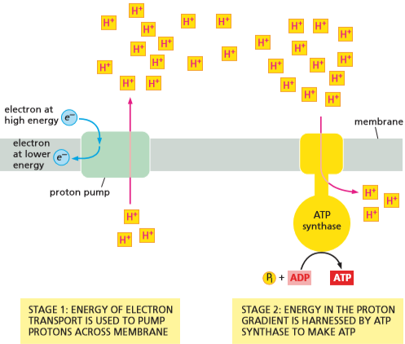
  + The membrane-based process for making ATP consists of two linked stages
  + Stage 1: High energy electrons derived from the oxidation of food molecules, sunlight, or other sources are transferred along a series of electron carriers embedded in the membrane
    - Called the electron-transport chain
    - Electron transfers release energy that is used to pump protons
    - An ion gradient across the membrane is a form of stored energy that can be used to perform other tasks as ions are allowed to flow down the gradient
  + Stage 2: Protons flow back down their electrochemical gradient through ATP synthase which catalyzes the energy-requiring synthesis of ATP from ADP and inorganic phosphate
    - The ATP synthase acts as a turbine, permitting the proton gradient to drive the production of ATP
    - Chemiosmotic coupling is a junction of chemical bond-forming reactions that synthesize ATP with the membrane transport process that pumps protons
      * Cells can harness the energy of electron transfers in the same way energy stored in a battery can be used
* Chemiosmotic coupling is an ancient process, preserved in present-day cells
  + The membrane-based chemiosmotic mechanism for making ATP is an early life mechanism that is present today
  + Chloroplasts and mitochondria reproduce in a similar manner to most prokaryotes
    - They also have bacterial-like biosynthetic machinery for making RNA and proteins, and they retain their own genomes
  + The bacteria that gave rise to chloroplasts and mitochondria gave up many of the genes required for independent living
    - These genes moved to the cell nucleus where they continue to function

**Mitochondria and Oxidative Phosphorylation**

* + Mitochondria are present in nearly all eukaryotic cells and produce the bulk of the cell’s ATP
    - Complex multicellular organisms would not have evolved without mitochondria because they would only be able to produce less than 10% the energy they can with mitochondria
  + Mitochondrial dysfunction is highly detrimental to the subject, as they will experience muscle weakness, heart problems, and often many brain conditions
    - Muscle and nerve cells are especially sensitive to mitochondrial defects because they need so much ATP to function
* Mitochondria can change their shape, location, and number to suit a cell’s needs
  + Isolated mitochondria are generally similar in size and shape to their bacterial ancestors
  + Mitochondria are adaptable and can adjust their location, shape, and number to suit the needs of the cell
    - In some cells mitochondria are fixed in one location to supply ATP directly to a site of unusually high energy consumption
      * In heart muscles mitochondria are located close to the contractile apparatus
      * In sperm mitochondria are wrapped tightly around the motile flagellum
    - In some cells mitochondria fuse to form elongated, dynamic tubular networks which are distributed throughout the cytoplasm
      * Mitochondria are present in large numbers (1000-2000) in the liver cell but vary depending on the cell type and can change based on the energy needs of cell
      * In skeletal muscle cells mitochondria can divide to increase their numbers 5-10 times if the muscles are repeatedly stimulated to contract
  + All mitochondria have the same basic internal structure
* A mitochondrion contains an outer membrane, an inner membrane, and two internal compartments
  + An individual mitochondrion is bounded by two highly specialized membranes (with one enclosed in the other) called the outer and inner mitochondrial membranes
    - Creates a large internal space called the matrix and a narrower intermembrane space
  + The outer membrane contains many molecules of a transport protein called porin
    - Porin forms wide aqueous channels through the lipid bilayer
    - The outer membrane is like a sieve that is permeable to all molecules of 5000 daltons or less, including small proteins
      * Makes the intermembrane space chemically equivalent to the cytosol with respect to the small molecules and inorganic ions
  + The inner membrane is impermeable to the passage of ions and most small particles, except where a path is provided by specific membrane transport proteins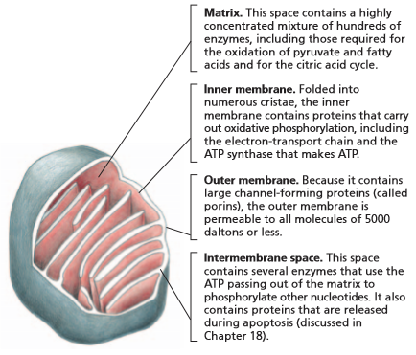
    - The mitochondrial matrix only contains molecules that are selectively transported into the matrix across the inner membrane so its contents are highly specialized
    - Inner membrane is the site of oxidative phosphorylation and contains the proteins of the electron transport chain, proton pumps, and the ATP synthase required for ATP production
    - The inner membrane contains a variety of transport proteins that allow entry of selected small molecules into the matrix
    - The inner membrane forms a series of infoldings (cristae) that project into the matrix space to increase the surface area of the membrane
* The citric acid cycle generates the high-energy electrons required for ATP production
  + ATP generation is powered by the flow of electrons derived from the burning of carbohydrates, fats, and other foodstuffs during glycolysis and the citric acid cycle
    - High energy electrons are provided by activated carriers generated during these two stages of catabolism
      * Majority are made from the citric acid cycle in the matrix
  + The citric acid cycle is fueled by food-derived molecules that enter the mitochondria from the cytosol
    - Pyruvates produced by glycolysis and fatty acids enter the mitochondrial intermembrane space through porins. They enter the inner mitochondrial membrane through membrane transporters
      * They are converted into acetyl CoA in the matrix
  + Acetyl CoA’s acetyl groups are oxidized to CO2 via the citric acid cycle
* The movement of electrons is coupled to the pumping of protons
  + Chemiosmotic generation of energy begins with activated carriers (NADH and FADH2) donating their high-energy electrons to the electron-transport chain in the inner mitochondrial membrane
    - NADH and FADH2 become oxidized to NAD+ and FAD in the process
    - Electrons are passed along the chain to O2 to make H2O molecules
  + The stepwise movement of high-energy electrons through the electron-transport chain releases energy that can be used to pump proteins across the inner membrane
  + The inner membrane serves to convert energy from high-energy electrons (NADH and FADH2) into the phosphate bond of ATP molecules
    - The chemiosmotic mechanism for ATP synthesis is called oxidative phosphorylation because it involves consuming O2 and the addition of a phosphate group to ADP to form ATP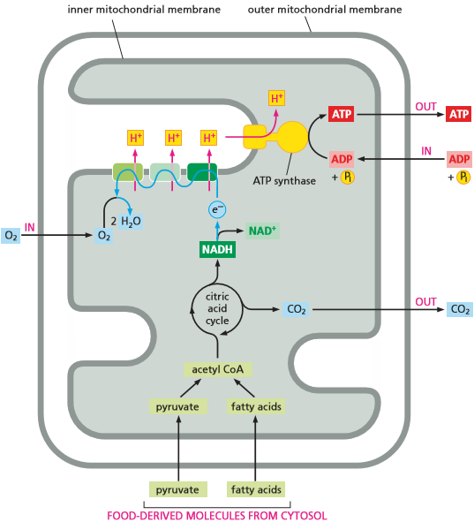
  + The source of high-energy electrons that power the proton pumping differs between different organisms and different processes
    - In cell respiration the high-energy electrons are derived from sugars or fats
    - In photosynthesis, the high energy electrons come from chlorophyll which captures energy from sunlight
    - In single-cell organisms, inorganic substances such as hydrogen, ion, and sulfur are the source of high-energy electrons that are needed to make ATP
* Protons are pumped across the inner mitochondrial membrane by proteins in the electron-transport chain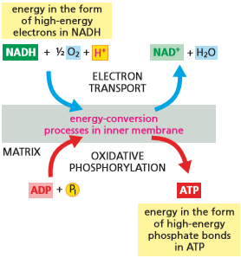
  + The electron-transport chain (aka respiratory chain) that carries out oxidative phosphorylation is present in the inner mitochondrial membrane
    - Each chain is over 40 proteins, grouped into 3 large respiratory enzyme complexes
    - Complexes each contain multiple individual proteins, including transmembrane proteins that anchor the complex firmly in the inner mitochondrial membrane
  + Three respiratory complexes:
    - NADH dehydrogenase complex
      * Accepts electrons from NADH in the form of H- which is converted into a proton and two high-energy electrons
      * H- → H+ + 2e-
      * Electrons are then passed to the next complex
    - Cytochrome c reductase complex
    - Cytochrome c oxidase complex
    - Each complex contains metal ions and chemical groups that act as stepping stones to facilitate passage of electrons
    - The movement of electrons is accompanied by the pumping of proteins from the mitochondrial matrix to the intermembrane space
      * Each complex can be thought of as a protein pump
    - Electrons are passed from electron carriers with weaker electron affinity to those with stronger affinity until they combine with O2 to form water
      * Final reaction is the only oxygen requiring step in cell respiration and consumes nearly all of the oxygen we breath

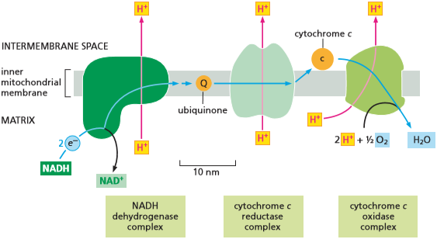

* Proton pumping produces a steep electrochemical proton gradient across the inner mitochondrial membrane
  + Without a mechanism for harnessing produced energy, the energy would be dissipated as heat
    - Cells are able to recover energy because the respiratory enzyme complexes use it to pump protons across the inner mitochondrial membrane, from the matrix into the intermembrane space
  + The pumping of protons creates a H+ gradient (or pH gradient) across the inner membrane
    - The pH in the matrix (around 7.9) is about 0.7 units higher than it is in the intermembrane space (which is 7.2 (same as the cytosol))
  + Proton pumping generates a voltage gradient across the inner membrane
    - As H+ flows outward, the matrix side of the membrane becomes negative and the intermembrane space side becomes positive
  + The electrochemical gradient drives the ion transport across the membrane passively
    - The driving force is proportional to the electrochemical gradient which depends on the voltage across the membrane, as measured by the membrane potential, and on the ion’s concentration gradient
      * Protons more readily cross the membrane if there is an excess of negative charge on the other side
  + In the inner mitochondrial membrane, the pH gradient and membrane potential work to create a steep electrochemical proton gradient that makes it favorable for H+ to flow back into the matrix
    - The proton-motive force pulls H+ back across the membrane
    - The greater the membrane potential, the more energy stored in the proton gradient
* ATP synthase uses the energy stored in the electrochemical proton gradient to produce ATP
  + If protons were allowed to flow back, the energy stored in the electrochemical proton gradient would be lost as heat
    - This is how hibernating bears stay warm
  + In most cells, the electrochemical proton gradient across the inner mitochondrial membrane is used to drive the synthesis of ATP from ADP and Pi
    - ATP synthase is a large, multisubunit protein embedded in the inner mitochondrial membrane that synthesizes ATP
  + ATP synthase is present in animal, plant, and bacteria cells, making it a very old enzyme
    - The passage of protons through the carrier makes the carrier and stalk of ATP synthase to spin, altering the conformation of proteins and encouraging them to produce ATP
    - Mechanical deformation gets converted into the chemical-bond energy of ATP
      * 100 molecules of ATP may be produced a second (3 molecules of ATP per revolution)
  + ATP synthase can operate in reverse by using the energy of ATP hydrolysis to pump proteins against the electrochemical gradient across the membrane
    - ATP synthase functions like the H+ pumps in this case
    - Whether ATP synthase primarily makes ATP or consumes it to pump protons depends on the magnitude of the electrochemical proton gradient across the membrane in which the enzyme is embedded
    - In many bacteria that can grow aerobically or anaerobically, the direction of synthase is reversed when the bacterium runs out of O2
* Coupled transport across the inner mitochondrial membrane is also driven by the electrochemical proton gradient
  + Small, charged molecules such as pyruvate, ADP, and inorganic phosphate are imported into the mitochondrial matrix from the cytosol while others, such as ATP, are exported
    - Carrier proteins bound to these molecules can couple their transport to the energetically favorable flow of H+ into the matrix
    - Pyruvate and Pi are each co-transported inward along with protons as they move down their gradient
  + The matrix side of the inner membrane is more negatively charged than the side facing the intermembrane space
    - An antiport carrier protein exploits the voltage gradient to export ATP from the mitochondrial matrix and to bring ADP in
  + In eukaryotic cells the electrochemical proton gradient is used to drive both the formation of ATP and the transport of selected metabolites across the inner mitochondrial membrane
  + In bacteria, the proton gradient across the plasma membrane is used to drive ATP synthesis and metabolite transport
    - In motile bacteria the flow of protons into the cell drives the rapid rotation of the bacterial flagellum
* The rapid conversion of ADP to ATP in mitochondria maintains a high ATP/ADP ratio in cells
  + ADP molecules are rapidly drawn back into the mitochondria for recharging while the bulk of ATP molecules are exported into the cytosol
    - Small amounts of ATP are used within the mitochondria to power DNA replication, protein synthesis, etc
  + Most biosynthetic enzyme drive energetically unfavorable reactions by coupling them with the energetically favorable hydrolysis of ATP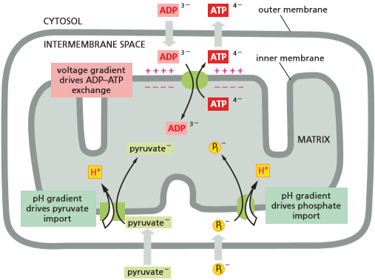
    - The pool of ATP in a cell is used to drive a huge variety of cell processes
    - The concentration of ATP in the cytosol must be kept about 10 times higher than that of ADP
    - If the activity of mitochondria were halted, ATP levels would fall dramatically and energetically unfavorable reactions could no longer take place and the cell would die
      * Cyanide has this effect
* Cell respiration is amazingly efficient
  + The oxidative pathways that allow cells to extract energy from food each differ only slightly from their predecessor, making it possible to parcel huge amounts of energy into small, consumable pockets
    - Parcels are NADH and FADH2
  + Much of the bond energy carried by NADH and FADH2 are converted into the bond energy of ATP
    - NADH molecules produced in the matrix during the citric acid cycle pass their high-energy electrons to the NADH dehydrogenase complex
  + As electrons pass from one enzyme complex to the next, they promote the pumping of protons across the inner mitochondrial membrane at each step along the way, letting each NADH molecule provide enough energy to generate about 2.5 molecules of ATP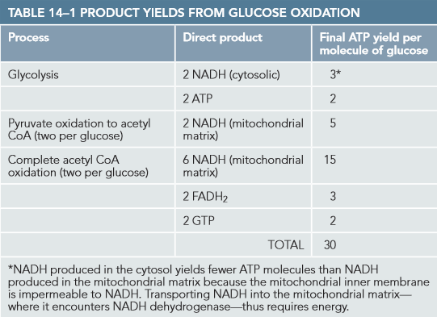
  + FADH2 molecules bypass the NADH dehydrogenase complex and pass their electrons to the membrane embedded mobile carrier ubiquinone
    - They promote the pumping of fewer protons because they’re further down the chain
  + The biological oxidation of glucose to CO2 and H2O is efficient.
    - 50% of the total energy that could be released by burning sugars was captured and stored in the phosphate groups of ATP during cell respiration

**Molecular Mechanisms of Electron Transport Port and Proton Pumping**

* + Transmembrane proton gradients drive the process of ATp production
* Protons are readily moved by the transfer of electrons
  + Hydrogen atoms are highly mobile and by far the most abundant ion in living organism. The protons are highly mobile by rapidly dissociating that water iw for ust oo
    - Protons can rapidly dissociate from one water molecule and associate with its neighbor
    - Protons often accompany electrons that are transferred during oxidation and reduction, in many cases immediately neutralizing the negative charge
  + It is relatively simple to move protons from one side of a membrane to another through the electron-transport chain by orienting the electron carrier in such a way that it accepts an electron on one side of the membrane and then releasing a proton on the other side of the membrane
* The redox potential is a measure of electron affinities
  + The proteins of the respiratory chain guide the electrons so that they move sequentially from one enzyme complex to the next without skips
    - Each electron transfer is an oxidation-reduction reaction
    - The molecule or atom donating the electron becomes oxidized while the recipient is being reduced
  + Electrons pass spontaneously from molecules that have relatively low affinity for their outer-shell electrons, and thus lose them easily, to molecules that have a higher affinity for electrons
    - NADH has a low electron affinity so electrons readily pass to the NADH dehydrogenase complex
  + In biochemical reactions, any electrons removed from one molecule are always passed to another
    - When one is oxidized, another is reduced
  + The tendency of redox reactions to proceed spontaneously depends on the free-energy change (ΔG) for the electron transfer, which in turn depends on the relative affinities of the two molecules for electrons
    - Electron transfers provide most of the energy in living things
  + Molecules that donate protons are acids while acceptors are bases
    - These molecules exist in conjugate acid-base pairs in which the acid is converted into a base by the loss of a proton
    - NADH and NAD+ are redox pairs because NADH is converted to NAD+ by the loss of electrons (NADH ↔ NAD+ +H+ + 2e-)
  + NADH is a strong electron donor because its electrons are held at high-energy because the ΔG for passing them to many other molecules is favorable
    - It is difficult to produce high-energy electrons in NADH so NAD+ is a weak electron acceptor
  + The tendency for a redox pair such as NADH/NAD+ to donate or accept electrons can be determined by measuring its redox potential
    - Electrons move spontaneously from a redox pair with low redox potential to a redox pair with high redox potential
      * ie: from NADH/NAD+ to O2/H2O
      * NADH is excellent at donating electrons to the respiratory chain while O2 is well suited to act as an electron “sink”
* Electron transfers release large amounts of energy
  + The amount of energy released by an electron transfer can be determined by comparing the redox potentials of the molecules involved
    - The redox potential from NADH to NAD+ is -320 mV, meaning NADH has a weak affinity to electrons and a strong tendency to donate
    - The redox potential from H2O to ½ O2 is +820 mV, indicating that O2 has a strong affinity for electrons and a strong tendency to accept them
    - The difference in redox potential between the two pairs is 1140 mV, meaning that the transfer of each electron from NADH to O2 is extremely favorable. The numbers can then be compared to determine that each transfer has enough energy to synthesize a couple of molecules of ATP
  + The electron transfer from NADH to O2 must occur in several steps or else it would have explosive effects, being dissipated as heat
* Metals tightly bound to proteins form versatile electron carriers
  + Each of the three enzyme complexes has metal atoms that are tightly bound to the proteins. Electrons move within the complex by skipping between embedded metal ions based on which has a greater affinity for electrons
  + When passing from one respiratory complex to the next the electrons are ferried by electron carriers that diffuse freely within the lipid bilayer
    - Ubiquinone picks up electrons from the NADH dehydrogenase complex and delivers them to the cytochrome c reductase complex
    - Quinone functions similarly during electron transport during photosynthesis
  + Ubiquinone can accept or donate either one or two electrons, picking up one H+ from water with each electron that it carries
    - The redox potential of +30 mV puts it between NADH dehydrogenase and cytochrome c reductase, making it ideal for transferring electrons
    - Ubiquinone also serves as the entry point for electrons donated by the FADH2 that is generated during the citric acid cycle and from fatty acid oxidation
  + Redox potentials for different metal complexes influence where they are located along the electron-transport chain
    - Iron-sulfur centers have relatively low affinities for electrons and are prominent early in the chain
    - Iron atoms held in heme groups are often used later, giving cytochromes their color
* Cytochrome c Oxidase catalyzes the reduction of molecular oxygen
  + Cytochrome c oxidase is the final electron carrier in the respiratory chain and has the highest redox potential
    - It hands electrons off to O2 to produce H2O
      * Four electrons are transferred to each O2
  + Four other protons are pumped across the membrane during the transfer of the four electrons from cytochrome c to O2
    - The transfer of electrons drives allosteric changes in the conformation of the protein that moves proteins out of the mitochondrial matrix
  + Oxygen is useful as an electron sink because of its high electron affinity
    - Once O2 picks up one electron, it forms the superoxide radical O2- that is super reactive and will take up another three electrons wherever it can find them
      * This reactivity can damage nearby DNA, proteins, and lipid membranes
  + Cytochrome c oxidase holds on tightly to an oxygen molecule until it receives all four of the electrons needed to convert it to two molecules of H2O
    - Prevents superoxide from attacking macromolecules throughout the cell
    - Cyanide is extremely toxic because it binds to cytochrome c oxidase complexes, halting the production of ATP

**Chloroplasts and Photosynthesis**

* + Photosynthesis is the series of light driven reactions that create organic molecules from atmospheric CO2
    - Splits water molecules to release large amounts of O2 gas into the atmosphere
  + Photosynthesis is carried out by chloroplasts which contain light-capturing pigments, such as chlorophyll, during daylight hours
  + Photosynthesis produces ATP and NADPH that can be used to convert CO2 into sugar inside the chloroplast (carbon fixation) any time during the day
* Chloroplasts resemble mitochondria but have an extra compartment - the Thylakoid
  + Chloroplasts are larger than mitochondria but are organized along similar principles
    - Highly permeable outer membrane and less permeable inner membrane
    - The two membranes and the intermembrane space form the chloroplast envelope
    - Inner membrane surrounds a large space called the stroma, which is analogous to the mitochondrial matrix and contains metabolic enzymes
  + The light-capturing systems, electron-transport chain, and ATP synthase are contained in the thylakoid membrane
    - The third membrane is folded to form a set of flattened disc-like sacs, called thylakoids, which are arranged in stacks, called grana
    - The space inside each thylakoid is thought to be connected with that of other thylakoids, creating a third internal compartment, the thylakoid space
* Photosynthesis generates - then consumes - ATP and NADPH
  + Light energy + CO2 + H2O → sugars + O2 + heat energy
    - This equation leaves out ATP and NADPH
      * In the first stage of photosynthesis, the energy from sunlight is used to produce ATP and NADPH
      * In the second stage the activated carriers are consumed to fuel the synthesis of sugars
  + Stage 1: equivalent to the oxidative phosphorylation that takes place in the mitochondrial inner membrane
    - An electron-transport chain in the thylakoid membrane harnesses the energy of electron transport to pump protons into the thylakoid space
    - The resulting proton gradient drives the synthesis of ATP by ATP synthase
    - The high-energy electrons donated to the photosynthetic electron-transport chain come from a molecule of chlorophyll that has absorbed energy from sunlight
      * Sometimes called light reactions
    - The high-energy electrons ultimately end up donated to NADP+ to make NADPH instead of donated to O2 to make H2O
  + Stage 2: The ATP and NADPH produced by stage 1 are used to drive the manufacture of sugars from CO2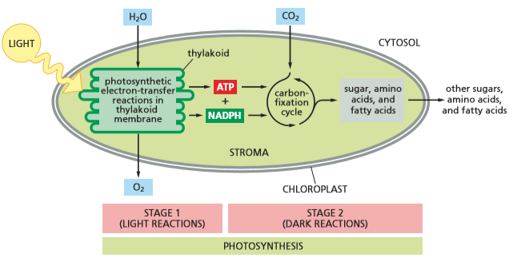
    - Carbon-fixation reactions can occur in the absence of sunlight
      * Called dark reactions
    - Three-carbon sugars (glyceraldehyde 3-phosphate) are generated in the chloroplast stroma
    - The simple sugars are exported to the cytosol where they produce sucrose and other organic molecules
  + Stage 1 and Stage 2 are linked by feedback mechanisms that allow a plant to manufacture sugars only when appropriate to do so
* Chlorophyll molecules absorb the energy of sunlight
  + Visible light is a form of electromagnetic radiation composed of many wavelengths
    - Wavelengths range from UV (400 nm) to deep red (700 nm)
    - Most chloroplasts best absorb light in the blue and red wavelengths. They look green because they absorb green light poorly, reflecting it at our eyes
  + The electrons in a chlorophyll molecule are distributed in a decentralized cloud around the molecule’s light-absorbing porphyrin ring
    - When light of an appropriate wavelength hits the chlorophyll molecule, it excites electrons in the diffuse network, changing the way they are distributed
    - Excited molecules will seek to remove excess energy so that they may return to a stable state
  + A chlorophyll on its own would release excess energy as light or heat
    - Chlorophyll molecules in a chloroplast can convert light energy into useful energy because they are associated with a special set of photosynthetic proteins in the thylakoid membrane
* Excited chlorophyll molecules funnel energy into a reaction center
  + Chlorophyll molecules are held in large multiprotein complexes called photosystems
    - Each photosystem consists of a set of antenna complexes, which capture light energy, and a reaction center, which converts that light into chemical energy
  + In each antenna complex, chlorophyll molecules are arranged so that they can transfer light energy to neighboring chlorophyll
    - Energy jumps randomly from one chlorophyll molecule to the next
    - Eventually the energy will encounter a chlorophyll dimer (called the special pair)
      * Special pair holds its electrons at a lower energy than other chlorophyll molecules, trapping transferred energy
  + The chlorophyll special pair is part of the reaction center
    - Reaction center is a transmembrane complex of proteins and pigments that transfers high energy electrons from the special pair to electron carriers
  + When the high-energy electron is handed off, the chlorophyll special pair becomes positively charged, and the electron carrier becomes negatively charged
    - The rapid movement of this electron along a set of electron carriers creates a charge separation that transports electrons from the reaction center to an electron-transport chain
* A pair of photosystems cooperate to generate both ATP and NADPH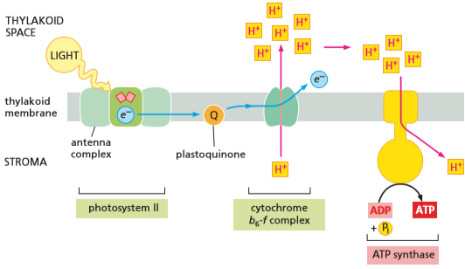
  + When the first photosystem (photosystem II) absorbs light energy, its reaction center passes electrons to a mobile electron carrier called plastoquinone
    - The carrier transfer the high-energy electrons to a proton pump, which uses the movement of electrons to generate a proton gradient that drives the production of ATP
  + A second nearby photosystem (photosystem I) captures energy from sunlight and passes high-energy electrons to a different mobile electron carrier, which brings them to an enzyme that reduces NADP+ to NADPH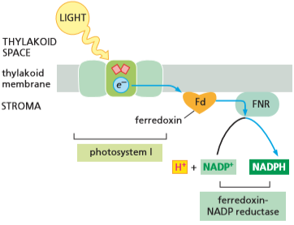
  + The combined action of the photosystems produces ATP and NADPH

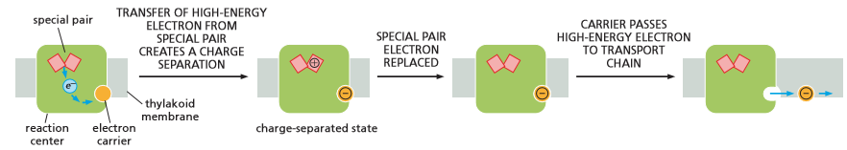

* Oxygen is generated by a water-splitting complex associated with photosystem II
  + When a mobile electron carrier removes an electron form a reaction center, it leaves behind a positively charged chlorophyll special pair that must be reset by replacing the electron for the process to repeat
  + For Photosystem II the missing electron is replaced by a protein complex that removes electrons from water
    - The water-splitting enzyme removes four electrons from two water molecules, releasing O2
    - Waiting for four electrons ensures no partially oxidized water molecules are released as dangerous, highly reactive chemicals
* The special pair in photosystem I receives its electron from photosystem II
  + The chlorophyll special pair in photosystem I serves as the final electron acceptor for the electron-transport chain that carries electrons from photosystem II
    - Electrons are transferred from photosystem II, through a proton pump, to an electron carrier (plastocyanin) to photosystem I to replace lost electrons
  + The photosystems operate in tandem, coupling their two electron-energizing steps with enough energy left over to pump H+ across the thylakoid membrane so that ATP synthase can harness some of the light-derived energy for ATP production

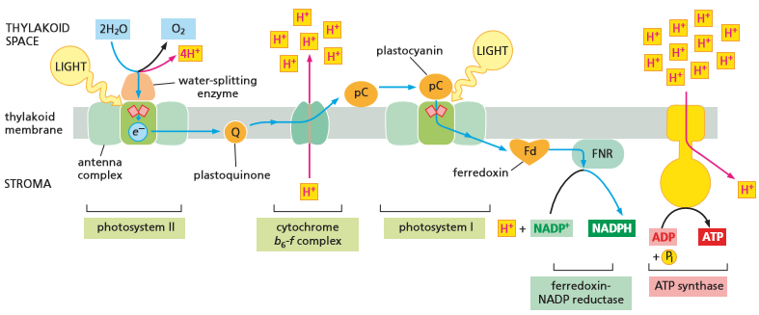

* Carbon fixation uses ATP and NADPH to convert CO2 into sugars
  + The inner membrane of chloroplasts are impermeable to ATP and NADPH, which means they cannot be exported into the cytosol
  + ATP and NADPH must be used within the chloroplast stroma to produce sugars, which can be exported by specific carrier proteins in the inner membrane
    - Sugars are produced from CO2 and H2O, which occurs in the dark reactions of photosynthesis (carbon fixation)
  + CO2 from the atmosphere is attached to a 5-carbon sugar derivative (ribulose 1,5-biphosphate) to yield two molecules of the 3-carbon compound (3-phosphoglycerate)
    - The carbon-fixing reaction is catalyzed in the chloroplast stroma by a large enzyme called ribulose bisphosphate carboxylase
      * Also called Rubisco
    - Rubisco processes about 3 molecules of substrate per second
      * Plants maintain a surplus of rubisco to ensure the efficient production of sugars
      * Comprises 50% of the chloroplast protein and claimed to be the most abundant protein on earth
  + The fixation of CO2 catalyzed by Rubisco is an energetically favorable reaction
    - Carbon fixation is energetically favorable because a continuous supply of the energy-rich ribulose 1,5-bisphosphate is fed into it
    - This is regenerated by ATP and NADPH reactions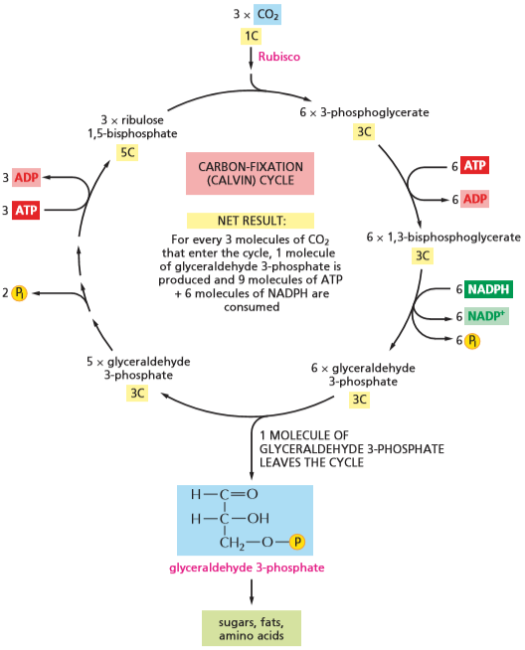
  + The series of reactions in which CO2 combines with ribulose 1,5-bisphosphate to produce a sugar forms the carbon-fixation cycle
    - For every three molecules of CO2 that enter the cycle, one molecule of glyceraldehyde 3-phosphate is produced, and 9 molecule of ATP and 6 molecules of NADPH are consumed
* Sugars generated by carbon fixation can be stored as starch or consumed to produce ATP
  + Glyceraldehyde 3-phosphate can be used in several ways:
    - During periods of excess photosynthesis, much of it is retained in the chloroplast stroma and converted into starch
      * Starch is a large polymer of glucose that serves as a carbohydrate reserve
    - It can be converted into fat in the stroma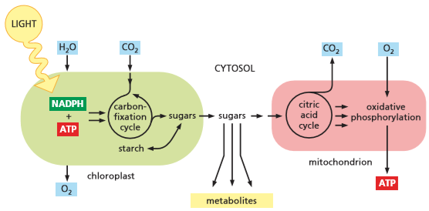
  + At night the stored starch and fat can be broken down into sugars and fatty acids
    - Some of the exported sugar enters the glycolytic pathway where it is converted into pyruvate
    - Pyruvate and fatty acids can enter the plant cell mitochondria and be fed into the citric acid cycle, ultimately producing ATP by oxidative phosphorylation
  + Glyceraldehyde 3-phosphate can also be converted into many other metabolites, including sucrose
    - Sucrose is the major form by which sugar is transported between cells of a plant

**The Evolution of Energy-Generating Systems**

* Oxidative phosphorylation evolved in stages
  + The first living cells on earth may have consumed geochemically produced organic molecules and produced ATP by fermentation
  + If acids lowered the pH of the environment, evolved transmembrane proteins could pump H+, possibly using ATP as an energy source
  + Organisms found a way to pump H+ without consuming ATP as geochemically produced nutrients dwindled
    - The need to conserve resources led to the evolution of electron-transport proteins
  + Some bacteria developed H+-pumping electron transport systems that were more efficient
    - They could harvest redox energy to maintain internal pH
* Photosynthetic bacteria made even fewer demands on their environment
  + The major evolutionary breakthrough in energy metabolism would have been photochemical reaction centers that could utilize sunlight
  + The next step is the evolution of organisms that could use H2O instead of H2S
  + The availability of O2 made it possible to develop bacteria that relied on aerobic metabolism to make their ATP
    - Some organisms lost their ability to survive on light and relied completely on cell respiration
* The lifestyle of Methanococcus suggests that chemiosmotic coupling is an ancient process
  + Deep ocean hydrothermal vents mimic what the atmosphere would have been like 3.5-3.8 billion years ago
  + Methanococcus jannaschii is an organism that grows in hydrothermal vents a mile beneath the ocean’s surface
    - Grows in complete absence of light and gaseous oxygen, using inorganic gases (H2, CO2, and N2) for nutrients
  + Methanococcus relies on N2 gas as its source of nitrogen for making organic molecules
    - Uses nitrogen fixation to reduce N2 to ammonia (NH3) by the addition of hydrogen
    - Nitrogen fixation requires a large amount of energy, most of which is derived from the transfer of electrons from H2 to CO2 with the release of methane (CH4) as a waste product
  + The existence of such chemiosmotic coupling suggests that the storage of energy in a proton gradient is an ancient process, potentially fuelling the evolution of nearly all lifeforms on earth

**How We Know - How Chemiosmotic Coupling Drives ATP Synthesis**

* + It was discovered early on that aerobic metabolism is more efficient to anaerobic metabolism
  + It took a long time to determine the process of chemiosmotic coupling
* Imaginary intermediates
  + Many researchers believed that a high-energy intermediate delivers a phosphate group to ADP to make ATP
* Harnessing the force
  + Peter Mitchell suggested that the “high-energy intermediate” was the electrochemical proton gradient generated by the electron-transport system
    - The chemiosmotic hypothesis states that the energy of an electrochemical proton gradient could be tapped to drive ATP synthesis
  + Mitochondria generate an electrochemical proton gradient across their inner membrane
    - Researchers found that disrupting the inner membrane to eliminate the proton gradient inhibits ATP production
  + In brown fat cells, most of the energy from the oxidation of fat is dissipated as heat instead of being converted into ATP
* Artificial ATP generation
  + Generating an artificial proton gradient should stimulate ATP synthesis
  + Bacteriorhodopsin, a protein that pumps H+ out of the cell in response to sunlight, generates a proton gradient
    - The system could catalyze the synthesis of ATP from ADP using this proton gradient

**Chapter 15**

* + If the cells of an organ are broken and allowed to mix together, chemical chaos would result
  + One method for isolating chemical reactions is aggregating enzymes into large, multicomponent complexes
  + Another method is to confine different metabolic processes into different membrane-enclosed compartments
    - Cell membranes provide selectively permeable barriers through which the transport of molecules can be regulated
  + Each compartment in cells contains a unique set of proteins that have to be transferred selectively from the cytosol
    - Transfer process is called protein sorting
  + Enclosed compartments in a eukaryotic cells communicate with one another by forming membrane-enclosed sacs (vesicles)
    - Vesicles pinch off from one compartment and move through the cytosol and fuse with other compartments through vesicular transport

**Membrane-Enclosed Organelles**

* + Eukaryotic cells are elaborately subdivided by internal membranes
    - Divided into membrane-enclosed organelles
* Eukaryotic cells contain a basic set of membrane-enclosed organelles
  + Membrane-enclosed organelles are enclosed by the plasma membrane
  + The nucleus is generally the most prominent organelle in eukaryotic cells
    - Surrounded by a double membrane (nuclear envelope) and communicates with the cytosol via nuclear pores that perforate the envelope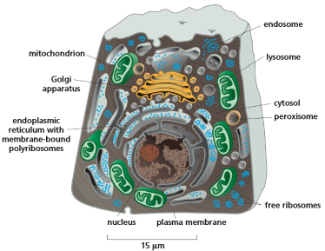
    - The outer nuclear membrane is continuous with the membrane of the endoplasmic reticulum
  + The ER is a system of interconnected sacs and tubes of membrane that often extends throughout the cell
    - Major site of synthesis of new membranes in the cell
    - The majority of the ER has ribosomes attached to the cytosolic surface and are designated rough endoplasmic reticulum (rough ER)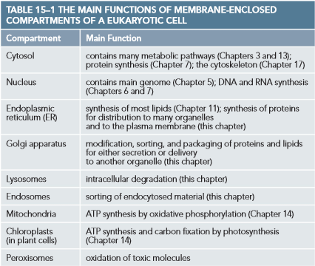
      * Ribosomes synthesize protons
    - The ER interior is the lumen
    - Smooth endoplasmic reticulum (smooth ER) lacks ribosomes
      * Has very specific purposes such as processing alcohol in the liver or synthesizing steroid hormone
  + The Golgi apparatus receives proteins and lipids from the ER, modifies them, then distributes them to other organelles
  + Lysosomes are small sacs of digestive enzymes that degrade damaged organelles and macromolecule particles
    - Endocytosed materials must first pass through endosomes which sort ingested molecules and recycle some back into the plasma membrane
    - Peroxisomes are small organelles that contain enzymes used in a variety of oxidative reactions that break down lipids and destroy toxic materials
  + Mitochondria and chloroplasts are surrounded by a double membrane and are the sites of oxidative phosphorylation and photosynthesis
    - Their internal membranes are specialized for the production of ATP
  + Many membrane-enclosed organelles are held in their relative locations in the cell by the cytoskeleton (microtubules)
    - Cytoskeletal filaments provide tracks for moving organelles and direct the traffic of vesicles
    - Movement is driven by motor proteins that consume ATP to propel organelles
  + On average, membrane-enclosed organelles occupy nearly half the volume of a eukaryotic cell
    - A very large amount of total membrane is used
* Membrane-enclosed organelles evolved in different ways
  + Compartments likely evolved in stages
    - Precursors of the first eukaryotic cells are thought to have been simple microorganisms which nad plasma membranes but no internal membranes
    - Bacteria are small enough that their plasma membrane provides enough surface area to volume ratio to let them survive
      * Lets them perform ATP synthesis and lipid synthesis
      * Modern eukaryotes have volumes 1000-10000 times larger than bacteria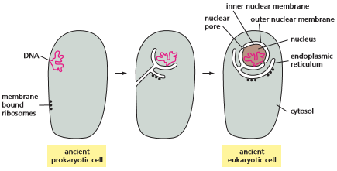
  + Membrane enclosed organelles are thought to have arisen in evolution in two ways:
    - The organelle membranes formed by the invagination of the plasma membrane
    - Mitochondria and chloroplasts possess their own small genomes and can make some of their own proteins, leading us to believe they evolved from bacteria that was engulfed by primitive pre-eukaryotic cells
      * Mitochondria and chloroplasts remain isolated from the extensive vesicular traffic connecting the interiors of most other membrane-enclosed organelles
  + The endomembrane system is a communication system between organelles by means of small vesicles that bud off from one organelle and fuse with another
    - Include the ER, golgi apparatus, peroxisomes, endosomes, and lysosomes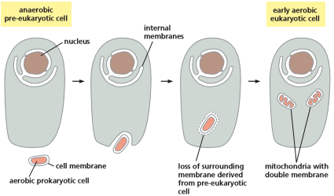
    - The interiors of these cells are treated by the cell as “extracellular”

**Protein Sorting**

* + Organelles divide with the cells when they duplicate and are distributed between the two daughter cells
  + Organelle growth requires a supply of lipids to make more membrane and a supply of proteins to occupy the interior of the organelle
    - Even when the cell is not dividing, proteins are constantly produced and must be delivered to the organelles
  + Direction newly made proteins to their correct organelle is necessary for any cell to grow, divide, or funciton properly
  + For some organelles, proteins are delivered direclty form the cytosol
    - Includes mitochondria, chloroplasts, peroxisomes, and the interior of the nucleus
  + Other organelles receive protein and lipid deliveries via the ER
    - Includes Golgi apparatus, lysosomes, endosomes, and inner nuclear membrane
  + Proteins enter the ER directly from the cytosol
* Proteins are transported into organelles by three mechanisms
  + Synthesis of proteins begins on ribosomes in the cytosol
  + Proteins are moved depending on their amino acid sequence
    - The amino acid sequence can contain a sorting signal that directs the protein to the organelle in which it is required
    - Proteins without a sorting signal stay in the cytosol
  + When a membrane-enclosed organelle imports a water-soluble protein to its interior, it must transport the protein across its membranes which are normally impermeable to hydrophilic macromolecules
  + Mechanism 1: Proteins moving from the cytosol into the nucleus are transported through the nuclear pores
    - Nuclear pores penetrate the inner and outer nuclear membranes
    - Pores function as selective gates that actively transport specific macromolecules but also allow passive diffusion of smaller molecules
  + Mechanism 2: Proteins moving from the cytosol into the ER, mitochondria, or chloroplasts are transported through protein translocators
    - Transported protein must usually unfold to snake across the membrane through the translocator
  + Mechanism 3: Proteins moving onward from the ER, or from one endomembrane system to another, are ferried by transport vesicles
    - Vesicles pinch off from the membrane of one compartment and then fuse with the membrane of a second
* Signal sequences direct proteins to the correct compartment
  + The signal sequence is often removed from the finished protein once it has been sorted
    - The sorting signal is typically 15-60 amino acids long
  + Signal sequences specifying the same destination can vary greatly even though they have the same function
    - Physical properties such as hydrophobicity or the placement of charged amino acids often appear to be more important to the function of the signals compared to the exact amino acid sequence
* Proteins enter the nucleus through nuclear pores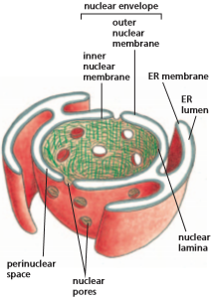
  + The nuclear envelope encloses the nuclear DNA and defines the nuclear compartment
    - It is formed from two concentric membranes
  + The inner nuclear membrane contains some proteins that act as binding sites for the chromosomes and provide anchorage for the nuclear lamina
    - Nuclear lamina is a finely woven meshwork of protein filaments that lines the inner face of the membrane and provides structural support for the nuclear envelope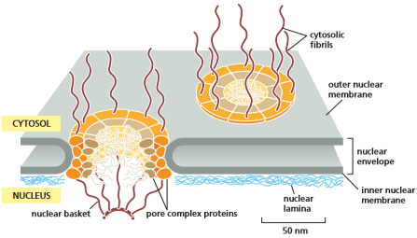
  + The outer nuclear membrane resembles the membrane of the ER, to which it is continuous
  + The nuclear envelope in all eukaryotic cells is perforated by nuclear pores
    - Nuclear pores are large elaborate structures of about 30 proteins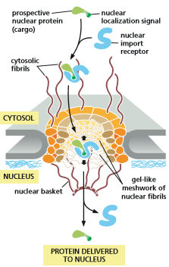
    - Proteins lining the pores contain unstructured regions in which the polypeptide chains are largely disordered
      * They form soft, tangled meshwork that fills the center of the channel, preventing the passage of large molecules but allowing small, water-soluble molecules to pass freely
    - Selected larger molecules and macromolecule complexes may enter through pores if they display the appropriate sorting signal
      * The sequence that directs a protein from the cytosol into the nucleus is the nuclear localization signal, consisting of one or two short sequences of positively charged lysine or arginines
  + The nuclear localization signal on proteins destined for the nucleus is recognized by nuclear import receptors
    - Receptors are in the cytosol and help direct the protein into a nuclear pore by interacting with the fibrils that extend from the rim of the pore into the cytosol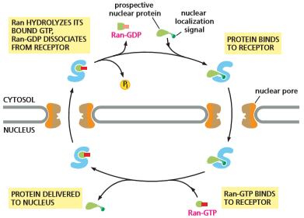
    - Nuclear import receptor enters the pore by grabbing onto the pore proteins that fill the center of the pore and blocking the interactions between amino acid sequences to open a local passageway through the meshwork
    - The empty receptor returns to the cytosol via the nuclear pore
  + The import of nuclear proteins requires energy
    - Energy is provided by the hydrolysis of GTP
    - Nuclear pore proteins operate the molecular gate at high speed
* Proteins unfold to enter mitochondria and chloroplasts
  + Mitochondria and chloroplasts are both surrounded by an inner and outer membrane
    - Chloroplasts contain a third membrane system (thylakoid membrane)
  + Even though both are capable of making proteins, most of their proteins originate in the nucleus and are imported from the cytosol
    - Proteins usually have a signal sequence at their N-terminus that allows them to enter the specific organelle
    - Proteins destined for either organelle are translocated simultaneously across both membranes at special sites where the two membranes touch each other
  + Chaperone proteins inside the organelles help to pull the protein across the two membranes and to fold it once it is inside
    - Subsequent transport usually requires further sorting signals in the protein
  + The growth and maintenance of mitochondria and chloroplasts require the import of new proteins and incorporation of new lipids into the organelle membranes
    - Most of the membrane phospholipids are transported from the ER, which is the main site of lipid synthesis in the cell
    - Phospholipids are transported to organelles by lipid-carrying proteins that extract a phospholipid molecule from one membrane and deliver it to another

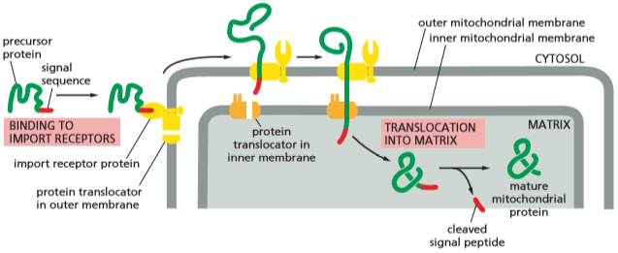

* Proteins enter peroxisomes from both the cytosol and the endoplasmic reticulum
  + Peroxisomes generally contain one or more enzymes that produce hydrogen peroxide, used to break down a variety of molecules
  + Peroxisomes acquire the majority of their proteins from selective transport from the cytosol
    - A short sequence of 3 amino acids acts as an import signal for the proteins
    - The peroxisomal membrane contains a protein translocator that aids in the transport of proteins
    - Proteins do not need to unfold to enter the peroxisome
  + A few peroxisomal proteins come from vesicles that bud from the ER membrane
    - Vesicles fuse with preexisting peroxisomes or import peroxisomal proteins from the cytosol to serve as the base to grow into mature peroxisomes
  + Peroxisomal disease cause mutations that block peroxisomal protein transport, creating abnormalities that kill within the first 6 months of life
* Proteins enter the endoplasmic reticulum while being synthesized
  + The ER is the most extensive membrane system in a eukaryotic cell and serves as an entry point for proteins destined for other organelles
  + Proteins destined for the Golgi apparatus, endosomes, and lysosomes, and those destined for the cell surface, at first enter the ER from the cytosol
  + Once inside the ER lumen, or embedded in the ER membrane, individual proteins will not re-enter the cytosol and will instead be ferried from organelle to organelle or to the plasma membrane by transport vesicles
  + Two kinds of protein transported from the cytosol to the ER:
    - Water soluble proteins are completely translocated across the ER membrane and released in the ER lumen
      * Destined for secretion or for the lumen of an organelle of the endomembrane system
    - Prospective transmembrane proteins are only partially translocated across the ER membrane and become embedded in it
      * Destined to reside in the membrane of the organelles or plasma membrane
    - All of these proteins are initially directed to the ER by an ER signal sequence
  + Most of the proteins that enter the ER begin to be threaded across the ER membrane before the polypeptide chain has been completely synthesized
    - Requires that the ribosome synthesizing the protein be attached to the ER membrane
    - Ribosomes coating the surface of the ER creates rough endoplasmic reticulum
  + Membrane-bound ribosomes are attached to the cytosolic side of the ER membrane and make proteins that are translocated into the ER
    - Because they are translocated as they are being made, no additional energy is required for their transport
    - The elongation of the polypeptide provides the thrust needed to push the growing chain through the ER membrane
  + Free ribosomes are unattached to any membrane and are making all the other proteins encoded by the nuclear DNA
  + As an mRNA molecule is translated, ribosomes bind to it, forming a polyribosome
* Soluble proteins made on the ER are released into the ER lumen
  + Two protein compounds help guide ER signal sequences to the ER membrane:
    - Signal-recognition particle (SRP)
      * Present in the cytosol
      * Binds to both the ribosome and the ER signal sequence when it emerges from the ribosome
    - SRP receptor
      * Embedded in the ER membrane
      * Recognizes the SRP
  + Binding of an SRP to a ribosome reduces protein synthesis by that ribosome until the SRP engages with an SRP receptor on the ER
    - Once the ER is bound, the SRP is released and the receptor passes the ribosome to a protein translocator in the ER membrane
    - The polypeptide is threaded across the ER membrane through a channel in the translocator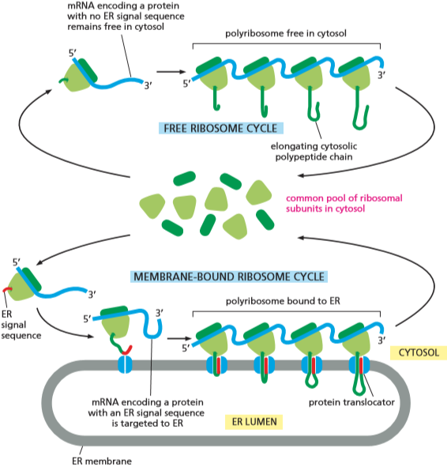
      * The SRP and SRP receptor function as molecular matchmakers, uniting ribosomes that are synthesizing proteins with an ER signal sequence and available translocation channels in the ER membrane
  + The signal sequence functions to open the channel in the protein translocator
    - The sequence remains bound to the channel while the rest of the polypeptide chain is threaded through the membrane as a large loop
    - The cleaved signal sequence is released from the translocation channel into the lipid bilayer and rapidly degraded
  + Once the C-terminus of a soluble protein has passed through the translocation channel, the protein will be released into the ER lumen
* Start and stop signals determine the arrangement of a transmembrane protein in the lipid bilayer
  + Some proteins made by ER-bound ribosomes remain embedded in the ER membrane as transmembrane proteins
    - The translocation process is more complicated for these proteins compared to soluble proteins, as they only partially translocated across the bilayer
  + For a transmembrane protein with a single membrane-spanning segment:
    - The N-terminal signal sequence initiates translocation
    - The transfer process is halted by an additional sequence of hydrophobic amino acids (stop-transfer sequence)
    - The N-terminal signal sequence is cleaved off while the stop-transfer sequence remains in the bilayer, where it is anchored to the membrane by a ɑ-helical membrane spanning segment
  + A transmembrane protein does not change its orientation, which is retained throughout any subsequence vesicle budding and fusion events
  + In some transmembrane proteins, an internal sequence sequence is used to start the protein transfer (start-transfer sequence)
    - The start-transfer sequence is never removed from the polypeptide
  + In complex multipass proteins, additional pairs of start- and stop-transfer sequences come into play, one sequence reinitiating translocation further down the polypeptide chain and the other stopping translocation and triggering polypeptide release
    - Multipass membrane proteins are stitched into the lipid bilayer as they are being synthesized

**How We Know - Tracking Protein and Vesicle Transport**

* In a tube
  + A protein bearing a single sequence can be introduced to a preparation of isolated organelles in a test tube
    - To see if a protein is taken up by an organelle
    - Protein is usually produce in vitro
  + Radioactive amino acids can be used to label the protein
* Ask a yeast
  + Movement of proteins between different cell compartments has been studied extensively
  + Mutant yeast cells encode temperature-sensitive proteins that, at high heat, are inactivated
    - Various proteins accumulate inappropriately in the ER, golgi apparatus, or transport vesicles depending on their mutation
* At the movies
  + Protein movement can be tracked by tagging the polypeptide with a fluorescent protein, such as GFP
  + The small protein can be fused to other cell proteins to monitor them with a fluorescence microscope
  + GFP fusion proteins are widely used to study the location and movement of proteins in cells
    - GFP fused to a plasma membrane protein can measure the kinetics of its movement through the secretory pathway

**Chapter 11**

Note: first half skipped

**Membrane Proteins**

* + The lipid bilayer provides the basic structure of all cell membranes and serves as a permeable barrier to the hydrophilic molecules on either side of it
    - Most membrane functions are carried out by membrane proteins
  + In animals, proteins constitute about 50% of the mass of most plasma membranes
    - A cell membrane typically contains 50 times more lipid molecules than protein molecules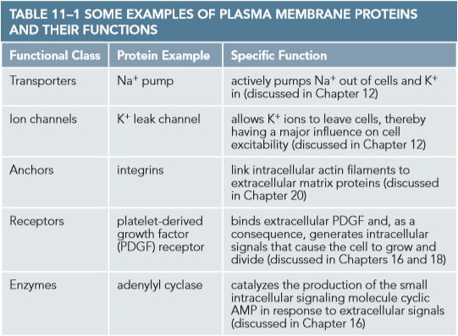
  + Membrane proteins serve many functions
    - Transporting particular nutrients, metabolites, and ions across the bilayer
    - Anchor the membrane to macromolecule on either side
    - Function as receptors that detect chemical signals in the cell’s environment
    - Work as enzymes to catalyze specific reactions in the membrane
  + Each type of cell membrane contains a different set of proteins
* Membrane proteins associate with the lipid bilayer in different ways
  + Many membrane proteins extend through the bilayer, with part of their mass on either side
    - Transmembrane proteins are amphipathic, having both hydrophobic and hydrophilic regions
    - Hydrophobic regions are inside the lipid bilayer
    - Hydrophilic regions are exposed to the aqueous environment on either side of the membrane
  + Other membrane proteins are located almost entirely in the cytosol and are associated with the cytosolic half of the lipid bilayer by an amphipathic ɑ helix exposed on the surface of the protein
  + Some proteins lie entirely outside the bilayer, attached to the membrane by one or more covalently attached lipid groups
  + Some proteins are bound indirectly to one or the face of the membrane, held in place by interactions with other membrane proteins

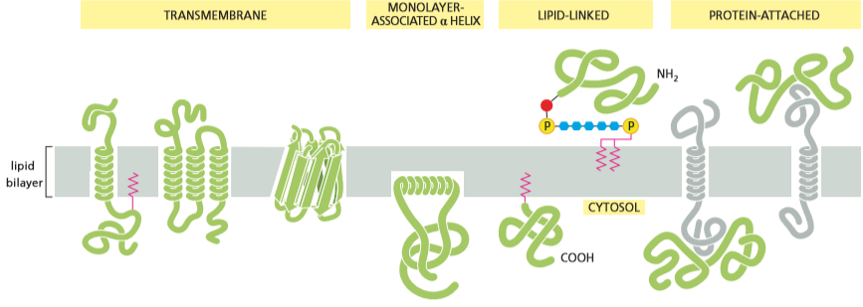

* + Proteins that are directly attached to the lipid bilayer can be removed by disrupting the bilayer with detergents
    - Integral membrane proteins
    - Remaining membrane proteins are the peripheral membrane proteins that can be released from the membrane by more gentle extraction procedures that interfere with protein-protein interaction but do not disturb the bilayer
* A polypeptide chain usually crosses the lipid bilayer as an ɑ helix
  + All membrane proteins have a unique orientation in the lipid bilayer
    - Consequence of the way in which membrane proteins are synthesized
  + Portions of a transmembrane protein located on either side of the lipid bilayer are connected by specialized membrane-spanning segments of the polypeptide chain
    - Segments are composed largely of amino acids with hydrophobic side chains
    - Because the side chains cannot form favorable interactions with water molecules, they interact with hydrophobic tails of the lipid molecules
  + The peptide bonds that join the successive amino acids in a protein are normally polar, making the polypeptide backbone hydrophilic
    - Because water is absent, the backbones are driven to form hydrogen bonds with one another
    - Hydrogen bonding is maximized if the polypeptide chain forms a regular ɑ helix
      * In ɑ helices, the hydrophobic side chains are exposed on the outside of the helix
  + In many transmembrane proteins, the polypeptide chain crosses the membrane only once
    - Single-pass transmembrane proteins are receptors for extracellular signals
    - Other transmembrane proteins serve as channels, consisting of a series of ɑ helices that cross the bilayer a number of times
  + Amino acids tend to be arranged so that the hydrophobic side chains fall on one side of the helix
    - In the hydrophobic environment of the lipid bilayer, ɑ helices pack side by side in a ring, with the hydrophobic side chains exposed to the lipids of the membrane and the hydrophilic side chains forming the lining of a hydrophilic pore through the lipid bilayer
  + Although the ɑ helix is the most common form in which a polypeptide chain crosses a lipid bilayer, the polypeptide chain of some transmembrane proteins crosses the lipid bilayer as a β sheet rolled into a cylinder
    - Forms a β barrel
    - Amino side chains that face the inside of the barrel are mostly hydrophilic
* Membrane proteins can be solubilized by detergents
  + Membrane proteins are hard to study because they require an environment that is partly aqueous and partly fatty, making it hard to purify them while preserving their structure
  + To study an individual protein, it must first be separated from all other cell proteins
  + Disruptive agents (detergents) are used to destroy the lipid bilayer by disrupting hydrophobic associations
    - Disruptive agents only have a single hydrophobic tail
    - Their single tail makes them aggregate in micelles rather than forming bilayers
    - When mixed with the membranes, the hydrophobic ends of detergent molecules interact with the membrane-spanning hydrophobic regions of the transmembrane proteins and the hydrophobic tails of the phospholipid molecules, disrupting the bilayer and separating proteins from phospholipids
* We know the complete structure of relatively few membrane proteins
  + A protein’s 3D structure can be determined by X-ray crystallography
    - With advances in protein preparation and X-ray crystallography, the structures of an increasing number of membrane proteins have now been determined in high resolution
  + Bacteriorhodopsin is a small protein found in large amounts in the plasma membrane of the archaean Halobacterium halobium
    - Acts as a membrane transport protein that pumps H+out of the cell
    - Gets energy to pump H+ directly from sunlight
    - Light absorbing nano proteins are called retinal and give the protein a deep purple color
* The plasma membrane is reinforced by the underlying cell cortex
  + A cell membrane by itself is extremely thin and fragile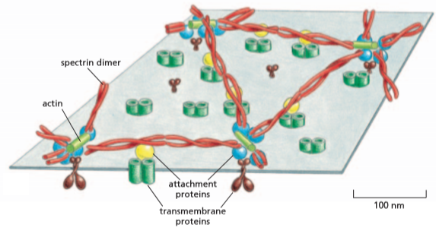
    - Most cell membranes are reinforced by a framework of proteins
  + The plasma membrane of animal cells is stabilized by the cell cortex that is attached to the underside of the membrane
    - In red blood cells it maintains the cell’s biconcave shape
  + The spectrin meshwork is connected to the membrane through intercellular attachment proteins
  + Proteins similar to spectrin are present in the cortex of most animal cells
* A cell can restrict the movement of its membrane proteins
  + Many of the membrane’s proteins can move freely within the plane of the lipid bilayer
  + Cells can confine particular proteins to localized areas, creating functionally specialized regions called membrane domains, on the cell or organelle surface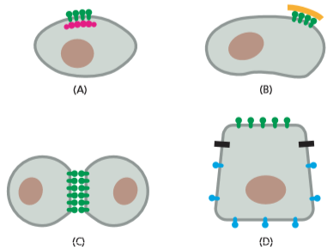
  + Plasma membrane proteins can be tethered to structures outside the cell or to relatively immobile structures inside the cell
    - Cells can create barriers that restrict particular membrane components to one membrane domain
  + The asymmetric distribution of membrane proteins is maintained by a barrier formed along the line where the cell is sealed to adjacent epithelial cells by “tight junctions”
* The cell surface is coated with carbohydrate
  + The great majority of proteins in the plasma membrane have short chains of sugars (oligosaccharides) linked to them
    - Together they form glycoproteins
  + Proteoglycans contain one or more long polysaccharide chains
  + All of the carbohydrates on the glycoproteins, proteoglycans, and glycolipids is located on the outside of the plasma membrane and forms a sugar coating called the carbohydrate layer (glycocalyx)
    - The layer of carbohydrates helps protect the cell surface from mechanical damage and give the cell a slimy surface, preventing certain cells from sticking to each other and letting white blood cells slide through tight spaces
    - Proteins called lectins are specialized to bind to particular oligosaccharide side chains
    - Sugars can be joined together in many different arrangements, often forming elaborate branched structures
  + The carbohydrate layer on the surface of cells in a multicellular organism serves as a kind of distinctive clothing, characteristic of each cell type.

**How We Know - Measuring Membrane Flow**

* + Lipid bilayers are fluid, letting membrane-embedded proteins move laterally in the plane of the bilayer, allowing for protein-protein interactions
* The FRAP attack
  + Fluorescence recovery after photobleaching (FRAP)
  + Involves uniformly labelling components of the cell membrane (lipids/proteins) with fluorescent marker
  + A small patch of membrane is irradiated with intense light, bleaching the fluorescence from the labelled proteins in the area
    - The time it takes for neighboring, unbleached fluorescent proteins to move into the bleached region is measured (rate of “fluorescence recovery”)
  + The membrane is about as viscous as olive oil
* One-by-one
  + The FRAP approach measures the movement of large populations of proteins across a relatively large area
  + There are methods of labelling and observing the movement of individual molecules or small clusters of molecules
  + Single-particle tracking (SPT) microscopy relies on tagging protein molecules with antibody-coated gold nanoparticles
    - Gold particles look like tiny black dots in the microscope and can be followed using video microscopy
* Freed from cells
  + Membrane proteins can be isolated from cells and the protein of interest purified and reconstituted in artificial phospholipid vesicles
  + Lipids allow the purified protein to maintain its proper structure and function so its behavior can be analyzed in detail